4.01 Midpoint
Year 9 Maths · A5 question sheet · Level 3 · Challenge
This worksheet practises midpoints with decimals and pronumerals, finding missing endpoints, and splitting an interval in a given ratio. Tip: to find the point a fraction of the way from A to B, work out how far you move in $x$ and in $y$ from A to B, take that fraction of each, and add it on to A.

 Understanding
- Find the midpoint of the interval joining each pair of points.
  - (−7, 2.5) and (4, −6.5)
  - (−3.2, 1.4) and (−0.8, −5)
  - $(2a,5)$ and $(4a,−1)$
  - $(p−3,q)$ and $(p+7,3q)$
- The interval AB is shown on the grid.
- 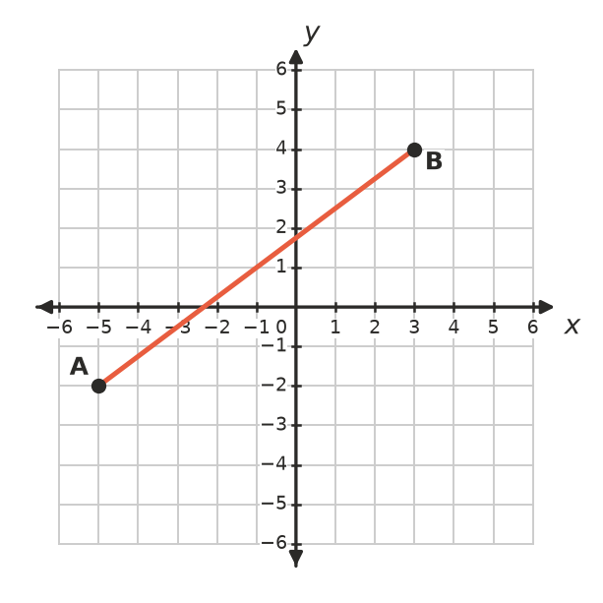
- Find the coordinates of the three points that split AB into four equal parts, and mark them on a copy of the grid in your book.

 Fluency
- M is the midpoint of AB. Find the missing endpoint.
  - A(−3, 8), M(2, 1). Find B.
  - M(−1.5, 4), B(4, −2). Find A.
  - A$(m,n)$, M(0, 0). Find B.
- A triangle has corners P(−4, 6), Q(8, 2) and R(2, −6).
  - X is the midpoint of PQ and Y is the midpoint of PR. Find X and Y.
  - Describe how you move (across and up or down) from X to Y, and from Q to R. What do you notice about XY and QR?

 Reasoning
- A is (−6, −2) and B is (10, 6). Find the point P on AB so that AP : PB = 1 : 3.
- A is (1, −4) and B is (10, 8). Find the point P on AB so that AP : PB = 2 : 1.
- Explain why the midpoint of $(a,b)$ and $(−a,−b)$ is always the origin.
- M(5, −2) is the midpoint of PQ, where P is $(2k,k+1)$ and Q is $(k+4,−3k−1)$. Find $k$, then write the coordinates of P and Q.

 Problem solving
- A(−2, 1), B(4, 3) and C(6, 7) are three corners of the parallelogram ABCD. The diagonals of a parallelogram bisect each other. Find the coordinates of D.
- A circle has centre (2, −1). One end of a diameter is at (−3, 3). Find the other end.
- On a farm map (units in metres), a straight water pipe runs from the tank T(−40, 25) to the trough R(60, −15). Valves are put along the pipe to split it into five equal sections. Find the coordinates of the four valves.
- A is (0, 0) and B is (32, 16). $M_{1}$ is the midpoint of AB. $M_{2}$ is the midpoint of $M_{1}$ and B. $M_{3}$ is the midpoint of $M_{2}$ and B, and so on.
  - Find $M_{1}$, $M_{2}$ and $M_{3}$.
  - Predict $M_{5}$ without finding $M_{4}$ first.
  - Will the points ever reach B? Explain.

