4.01 Midpoint
Year 9 Maths · A5 question sheet · Level 1 · Warm-up
This worksheet practises finding the point exactly halfway between two points. Tip: the midpoint’s $x$-coordinate is the average of the two $x$-coordinates, and its $y$-coordinate is the average of the two $y$-coordinates. Add them and halve.

 Understanding
- Find the number exactly halfway between each pair of numbers.
  - 2 and 8
  - −4 and 6
  - −7 and −1
  - 3 and 6
- Use the grid to find the midpoint of each interval.
- 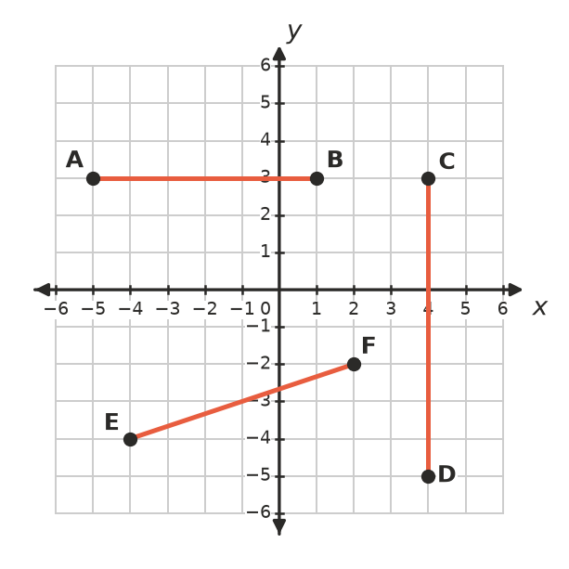
  - AB
  - CD
  - EF

 Fluency
- Find the midpoint of the interval joining each pair of points.
  - (2, 4) and (6, 10)
  - (1, 3) and (7, 5)
  - (0, 0) and (8, −6)
  - (−2, 5) and (4, 1)
  - (−6, −3) and (−2, 7)
  - (3, 2) and (6, 9)

 Reasoning
- Mia found the midpoint of (2, 6) and (8, 4) like this:
- $\left(\frac{8−2}{2},\frac{6−4}{2}\right)=(3,1)$
- What mistake did she make? Find the correct midpoint.
- M(4, 3) is the midpoint of the interval AB. Point A is (1, 2).
  - How far right do you move to get from A to M?
  - How far up do you move to get from A to M?
  - Move the same amounts again from M to find point B.
- Which point is the midpoint of (−2, 0) and (6, 4)?
  - (4, 4)
  - (2, 2)
  - (2, 4)
  - (4, 2)

 Problem solving
- On a map grid, Sam’s house is at (2, 9) and his school is at (10, 3). Sam and a friend agree to meet halfway between the two. Where should they meet?
- A footy oval is drawn on a grid where each unit is 1 metre. The two goals are at (10, 70) and (170, 70). The centre square goes exactly halfway between the goals. Where is it?
- The interval joining (−3, 2) and (5, 2) is a diameter of a circle.
  - Find the centre of the circle.
  - Find the radius of the circle.
- A rectangle has corners A(0, 0), B(8, 0), C(8, 6) and D(0, 6).
  - Find the midpoint of the diagonal AC.
  - Find the midpoint of the diagonal BD.
  - What do you notice?

