Finance: Practice test 3
Year 9 Maths · Test · Test 3
Name: ____________________ Date: ______________
Time: 45 minutes
Total: 40 marks
Show your working in the boxes. Then write each final answer on the answer sheet on the last page. Use 52 weeks, 26 fortnights and 12 months in a year.

 Section A: No calculator
- Noah runs a mobile car-washing business. Each month he pays $90 for insurance and trailer registration. Each car costs him $6 in water, soap and fuel, and he charges $36 per car.
  - Write a formula for Noah’s monthly cost, $C$ dollars, when he washes $x$ cars. (1 mark)

  - Write a formula for Noah’s monthly revenue, $R$ dollars. (1 mark)

  - How many cars must Noah wash in a month to break even? (1 mark)

  - Noah wants to make a profit of at least $600 a month. What is the smallest number of cars he must wash? (2 marks)

- The Year 9 class sells bottles of homemade lemonade at the school fete. The graph shows the cost and the revenue for different numbers of bottles.
- 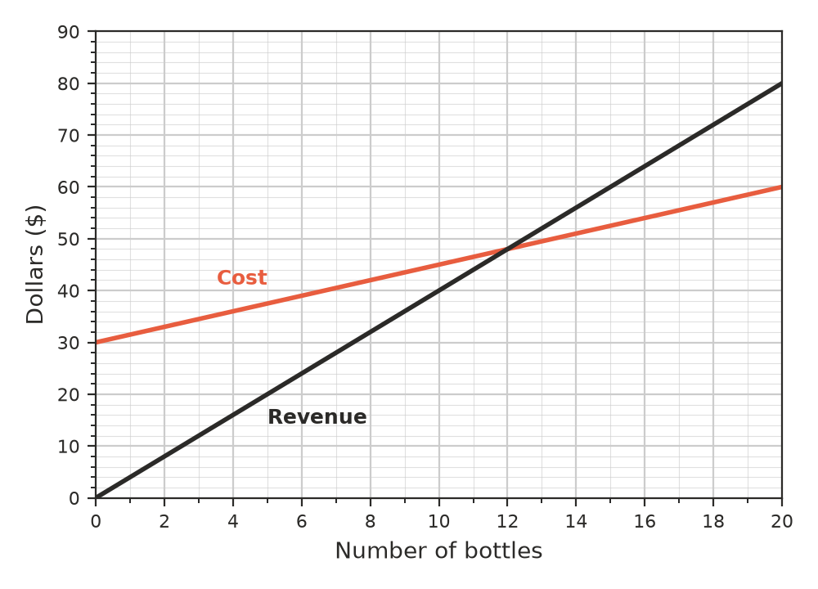
  - Write a formula for the cost, $C$ dollars, of making $x$ bottles. (1 mark)

  - Write a formula for the revenue, $R$ dollars, from selling $x$ bottles. (1 mark)

  - Write the break-even point: the number of bottles and the dollar amount. (1 mark)

  - Find the profit when the class sells 20 bottles. (1 mark)

- Ava works at a café. Her normal rate is $18 per hour. Saturday hours are paid at time and a half, and Sunday hours at time and three-quarters. One week she works 3 hours on Thursday, 4 hours on Saturday and 4 hours on Sunday. Find her pay for the week. (2 marks)

- Mr Nguyen is a teacher. He is paid $3400 per fortnight.
  - What is Mr Nguyen’s annual salary? (1 mark)

  - How much does he earn per week? (1 mark)

- Chloe works in an electronics store. Each month she earns commission of 3% on the first $20 000 of her sales, and 5% on any sales above $20 000. Find Chloe’s commission in a month when her sales are $32 000. (2 marks)

- Find the simple interest earned on each investment.
  - $8000 at 4.5% p.a. for 2 years (1 mark)

  - $3000 at 6% p.a. for 8 months (1 mark)

- An investment of $2400 earns $288 simple interest in 3 years. Find the interest rate per annum. (2 marks)

- Liam and Zoe each invest $1000 at 5% p.a. for 2 years. Liam earns simple interest and ends with $1100. Zoe earns simple interest for one year at a time and re-invests the whole amount after the first year. She ends with $1102.50. Explain exactly where Zoe’s extra $2.50 comes from. (2 marks)

- Sienna invests $4000 at 10% p.a. simple interest. Every 6 months she re-invests the whole amount for the next 6 months at the same rate.
Period (6 months) | Amount at start | Interest | Amount at end
1 | $4000 | $200 | $4200
2
3

  - Complete the table. Write the amount Sienna has after 18 months on the answer sheet. (2 marks)

  - How much more is this than simple interest at 10% p.a. on $4000 for 18 months, without re-investing? (1 mark)

- Leah earns $840 per week. Her weekly budget is: rent 35% of her pay, food $150, transport $84, and she saves the rest.
  - How much does Leah spend on rent each week? (1 mark)

  - How much does Leah save each week? (1 mark)

- Some money is invested at 5% p.a. simple interest. How many years will it take for the money to double? Explain how you know. (2 marks)

 Section B: Calculator allowed
- A Year 9 class is making a yearbook. The printer charges $450 to set up, plus $6.80 for each copy. The class sells each yearbook for $12.50.
  - What is the smallest number of copies the class must sell to make a profit? (2 marks)

  - Find the profit if they print and sell 120 copies. (1 mark)

- Jordan earns $1265.40 for a 38-hour week.
  - What is Jordan’s rate of pay per hour? (1 mark)

  - What is Jordan’s annual income? (1 mark)

- Hannah takes out a personal loan at 8.4% p.a. simple interest over 3 years. She pays $1512 in interest.
  - How much did Hannah borrow? (2 marks)

  - Hannah repays the loan and interest in equal monthly repayments. Find each repayment, to the nearest cent. (1 mark)

- Ryan has $10 000 to invest for 4 years. Bank A offers simple interest at 5.5% p.a. for the whole 4 years. Bank B offers 5.2% p.a. simple interest for one year at a time, and the whole amount is re-invested at the end of each year.
  - Find the amount Ryan would have after 4 years with Bank A. (1 mark)

  - Find the amount Ryan would have after 4 years with Bank B, to the nearest cent. (2 marks)

  - Which bank gives Ryan more money, and by how much? (1 mark)

 Answer sheet
Name: ____________________
Write your final answer for each question in the table.
Question | Answer | Marks | Question | Answer | Marks
1a |  | /1 | 8 |  | /2
1b |  | /1 | 9a |  | /2
1c |  | /1 | 9b |  | /1
1d |  | /2 | 10a |  | /1
2a |  | /1 | 10b |  | /1
2b |  | /1 | 11 |  | /2
2c |  | /1 | 12a |  | /2
2d |  | /1 | 12b |  | /1
3 |  | /2 | 13a |  | /1
4a |  | /1 | 13b |  | /1
4b |  | /1 | 14a |  | /2
5 |  | /2 | 14b |  | /1
6a |  | /1 | 15a |  | /1
6b |  | /1 | 15b |  | /2
7 |  | /2 | 15c |  | /1
 |  |  |  | Total | /40

