Finance: Practice test 2
Year 9 Maths · Test · Test 2
Name: ____________________ Date: ______________
Time: 45 minutes
Total: 40 marks
Show your working in the boxes. Then write each final answer on the answer sheet on the last page. Use 52 weeks, 26 fortnights and 12 months in a year.

 Section A: No calculator
- The Year 9 class runs a hot chocolate stand at the winter sports day to raise money for camp. The urn hire and permit cost $80 in total. Each hot chocolate costs $1.20 to make, and they sell each one for $3.
  - Write a formula for the total cost, $C$ dollars, of making $x$ hot chocolates. (1 mark)

  - Write a formula for the revenue, $R$ dollars, from selling $x$ hot chocolates. (1 mark)

  - Write a formula for the profit, $P$ dollars, in its simplest form. (1 mark)

  - Find the profit if they sell 250 hot chocolates. (1 mark)

  - What is the smallest number they must sell to make a profit? (2 marks)

- Lachlan prints T-shirts for local sports clubs. The graph shows his cost and his revenue for different numbers of T-shirts.
- 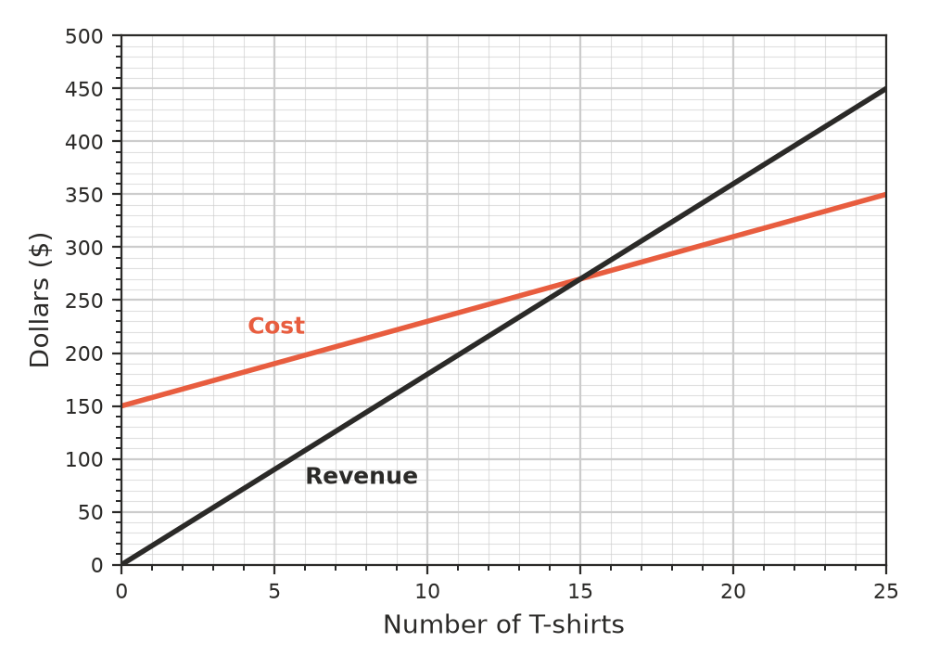
  - What are Lachlan’s fixed costs? (1 mark)

  - How much does it cost Lachlan to print each T-shirt, on top of his fixed costs? (1 mark)

  - How many T-shirts must he sell to break even? (1 mark)

  - Find Lachlan’s profit when he sells 25 T-shirts. (1 mark)

- Tess picks strawberries on a farm near Caboolture. She is paid $1.80 for every kilogram she picks.
  - How much does Tess earn on a day when she picks 120 kg? (1 mark)

  - That day, Tess worked for 8 hours. How much did she earn per hour? (1 mark)

  - How many kilograms must Tess pick to earn $270 in a day? (1 mark)

- A pool lifeguard earns $32 per hour from Monday to Friday. Saturday hours are paid at time and a half, and Sunday hours at double time. One week she works 20 hours from Monday to Friday, 6 hours on Saturday and 5 hours on Sunday. Find her pay for the week. (2 marks)

- Nadia is a nurse. She earns a salary of $93 600 per year.
  - How much does Nadia earn each week? (1 mark)

  - How much does Nadia earn each month? (1 mark)

- Callum sells cars. He is paid a retainer of $500 per week plus 4% commission on the value of the cars he sells. Last week his total income was $1700. What was the value of the cars he sold? (2 marks)

- Find the simple interest earned on each investment.
  - $5000 at 6% p.a. for 3 years (1 mark)

  - $1200 at 5% p.a. for 18 months (1 mark)

- What amount must be invested at 4% p.a. simple interest for 5 years to earn $600 in interest? (2 marks)

- Mila puts $2000 in a term deposit at 4% p.a. simple interest for one year. At the end of the year, she re-invests the whole amount for a second year at the same rate.
  - How much does Mila have at the end of the first year? (1 mark)

  - How much does Mila have at the end of the second year? (1 mark)

  - Explain why Mila earns more interest in the second year than in the first year. (1 mark)

- Sophie runs a dog-walking business. She charges $15 per walk. Each month she pays $45 for insurance, and each walk costs her $3 for bags and treats. How many walks must she do in a month to make a profit of $315? (2 marks)

 Section B: Calculator allowed
- Ollie is offered two jobs.
  - Job A pays $24.50 per hour for 36 hours each week.
  - Job B pays a salary of $47 840 per year for 38 hours each week.
  - Find Ollie’s weekly pay in Job A. (1 mark)

  - Find the pay per hour in Job B, to the nearest cent. (1 mark)

  - Which job pays more per year, and by how much? (1 mark)

- Zara buys an e-bike for $2850. She pays a deposit of $450 and borrows the rest at 9.5% p.a. simple interest. She repays the loan in equal monthly repayments over 18 months.
  - Find the interest Zara pays. (2 marks)

  - Find Zara’s monthly repayment, to the nearest cent. (1 mark)

- A savings account pays simple interest of 0.35% per month. Find the interest earned on $6400 in 2 years. (1 mark)

- Jai’s grandparents give him $3000. He invests it at 6% p.a. simple interest for one year at a time, and re-invests the whole amount at the end of each year.
  - After how many years will Jai first have more than $4000? Show your yearly amounts. (2 marks)

  - If Jai had left $3000 earning simple interest at 6% p.a. without re-investing, after how many years would he first have more than $4000? (1 mark)

- The graph shows the balance of a bank account that earns simple interest. No money is added or taken out.
- 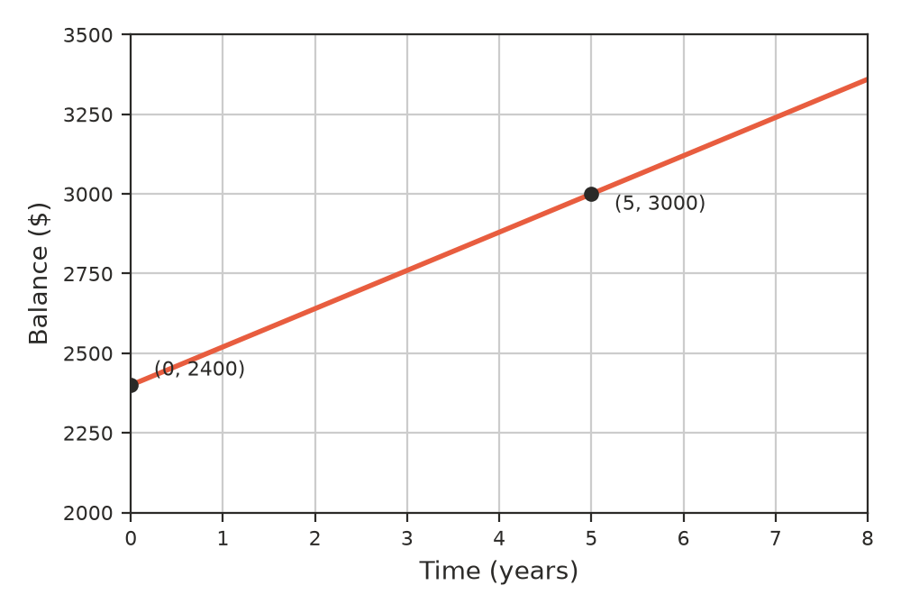
  - What is the principal? (1 mark)

  - Find the interest rate per annum. (1 mark)

 Answer sheet
Name: ____________________
Write your final answer for each question in the table.
Question | Answer | Marks | Question | Answer | Marks
1a |  | /1 | 7b |  | /1
1b |  | /1 | 8 |  | /2
1c |  | /1 | 9a |  | /1
1d |  | /1 | 9b |  | /1
1e |  | /2 | 9c |  | /1
2a |  | /1 | 10 |  | /2
2b |  | /1 | 11a |  | /1
2c |  | /1 | 11b |  | /1
2d |  | /1 | 11c |  | /1
3a |  | /1 | 12a |  | /2
3b |  | /1 | 12b |  | /1
3c |  | /1 | 13 |  | /1
4 |  | /2 | 14a |  | /2
5a |  | /1 | 14b |  | /1
5b |  | /1 | 15a |  | /1
6 |  | /2 | 15b |  | /1
7a |  | /1
 |  |  |  | Total | /40

