Finance: Practice test 1
Year 9 Maths · Test · Test 1
Name: ____________________ Date: ______________
Time: 45 minutes
Total: 40 marks
Show your working in the boxes. Then write each final answer on the answer sheet on the last page. Use 52 weeks, 26 fortnights and 12 months in a year.

 Section A: No calculator
- Jarrah runs a coffee cart at junior footy on Saturdays. He pays $120 each week to hire his spot. Each coffee costs him $1.50 to make, and he sells each coffee for $4.50.
  - Write a formula for the total cost, $C$ dollars, of making $x$ coffees in a week. (1 mark)

  - Write a formula for the revenue, $R$ dollars, from selling $x$ coffees. (1 mark)

  - Find Jarrah’s profit in a week when he sells 100 coffees. (1 mark)

  - How many coffees must Jarrah sell in a week to break even? (2 marks)

- Mia builds wooden bird boxes in her shed and sells them at the market. The graph shows her cost and her revenue for different numbers of bird boxes.
- 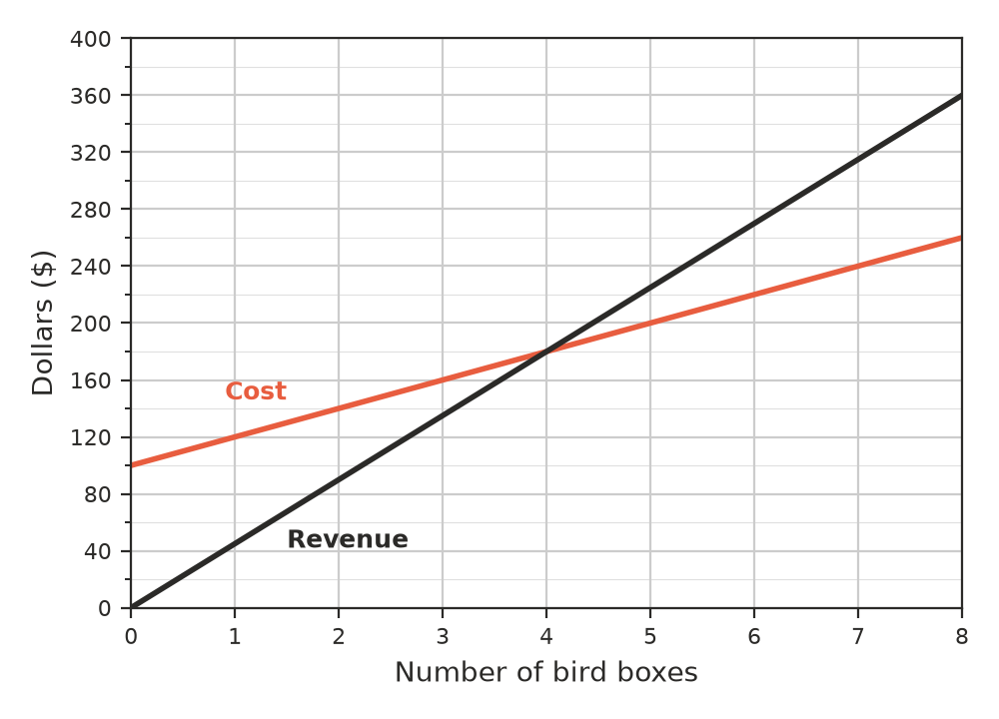
  - What are Mia’s fixed costs? (1 mark)

  - How much does Mia sell each bird box for? (1 mark)

  - Write the break-even point: the number of bird boxes and the dollar amount. (1 mark)

  - Does Mia make a profit or a loss when she sells 2 bird boxes? By how much? (1 mark)

- Sam works at a supermarket. His normal rate of pay is $26 per hour. Overtime is paid at time and a half.
  - How much does Sam earn for a normal 38-hour week? (1 mark)

  - One week Sam works his 38 normal hours plus 6 hours of overtime. Find his total pay for that week. (2 marks)

- Priya is an engineer. She earns a salary of $78 000 per year.
  - How much is Priya paid each fortnight? (1 mark)

  - Priya works 40 hours each week. What is her pay per hour? (1 mark)

- Ben sells solar panels. He is paid $600 per week plus a commission of 5% of the value of his sales.
  - Write a formula for Ben’s weekly income, $I$ dollars, when his sales are worth $s$ dollars. (1 mark)

  - Find Ben’s income in a week when his sales are worth $8000. (1 mark)

  - What must Ben’s sales be worth for him to earn $1100 in a week? (1 mark)

- Find the simple interest earned on each investment.
  - $4000 at 3% p.a. for 5 years (1 mark)

  - $2500 at 4% p.a. for 6 months (1 mark)

- How many years will it take for $6000 invested at 5% p.a. simple interest to earn $900 in interest? (2 marks)

- $2000 invested at 3% p.a. simple interest for 2 years earns $120. Jack says, “If I double the rate to 6% p.a. and double the time to 4 years, I will earn double the interest, $240.” Is Jack correct? Explain, and find the correct interest. (2 marks)

- Hugo invests $5000 for one year at 10% p.a. simple interest. At the end of each year, he re-invests the whole amount for another year at the same rate.
Year | Amount at start | Interest | Amount at end
1 | $5000 | $500 | $5500
2
3

  - Complete the table. Write the amount Hugo has at the end of Year 3 on the answer sheet. (2 marks)

  - If Hugo had left $5000 earning simple interest at 10% p.a. for 3 years without re-investing, how much less would he have at the end? (1 mark)

- The Year 9 class runs a slushie stand at the school athletics carnival. They pay $60 to hire the slushie machine, each slushie costs them $2 to make, and they sell each slushie for $5. What is the smallest number of slushies they must sell to make a profit of at least $150? (2 marks)

 Section B: Calculator allowed
- Ella is choosing between two gym memberships.
  - Plan A: $12.50 per visit.
  - Plan B: $45 per month plus $5 per visit.
  - Write a formula for the monthly cost, $C$ dollars, of $v$ visits for each plan. (1 mark)

  - For how many visits in a month do the two plans cost the same? (1 mark)

  - Ella plans to go to the gym 10 times a month. Which plan is cheaper, and by how much? (1 mark)

- Kai borrows $3600 to buy a used ute. He is charged simple interest at 7.5% p.a. and repays the loan in equal monthly repayments over 2 years.
  - Find the total interest Kai pays. (1 mark)

  - Find Kai’s monthly repayment. (2 marks)

- An investment of $12 500 earned $1750 simple interest over 4 years. Find the interest rate per annum. (2 marks)

- Grace has $8000 to invest for 3 years at 4.5% p.a.
  - Option A: simple interest for the whole 3 years.
  - Option B: simple interest for one year at a time, and the whole amount is re-invested at the end of each year.
  - Find the amount Grace has at the end of 3 years with Option A. (1 mark)

  - Find the amount Grace has at the end of 3 years with Option B. Give your answer to the nearest cent. (2 marks)

  - How much more does Option B give than Option A? (1 mark)

 Answer sheet
Name: ____________________
Write your final answer for each question in the table.
Question | Answer | Marks | Question | Answer | Marks
1a |  | /1 | 6b |  | /1
1b |  | /1 | 7 |  | /2
1c |  | /1 | 8 |  | /2
1d |  | /2 | 9a |  | /2
2a |  | /1 | 9b |  | /1
2b |  | /1 | 10 |  | /2
2c |  | /1 | 11a |  | /1
2d |  | /1 | 11b |  | /1
3a |  | /1 | 11c |  | /1
3b |  | /2 | 12a |  | /1
4a |  | /1 | 12b |  | /2
4b |  | /1 | 13 |  | /2
5a |  | /1 | 14a |  | /1
5b |  | /1 | 14b |  | /2
5c |  | /1 | 14c |  | /1
6a |  | /1
 |  |  |  | Total | /40

