6.03 Simple interest
Year 9 Maths · Worksheet · Level 2 · Core
Name: ____________________ Date: ______________
This worksheet practises simple interest on savings and loans with $I=PRT$, including times in months, weeks and days, and working backwards to find the rate, time or principal. Tip: $T$ must be in years when $R$ is per year (p.a. means “per annum”, or per year): 30 months = $\frac{30}{12}$ = 2.5 years, 26 weeks = $\frac{26}{52}$ years, 73 days = $\frac{73}{365}$ years. You may use a calculator.

 Understanding
- Explain why a graph of the balance of an account earning simple interest is a straight line.

 Fluency
- Find the simple interest. Round to the nearest cent where needed.
  - $4500 at 3.2% p.a. for 3 years ______________
  - $12 000 at 4.75% p.a. for 30 months ______________
  - $850 at 6.5% p.a. for 26 weeks ______________
  - $3650 at 5% p.a. for 73 days ______________
  - $20 000 at 0.4% per month for 18 months ______________
- $6400 is invested at 2.75% p.a. simple interest for 4 years. Find the total value of the investment at the end. ______________
- Find the missing value.
  - $5000 earns $600 simple interest in 4 years. Find the rate. ______________
  - $2400 at 4.5% p.a. earns $270 simple interest. Find the time. ______________
  - What principal earns $378 simple interest in 3 years at 4.2% p.a.? ______________
- Zoe buys a $1450 phone on a plan. She is charged 11% p.a. simple interest over 2 years.
  - Find the interest. ______________
  - Find the total she pays. ______________
  - Find her monthly payment, to the nearest cent. ______________
- The graph shows the balance of a term deposit that earns simple interest.
- 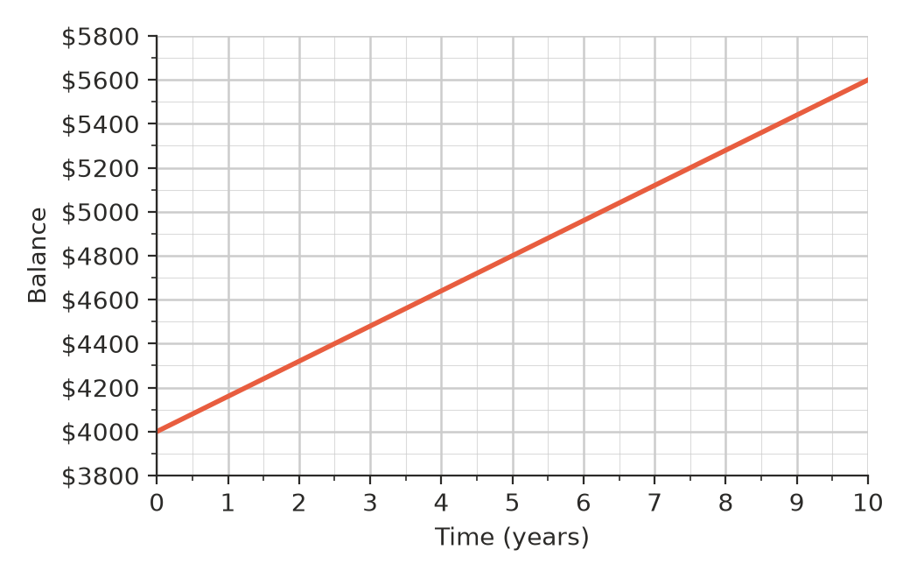
  - What is the principal? ______________
  - How much interest is earned in 5 years? ______________
  - Find the interest rate. ______________
  - After how many years is the balance $5200? ______________

 Reasoning
- Lucy says, “If I leave my money in a simple interest account for twice as long, I will have twice as much money.” Test this with $2000 at 5% p.a. for 2 years and for 4 years, then explain whether Lucy is right.

- Ethan borrows $8000 for a car. He has two loan options.
- Option A: 7.5% p.a. simple interest over 3 years.
- Option B: 0.6% per month simple interest over 30 months.
  - Find the total interest for each option. ______________
  - Find the monthly payment for each option, to the nearest cent. ______________
  - Which option would you choose? Explain.

- A savings account pays 4.2% p.a. Another pays 0.36% per month. Both pay simple interest. Which pays more over a year? Explain.

 Problem solving
- How long will it take $2500 to grow to $2950 at 3.6% p.a. simple interest? ______________
- A $1800 TV can be bought with store finance at 19.9% p.a. simple interest over 2 years.
  - Find the total cost of the TV with the finance. ______________
  - Find the monthly payment, to the nearest cent. ______________
  - Instead, Isla could save $150 a month and buy the TV for $1800 cash. How many months would she need to save, and how much would she save by not using the finance? ______________
- Leo invests some money at 5% p.a. simple interest. After 3 years the interest is $420. How much did he invest, and what is the total value after 3 years? ______________
- Amira wants to earn at least $500 interest in 2 years. Her bank pays 3.8% p.a. simple interest. What is the smallest whole-dollar amount she could invest? ______________

