6.03 Simple interest
Year 9 Maths · Worksheet · Level 1 · Warm-up
Name: ____________________ Date: ______________
This worksheet practises simple interest: the same amount of interest is added for each year. Use $I=PRT$, where $P$ is the principal (the amount saved or borrowed), $R$ is the interest rate per year written as a decimal, and $T$ is the time in years. Tip: 5% = 0.05, and 6 months = 0.5 years. You may use a calculator.

 Understanding
- Fill in each gap with one of these words: principal, rate, interest, time.
  - The amount of money you first save or borrow is the ______________
  - The extra money earned on savings, or paid on a loan, is the ______________
  - The percentage charged or earned each year is the ______________
  - In $I=PRT$, the letter $T$ stands for the ______________ in years.
- Write each time in years.
  - 6 months ______________
  - 18 months ______________
  - 3 months ______________
  - 9 months ______________
- Write each percentage as a decimal.
  - 5% ______________
  - 3.5% ______________
  - 12% ______________

 Fluency
- Find the simple interest.
  - $1000 at 5% per year for 3 years ______________
  - $2500 at 4% per year for 2 years ______________
  - $800 at 6% per year for 5 years ______________
- Hannah puts $600 in a savings account that pays 3% per year simple interest.
  - Find the interest after 4 years. ______________
  - Find the total amount in the account after 4 years. ______________
- Complete the table for $2000 invested at 5% per year simple interest.
Year | 0 | 1 | 2 | 3 | 4
Interest earned that year ($) | (none)
Balance at the end of the year ($) | 2000

- Find the simple interest on $1200 at 6% per year for 6 months. ______________

 Reasoning
- The graph shows the balance of a savings account that earns simple interest.
- 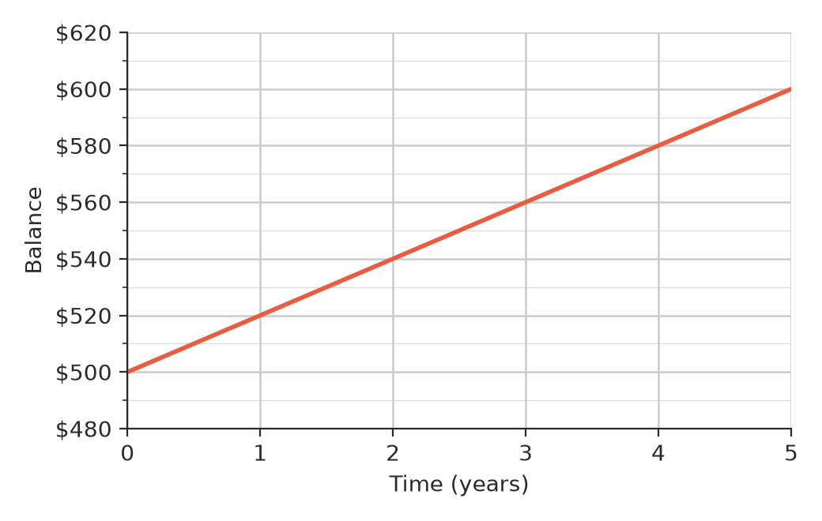
  - What is the principal? ______________
  - What is the balance after 3 years? ______________
  - How much interest is earned each year? ______________
  - What is the interest rate per year? ______________
- Which earns more interest: $1000 at 4% per year for 3 years, or $1000 at 3% per year for 4 years? Show your working and explain what you notice.

 Problem solving
- Josh’s older brother borrows $4000 for a motorbike at 8% per year simple interest for 2 years.
  - Find the interest. ______________
  - Find the total amount he must pay back. ______________
  - He pays it back in equal monthly payments over the 2 years. How much is each payment? ______________
- Mia puts $1500 in an account that pays 3% per year simple interest. How many years will it take to earn $90 interest? ______________

