6.03 Simple interest
Year 9 Maths · A5 question sheet · Level 3 · Challenge
This worksheet uses simple interest to solve harder problems: rearranging $I=PRT$, comparing savings and loan options, and working backwards from the final amount. Tip: the total amount is $A=P+I=P(1+RT)$, which is a linear rule in $T$. Round money to the nearest cent. You may use a calculator.

 Understanding
- Rearrange $I=PRT$ to make each letter the subject.
  - $R$ =
  - $T$ =
  - $P$ =
- An account balance follows the rule $A=2500+112.5T$, where $T$ is the time in years.
  - What is the principal?
  - How much interest is earned each year?
  - What is the interest rate?

 Fluency
- Copy and complete the table for simple interest.
Principal | Rate p.a. | Time | Interest
$7200 | 3.8% | 15 months
 | 5.5% | 4 years | $1980
$15 000 |  | 30 months | $1687.50
$4800 | 6.25% |  | $450
$2190 | 8% | 146 days

- An investment earns 4% p.a. simple interest. After 5 years it is worth $6912. Find the principal.
- $9000 is invested at 4% p.a. simple interest for 18 months, then the rate changes to 5.2% p.a. for another 6 months. Find the total interest.
- Nathan borrows $2400 and repays $115 a month for 24 months. Find the simple interest rate per year.

 Reasoning
- The graph shows the balances of two accounts that earn simple interest.
- 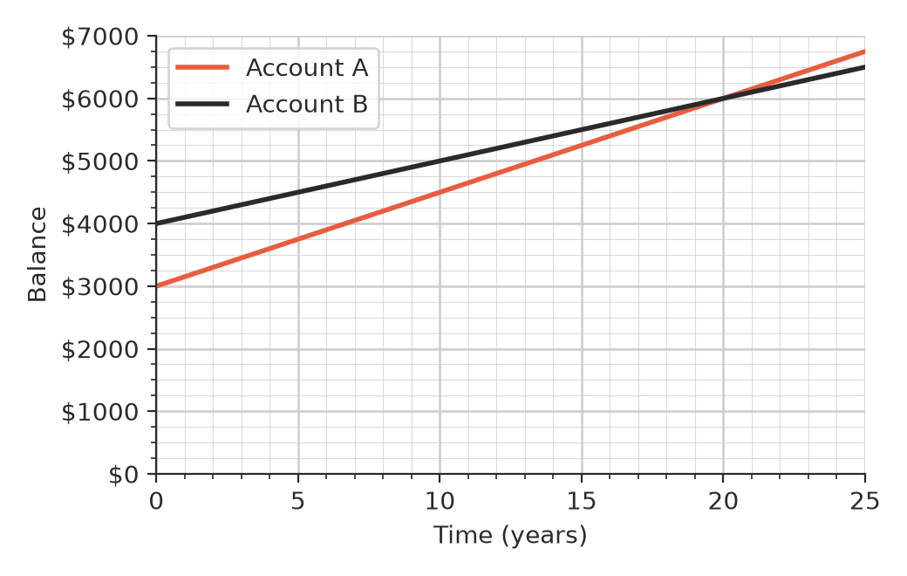
  - Find the interest rate for each account.
  - Write a rule for the balance $A$ after $T$ years for each account.
  - Use your rules to find when the two balances are equal.
  - Which account has more money after 10 years, and which earns more interest in those 10 years?
- At 6.25% p.a. simple interest, how long does it take for an investment to double? Show that the answer is the same for any principal.
- A loan of $6000 at 10% p.a. simple interest over 3 years is repaid in equal monthly payments. Explain why this loan costs the borrower more than it seems: think about how much is still owed near the end of the 3 years.

 Problem solving
- A car costs $18 500. Hamish pays a 10% deposit and borrows the rest at 8.5% p.a. simple interest over 4 years.
  - How much does he borrow?
  - Find the monthly payment.
  - Find the total he pays for the car, including the deposit.
- Kai has $5000 to save for 3 years. Which option gives him the most money? Show your working.
- Option 1: 4.1% p.a. simple interest.
- Option 2: 0.33% per month simple interest.
- Option 3: a $150 bonus when he opens the account, plus 3.5% p.a. simple interest on the $5000.
- A term deposit of $10 950 earns 4% p.a. simple interest, worked out daily. How many days does it take to earn $60?
- Ana invests some money at 5% p.a. simple interest. Ben invests $1000 more than Ana at 3% p.a. simple interest. After 4 years they have earned the same amount of interest. How much did Ana invest? Show your working.

