6.01 Cost, profit, revenue
Year 9 Maths · Worksheet · Level 3 · Challenge
Name: ____________________ Date: ______________
This worksheet uses linear (and one quadratic) models to make business decisions: finding break-even points, working backwards to a price or cost, and comparing options. Tip: when the answer is a number of items, think about whether to round up or down; you can’t sell part of an item, and “at least” usually means round up. You may use a calculator.

 Understanding
- A business has cost $C=800+12x$ and revenue $R=28x$, where $x$ is the number of items sold.
  - What does the 800 in the cost rule tell you about the business? ______________
  - What does the 12 tell you? ______________
  - What does the 28 tell you? ______________
  - On a graph, which of these numbers is a gradient, and which is a vertical intercept? ______________
- A business has a profit rule of $P=15x−600$. Explain what it means when $x=20$ and $P=−300$.

 Fluency
- A business has fixed costs of $1250 a month. Each unit costs $17.50 to make and sells for $42.50.
  - Write a rule for the monthly profit, $P$, from selling $x$ units. ______________
  - Find the break-even point. ______________
  - Find the profit in a month when 320 units are sold. ______________
- The graph shows the cost and revenue for a small business.
- 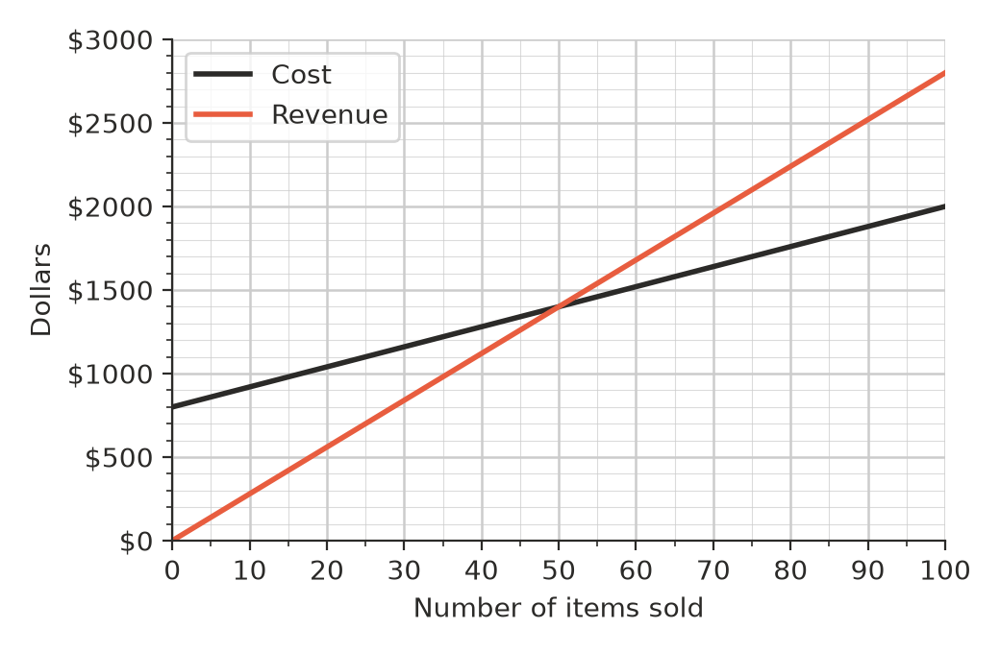
  - Find the fixed costs and the cost of making each item. ______________
  - Find the selling price of each item. ______________
  - Write the cost rule, the revenue rule and the profit rule. ______________
  - Find the profit when 120 items are sold. ______________
- A business has costs $C=3000+4.25x$ and revenue $R=12.5x$. How many items must it sell to make a profit? Show your working.

- A market stall has fixed costs of $640. Each item costs $3.20 to make. The stall sells 200 items. What price per item gives a profit of $500?

 Reasoning
- A business breaks even when it sells 75 items. Its fixed costs are $900 and it sells each item for $20. Find the cost of making each item.

- A business has cost $C=500+10x$ and revenue $R=20x$. The owner says, “This month our revenue went up by 20%, so our profit went up by 20% too.”
  - Find the revenue and profit when 100 items are sold and when 120 items are sold. ______________
  - Is the owner right? Explain why the profit changes by a different percentage.

- Sarah fixes phones at a shopping centre. Option A: she rents her own kiosk for $1500 a month, and each repair costs her $20 in parts. Option B: she shares a shop for $600 a month, but each repair costs her $35 (parts plus a fee to the shop owner). She charges $90 per repair.
  - Find the break-even number of repairs for each option. ______________
  - For how many repairs do both options give the same profit? ______________
  - She expects about 80 repairs a month. Which option should she choose? Show the profit for each.

  - Explain when Option B is the better choice.

- A café finds that if it charges $p$ dollars for a smoothie, it sells $200−20p$ smoothies a day. So the daily revenue is $R=p(200−20p)$.
  - Complete the table.
Price, $p$ ($) | 3 | 4 | 5 | 6 | 7
Smoothies sold
Revenue, $R$ ($)

  - Which price gives the most revenue? ______________
  - Explain why a higher price does not always give more revenue.

 Problem solving
- A school BBQ fundraiser has fixed costs of $480 (gas, hire and permits). Each meal costs $2.40 to make and sells for $6.
  - How many meals must be sold to make a profit? ______________
  - A local business offers to pay half the fixed costs. How many meals must now be sold to make a profit? ______________
  - Instead, the organisers could raise the price to $7. How many meals would then be needed to make a profit? ______________
  - Which change helps more? ______________
- A pie stall can make at most 150 pies a day. Its fixed costs are $210 a day, each pie costs $2.60 to make, and pies sell for $5.40.
  - Find the break-even point. ______________
  - Find the most profit the stall can make in a day. ______________
  - Can the stall make a profit of $300 in one day at this price? Explain. ______________
  - What price per pie would give a profit of exactly $300 when all 150 pies are sold? ______________
- A Year 9 class needs to raise $1500 profit for camp by selling chocolate bars. The chocolate comes in boxes of 30 bars for $36 a box. The stall permit and signs cost $60 in total.
  - Find the cost of each bar. ______________
  - They sell each bar for $2.50. How many bars, and how many full boxes, must they sell to raise $1500? ______________
  - They sell each bar for $3 instead and only buy full boxes. How many boxes must they buy and sell to raise at least $1500? ______________
  - Give one reason why the class might choose $2.50 rather than $3.

