6.01 Cost, profit, revenue
Year 9 Maths · Worksheet · Level 1 · Warm-up
Name: ____________________ Date: ______________
This worksheet practises the three key money words for any business or fundraiser: cost (money going out), revenue (money coming in) and profit (what is left). Tip: profit = revenue − cost. If the answer is negative, it is a loss. You may use a calculator.

 Understanding
- Fill in each gap with one of these words: revenue, cost, profit, fixed, break-even.
  - The money a business receives from selling things is its ______________
  - The money a business spends to make and sell things is its ______________
  - Revenue − cost = ______________
  - A cost that stays the same no matter how many items you sell is a ______________ cost.
  - The point where revenue equals cost is the ______________ point.
- A Year 9 class sells cupcakes at the school fete. Is each cost fixed or variable? Write F or V in each empty box.
Cost | F or V
$25 to hire a stall at the fete
Flour, sugar and icing for each cupcake
A paper case for each cupcake
$18 for a banner for the stall

 Fluency
- Find the profit or loss. Write “profit” or “loss” with each answer.
  - Revenue $350, cost $210 ______________
  - Revenue $1200, cost $1450 ______________
  - Revenue $86.50, cost $54.20 ______________
- The school canteen sells muesli bars for $2.50 each. The revenue is $R=2.5x$, where $x$ is the number of bars sold.
  - Find the revenue from selling 40 bars. ______________
  - Find the revenue from selling 120 bars. ______________
  - How many bars must be sold to make $75 of revenue? ______________
- For the cupcake stall, the stall costs $30 and each cupcake costs $1.20 to make. The total cost is $C=30+1.2x$, where $x$ is the number of cupcakes.
  - Find the cost of making 50 cupcakes. ______________
  - Find the cost of making 100 cupcakes. ______________
- The class sells each cupcake from question 5 for $3.
  - Find the revenue from selling 50 cupcakes. ______________
  - Find the profit from selling 50 cupcakes. ______________
  - Find the profit or loss from selling only 10 cupcakes. ______________

 Reasoning
- The graph shows the cost and the revenue for a small stall.
- 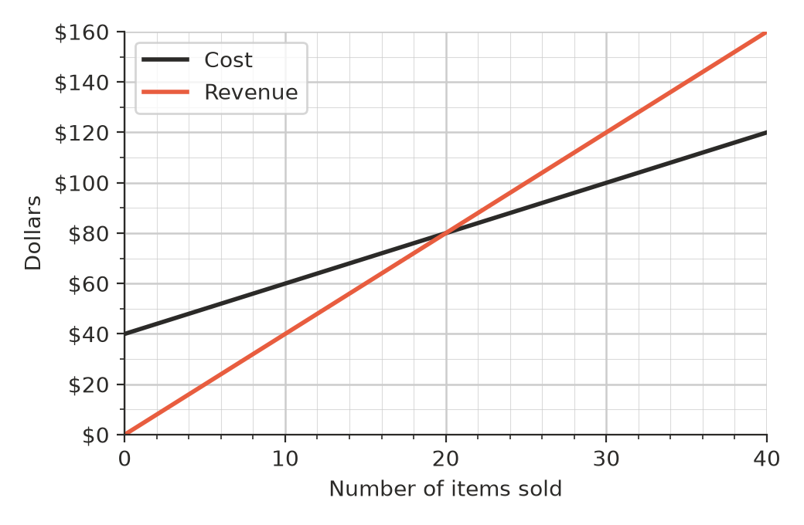
  - What are the fixed costs? (Hint: look at the cost when 0 items are sold.) ______________
  - How many items must be sold to break even? ______________
  - What are the cost and the revenue at the break-even point? ______________
  - Is there a profit or a loss when 10 items are sold? ______________
  - Find the profit when 30 items are sold. ______________
- Ali’s stall took $500 at a market. Ali says, “I made $500 profit!” Explain why Ali might be wrong.

 Problem solving
- Mia starts a lawn-mowing business. She paid $120 for a second-hand mower. Fuel costs her $5 for each lawn, and she charges $25 for each lawn.
  - Write a rule for her cost, $C$, for mowing $x$ lawns. ______________
  - Write a rule for her revenue, $R$, for mowing $x$ lawns. ______________
  - Each lawn makes $20 more revenue than it costs. How many lawns must she mow to pay off the mower (break even)? ______________
  - Find her profit after mowing 15 lawns. ______________
- A youth group runs a sausage sizzle. The costs are $C=60+1.5x$ and the revenue is $R=3x$, where $x$ is the number of sausages sold.
  - Complete the table.
Sausages sold, $x$ | 0 | 50 | 100 | 150
Cost, $C$ ($)
Revenue, $R$ ($)
Profit ($)

  - The break-even point is between two of the numbers in the table. Which two? ______________
  - Find the exact number of sausages needed to break even. ______________
- The youth group wants to raise exactly $150 profit at the sausage sizzle from question 10. Each sausage makes $1.50 profit after the fixed cost of $60 is covered. How many sausages must they sell?

