6.01 Cost, profit, revenue
Year 9 Maths · A5 question sheet · Level 2 · Core
This worksheet practises modelling a business with algebra. The cost is usually fixed costs plus a cost for each item, like $C=300+5x$. The revenue is the price times the number sold, like $R=11x$. Tip: profit = revenue − cost, and the break-even point is where $R=C$ (profit = 0). You may use a calculator.

 Understanding
- Explain the difference between a fixed cost and a variable cost. Give one example of each for a food truck.
- Is each statement true or false? Write True or False in your book.
Statement
Profit = revenue − cost
If the revenue is less than the cost, there is a loss.
Fixed costs go up as more items are made.
At the break-even point the profit is $0.
A business with a large revenue always makes a profit.

 Fluency
- Find the profit or loss. Write “profit” or “loss” with each answer.
  - Revenue $2480, cost $1965
  - Revenue $730.50, cost $812.25
  - Revenue $12 600, cost $9845
- Jayden makes timber chopping boards in the Woodtech room to sell. He spent $180 on clamps and tools. Each board uses $14 of timber and oil, and he sells each board for $32.
  - Write a rule for his cost, $C$, of making $x$ boards.
  - Write a rule for his revenue, $R$, from selling $x$ boards.
  - Write a rule for his profit, $P$, in simplest form.
  - Find his cost of making 25 boards.
  - Find his profit from selling 25 boards.
  - How many boards must he sell to break even?
- A food truck has costs $C=450+6x$ and revenue $R=15x$ each day, where $x$ is the number of meals sold.
  - How many meals give a revenue of $1800?
  - How many meals were made if the cost was $1290?
  - Solve $15x=450+6x$ to find the break-even point.
- The graph shows the cost and revenue for a business that makes phone cases.
- 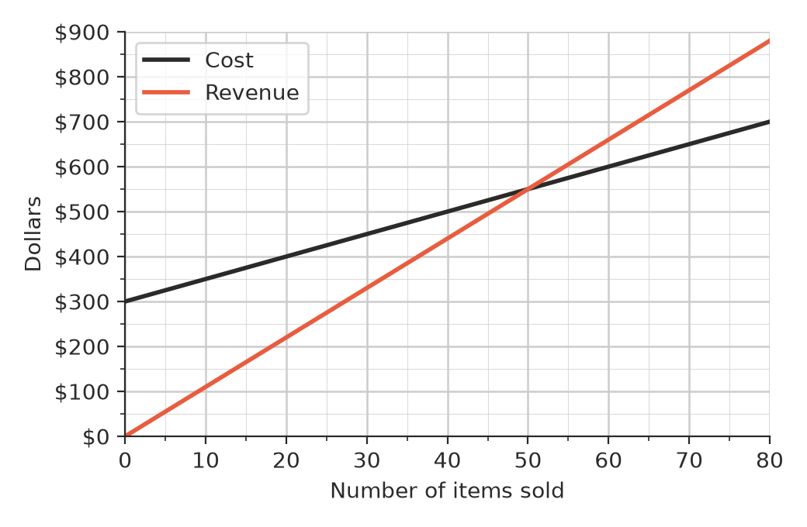
  - What are the fixed costs?
  - Write the break-even point as a number of cases and a dollar amount.
  - Find the profit or loss when 30 cases are sold.
  - Find the profit or loss when 80 cases are sold.
  - Use the break-even point to find the cost of making each case.

 Reasoning
- A school needs printed T-shirts for a sports carnival. Company A charges a $120 set-up fee plus $9 per shirt. Company B has no set-up fee and charges $15 per shirt.
  - Find the cost of 15 shirts from each company.
  - For how many shirts do the two companies charge the same amount?
  - Which company is cheaper for 40 shirts, and by how much?
- Erin sells cupcakes. Her cost is $C=40+1.5x$ and her revenue is $R=3.5x$. She says, “If I sell twice as many cupcakes, I will make twice as much profit.” Find her profit for 30 cupcakes and for 60 cupcakes, then explain whether Erin is right.
- A stall has fixed costs of $200 and each item costs $4 to make. The stall expects to sell 50 items.
  - What price per item would make the stall break even?
  - What price per item would make a profit of $150?

 Problem solving
- Year 9 runs a trivia night to raise money. The hall costs $350 to hire, supper costs $6 per person, and tickets are $20 each.
  - Write a rule for the profit, $P$, when $x$ people come.
  - How many people must come to break even?
  - How many people must come to raise at least $1000 profit?
  - The hall holds 120 people. What is the most profit they can make?
- A business has costs $C=240+3x$ and revenue $R=7x$.
  - Copy and complete the table.
Items sold, $x$ | 0 | 20 | 40 | 60 | 80
Cost, $C$ ($)
Revenue, $R$ ($)
Profit ($)

  - Use the table to write the break-even point.
  - By how much does the profit go up for every 20 extra items sold?
- Lena runs a hairdressing business from home. Her fixed costs are $2400 a month. Each haircut costs her $8 in products, and she charges $38 per haircut.
  - How many haircuts a month does she need to break even?
  - Find her profit in a month when she does 110 haircuts.
  - Her fixed costs go up by $300 a month. How many haircuts does she now need to break even?
- On a cost and revenue graph, the cost line starts above zero on the vertical axis, but the revenue line starts at zero. Explain why.

