Algebra: Practice test 3
Year 9 Maths · Test · Test 3
Name: ____________________ Date: ______________
Time: 45 minutes
Total: 40 marks
Show your working in the boxes. Then write each final answer on the answer sheet on the last page. Write every expression in its simplest form, without × or ÷ signs.

 Section A: No calculator
- Simplify each expression by collecting like terms.
  - $8y−3z−5y−2z$ (1 mark)

  - $7x^{2}−4x+3−2x^{2}+x$ (1 mark)

- Simplify each of these.
  - $4a^{2}×5a^{3}$ (1 mark)

  - $\frac{−15m^{3}n^{2}}{5mn^{2}}$ (1 mark)

- Expand each of these.
  - $−4(2x+7)$ (1 mark)

  - $5ab(a−3b)$ (1 mark)

- Expand and simplify $x(x+6)−2x(3−x)$. (2 marks)

- Expand and simplify each of these.
  - $(k+9)(k+1)$ (1 mark)

  - $(t−4)(t+10)$ (1 mark)

  - $(2x−5)(3x−1)$ (2 marks)

- Expand each of these.
  - $(y+8)^{2}$ (1 mark)

  - $(5a−1)(5a+1)$ (1 mark)

- Factorise each expression fully.
  - $24x−16$ (1 mark)

  - $6p^{2}q+9pq^{2}$ (1 mark)

  - $a(b−5)+(b−5)$ (1 mark)

- Factorise each expression by grouping in pairs.
  - $mn+3m+4n+12$ (1 mark)

  - $2ab−8a−3b+12$ (2 marks)

- Factorise each quadratic expression.
  - $x^{2}+7x+10$ (1 mark)

  - $x^{2}−x−20$ (1 mark)

  - $x^{2}−13x+36$ (1 mark)

- Noah says that $−2(x−3)=−2x−6$. Explain Noah’s mistake, then write the correct expansion. (2 marks)

- This square has sides of length $a+b$.
- 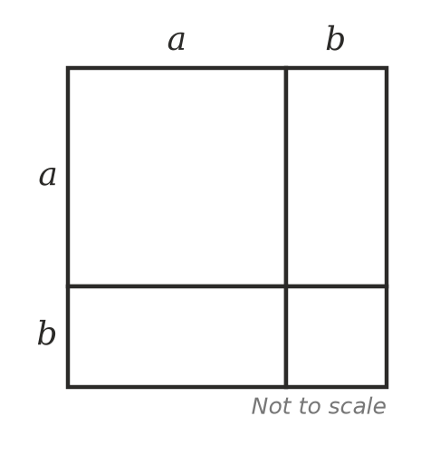
  - Write the area of the whole square as the sum of the areas of the four parts. Simplify your answer. (1 mark)

  - Explain how the diagram shows that $(a+b)^{2}$ is not equal to $a^{2}+b^{2}$. (1 mark)

- When $(x+a)(x+3)$ is expanded, the answer is $x^{2}+bx+15$. Find the values of $a$ and $b$. Show your working. (2 marks)

 Section B: Calculator allowed
- Use $x=6.4$.
  - Find the value of $(2x+3)(x−4)$. (1 mark)

  - Expand and simplify $(2x+3)(x−4)$. Then substitute $x=6.4$ into your answer to check it. (1 mark)

- A rectangular piece of plywood is $(2x+5)$ cm long and $(x+4)$ cm wide. A square hole with sides of $x$ cm is cut out of it.
- 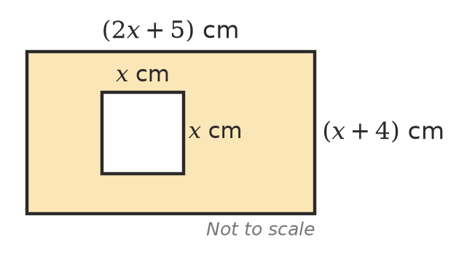
  - Write and simplify an expression for the area of plywood left. (2 marks)

  - Find the area of plywood left when $x=8.5$. (1 mark)

- On this calendar, a 3 by 3 square of dates is outlined. Its four corner dates are shaded.
- 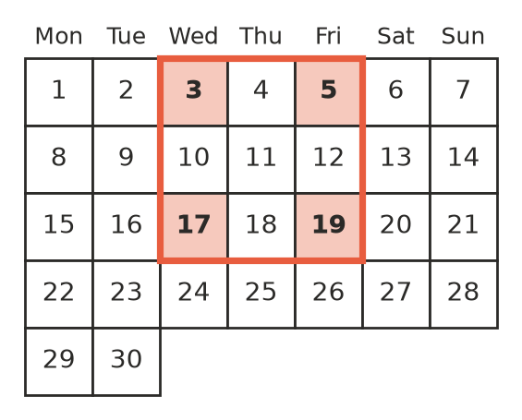
  - Multiply the numbers in opposite corners (5 × 17 and 3 × 19). Find the difference between the two products. (1 mark)

  - Let the top-left corner of any 3 by 3 square on a calendar be $n$. Write the other three corners in terms of $n$, then use algebra to show that the difference is always the same. (2 marks)

- The school musical normally sells 200 tickets at $15 each. For every $1 the price goes up, 8 fewer tickets are sold. If the price goes up by $x$ dollars, the money from ticket sales, in dollars, is $(15+x)(200−8x)$.
  - Expand and simplify $(15+x)(200−8x)$. (1 mark)

  - Use your answer to find the money from ticket sales when tickets cost $20. (1 mark)

  - Show that a ticket price of $25 brings in the same money as a price of $15. (1 mark)

 Answer sheet
Name: ____________________
Write your final answer for each question in the table.
Question | Answer | Marks | Question | Answer | Marks
1a |  | /1 | 9a |  | /1
1b |  | /1 | 9b |  | /1
2a |  | /1 | 9c |  | /1
2b |  | /1 | 10 |  | /2
3a |  | /1 | 11a |  | /1
3b |  | /1 | 11b |  | /1
4 |  | /2 | 12 |  | /2
5a |  | /1 | 13a |  | /1
5b |  | /1 | 13b |  | /1
5c |  | /2 | 14a |  | /2
6a |  | /1 | 14b |  | /1
6b |  | /1 | 15a |  | /1
7a |  | /1 | 15b |  | /2
7b |  | /1 | 16a |  | /1
7c |  | /1 | 16b |  | /1
8a |  | /1 | 16c |  | /1
8b |  | /2
 |  |  |  | Total | /40

