Algebra: Practice test 2
Year 9 Maths · Test · Test 2
Name: ____________________ Date: ______________
Time: 45 minutes
Total: 40 marks
Show your working in the boxes. Then write each final answer on the answer sheet on the last page. Write every expression in its simplest form, without × or ÷ signs.

 Section A: No calculator
- Simplify each expression by collecting like terms.
  - $9k−4−3k+10$ (1 mark)

  - $2a^{2}b+5ab^{2}−a^{2}b$ (1 mark)

- Simplify each of these.
  - $−6m×3mn$ (1 mark)

  - $\frac{24p^{4}q^{2}}{8p^{2}q}$ (1 mark)

- Expand each of these.
  - $−3(4−5t)$ (1 mark)

  - $2x^{2}(3x−4y)$ (1 mark)

- Expand and simplify $3(2y−5)−4(y−6)$. (2 marks)

- Expand and simplify each of these.
  - $(a+7)(a−3)$ (1 mark)

  - $(x−8)(x−2)$ (1 mark)

  - $(4m+1)(m−6)$ (2 marks)

- Expand each of these.
  - $(3h+2)^{2}$ (1 mark)

  - $(10−p)(10+p)$ (1 mark)

- Factorise each expression fully.
  - $14ab+21a$ (1 mark)

  - $−5x^{2}−30x$ (take out a negative common factor) (1 mark)

  - $2m(m−4)+7(m−4)$ (1 mark)

- Factorise each expression by grouping in pairs.
  - $x^{2}+4x+3x+12$ (1 mark)

  - $5pq−10p−q+2$ (2 marks)

- Factorise each quadratic expression.
  - $x^{2}+9x+18$ (1 mark)

  - $x^{2}+3x−40$ (1 mark)

  - $x^{2}−14x+49$ (1 mark)

- Ruby factorised $x^{2}−5x−14$ and got $(x−2)(x+7)$. Expand Ruby’s answer to show that it is wrong, then write the correct factorisation. (2 marks)

- This rectangle has sides of $(2x+3)$ and $(x+4)$. It is split into four parts, A, B, C and D.
- 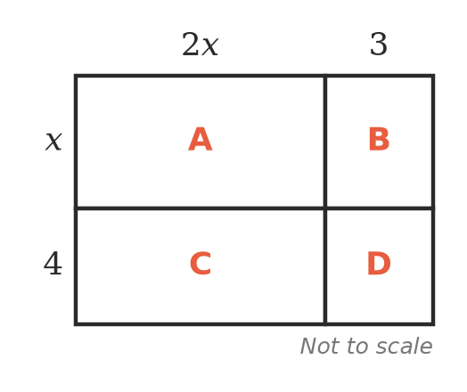
  - Write the area of each part. (1 mark)

  - Use your answers to write $(2x+3)(x+4)$ in expanded form. (1 mark)

- Show that $(n+1)^{2}−(n−1)^{2}=4n$. Then use this to work out ${101}^{2}−{99}^{2}$ without a calculator. (2 marks)

 Section B: Calculator allowed
- Use $a=1.6$ and $b=−2.5$.
  - Find the value of $3a^{2}−2ab$. (1 mark)

  - Factorise $3a^{2}−2ab$. Then substitute the same values into your factorised form to check that it gives the same value. (1 mark)

- A square lawn has sides of $x$ metres. A path 1.5 m wide is built all the way around it.
- 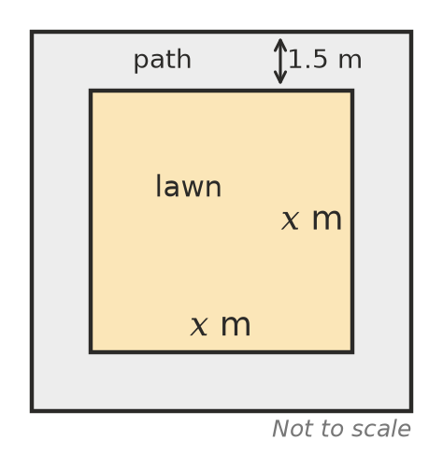
  - Show that the area of the path, in square metres, is $6x+9$. (2 marks)

  - The lawn has sides of 14.6 m. Find the area of the path. (1 mark)

  - Pavers cost $42.80 per square metre. Find the cost of paving the path. (1 mark)

- Part of a hundred chart is shown. A 2 by 2 square of numbers is shaded.
- 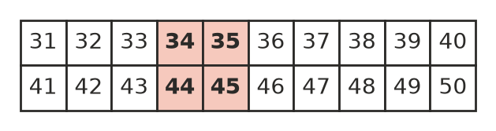
  - Multiply the numbers on each diagonal of the shaded square (35 × 44 and 34 × 45). Find the difference between the two products. (1 mark)

  - Let the top-left number of any 2 by 2 square on the hundred chart be $n$. Use algebra to show that the difference between the diagonal products is always the same. (2 marks)

- A surf school charges $60 for a lesson and has 30 students. For every $2 it raises the price, it expects to lose one student. If it raises the price $x$ times, the money it takes in, in dollars, is $(60+2x)(30−x)$.
  - Expand and simplify $(60+2x)(30−x)$. (1 mark)

  - Use your answer to explain why raising the price will never bring in more money than $1800. (1 mark)

 Answer sheet
Name: ____________________
Write your final answer for each question in the table.
Question | Answer | Marks | Question | Answer | Marks
1a |  | /1 | 9a |  | /1
1b |  | /1 | 9b |  | /1
2a |  | /1 | 9c |  | /1
2b |  | /1 | 10 |  | /2
3a |  | /1 | 11a |  | /1
3b |  | /1 | 11b |  | /1
4 |  | /2 | 12 |  | /2
5a |  | /1 | 13a |  | /1
5b |  | /1 | 13b |  | /1
5c |  | /2 | 14a |  | /2
6a |  | /1 | 14b |  | /1
6b |  | /1 | 14c |  | /1
7a |  | /1 | 15a |  | /1
7b |  | /1 | 15b |  | /2
7c |  | /1 | 16a |  | /1
8a |  | /1 | 16b |  | /1
8b |  | /2
 |  |  |  | Total | /40

