Algebra: Practice test 1
Year 9 Maths · Test · Test 1
Name: ____________________ Date: ______________
Time: 45 minutes
Total: 40 marks
Show your working in the boxes. Then write each final answer on the answer sheet on the last page. Write every expression in its simplest form, without × or ÷ signs.

 Section A: No calculator
- Simplify each expression by collecting like terms.
  - $7a+3b−2a+5b$ (1 mark)

  - $4x^{2}−3x+x^{2}+8x$ (1 mark)

- Simplify each of these.
  - $5p×(−4q)$ (1 mark)

  - $\frac{18x^{3}y}{6xy}$ (1 mark)

- Expand each of these.
  - $5(3k−4)$ (1 mark)

  - $3a(2a^{2}+a−5)$ (1 mark)

- Expand and simplify $5m(m−2)−3(m^{2}−4m)$. (2 marks)

- Expand and simplify each of these.
  - $(x+4)(x+6)$ (1 mark)

  - $(y−5)(y+2)$ (1 mark)

  - $(3a−2)(2a+5)$ (2 marks)

- Expand each of these.
  - $(n−6)^{2}$ (1 mark)

  - $(2k+3)(2k−3)$ (1 mark)

- Factorise each expression fully.
  - $8x^{2}−20x$ (1 mark)

  - $−9ab−15b$ (take out a negative common factor) (1 mark)

  - $x(y+3)−4(y+3)$ (1 mark)

- Factorise each expression by grouping in pairs.
  - $ab+5a+2b+10$ (1 mark)

  - $3xy−6x+4y−8$ (2 marks)

- Factorise each quadratic expression.
  - $x^{2}+8x+15$ (1 mark)

  - $x^{2}−2x−24$ (1 mark)

  - $x^{2}−11x+28$ (1 mark)

- Liam says that $(x+5)^{2}=x^{2}+25$. Explain Liam’s mistake, then write the correct expansion. (2 marks)

- A rectangle is split into four parts. The area of each part is written inside it.
- 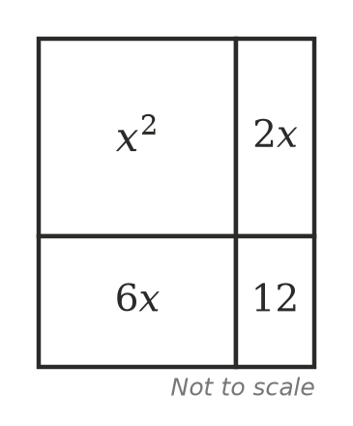
  - Write the length and the width of the whole rectangle, in terms of $x$. (1 mark)

  - Write $x^{2}+8x+12$ in factorised form. (1 mark)

- The expression $x^{2}+kx+12$ can be factorised as $(x+a)(x+b)$, where $a$, $b$ and $k$ are positive whole numbers. Find all three possible values of $k$. Show how you found them. (2 marks)

 Section B: Calculator allowed
- Ella expanded $(2x−3)(x+4)$ and got $2x^{2}+11x−12$.
  - Substitute $x=3.7$ into $(2x−3)(x+4)$ and into Ella’s answer. Write both values. (1 mark)

  - Write the correct expansion of $(2x−3)(x+4)$. (1 mark)

- A rectangular paddock is $(3x+2)$ metres long and $(x+5)$ metres wide.
  - Write an expanded expression for the area of the paddock. (1 mark)

  - Find the area of the paddock when $x=12.5$. (1 mark)

  - Fencing costs $18.50 per metre. Write an expanded expression for the cost, in dollars, of fencing the whole perimeter. Then find the cost when $x=12.5$. (2 marks)

- On a calendar, Hana chooses three dates in a column, one under the other, like 9, 16 and 23 below.
- 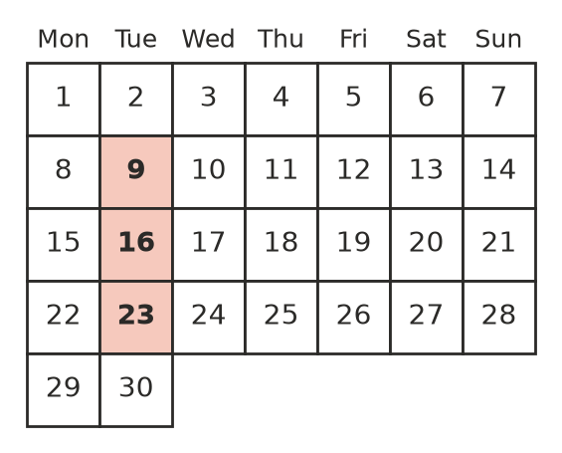
  - For 9, 16 and 23, square the middle number, then subtract the product of the top and bottom numbers. (1 mark)

  - Let the top number be $n$. Write the other two numbers in terms of $n$, then use algebra to show that the answer to part a) is the same for every column of three dates. (2 marks)

- A youth group sells hoodies for $40 each and expects to sell 20. For every $1 they lower the price, they expect to sell 2 more hoodies. If they lower the price by $x$ dollars, the money they take in, in dollars, is $(40−x)(20+2x)$.
  - Expand and simplify $(40−x)(20+2x)$. (1 mark)

  - Find the money they take in if they lower the price to $32.50. (1 mark)

 Answer sheet
Name: ____________________
Write your final answer for each question in the table.
Question | Answer | Marks | Question | Answer | Marks
1a |  | /1 | 9a |  | /1
1b |  | /1 | 9b |  | /1
2a |  | /1 | 9c |  | /1
2b |  | /1 | 10 |  | /2
3a |  | /1 | 11a |  | /1
3b |  | /1 | 11b |  | /1
4 |  | /2 | 12 |  | /2
5a |  | /1 | 13a |  | /1
5b |  | /1 | 13b |  | /1
5c |  | /2 | 14a |  | /1
6a |  | /1 | 14b |  | /1
6b |  | /1 | 14c |  | /2
7a |  | /1 | 15a |  | /1
7b |  | /1 | 15b |  | /2
7c |  | /1 | 16a |  | /1
8a |  | /1 | 16b |  | /1
8b |  | /2
 |  |  |  | Total | /40

