3.03 Binomial expansion
Year 9 Maths · Worksheet · Level 3 · Challenge
Name: ____________________ Date: ______________
This worksheet stretches your expanding skills: harder binomial products, fractions, three brackets, and using expansion to prove number facts. Tip: when you subtract a product of brackets, expand it inside its own brackets first, then subtract every term.

 Understanding
- This square has sides of length $(x+y)$.
- 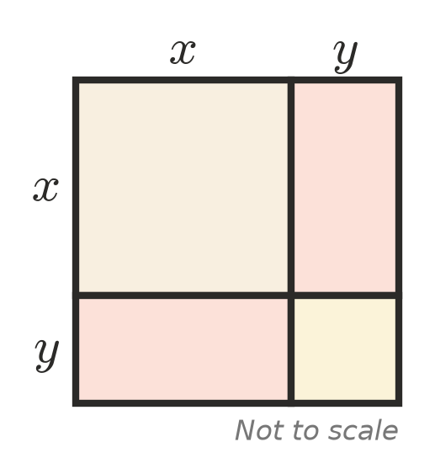
  - Write the area of each of the four parts. ______________
  - Use the picture to explain why $(x+y)^{2}=x^{2}+2xy+y^{2}$.

- Expand $(a+b)(c+d+e)$. How many terms are there? ______________

 Fluency
- Expand and simplify.
  - $(3x−4)(2x+5)$ = ______________
  - $(5−2a)(3−a)$ = ______________
  - $(2m−3n)(4m+n)$ = ______________
  - $(x^{2}−3)(x^{2}+5)$ = ______________
  - $\left(\frac{1}{2}x+4\right)(2x−6)$ = ______________
  - $(x+2)(x^{2}−3x+1)$ = ______________
- Expand and simplify.
  - $(4x−3y)^{2}$ = ______________
  - ${\left(x+\frac{1}{x}\right)}^{2}$ = ______________
  - $(2a^{2}+5)(2a^{2}−5)$ = ______________
  - $(x+1)^{3}$ = ______________
- Expand and simplify.
  - $(2x+3)^{2}−(x−1)(x+4)$ = ______________
  - $2(a−4)^{2}−3(a+2)(a−2)$ = ______________
  - $(x+1)(x+2)(x+3)$ = ______________

 Reasoning
- Find the values of $a$ and $b$.
  - $(x+a)(x+b)=x^{2}+2x−24$ ______________
  - $(ax−2)(3x+b)=6x^{2}+4x−10$ ______________
- Odd numbers next to each other can be written as $2n−1$ and $2n+1$. Prove that the product of two odd numbers next to each other is always 1 less than a multiple of 4.

- Show that $(a+b)^{2}−(a−b)^{2}=4ab$. Use it to work out ${63}^{2}−{37}^{2}$ without a calculator.

 Problem solving
- Use a binomial expansion to work these out in your head.
  - 103 × 97 = ______________
  - ${49}^{2}$ = ______________
  - 1002 × 998 = ______________
- A rectangular pool is $x$ metres wide and $(x+4)$ metres long. It has a path 2 m wide all the way around it.
- 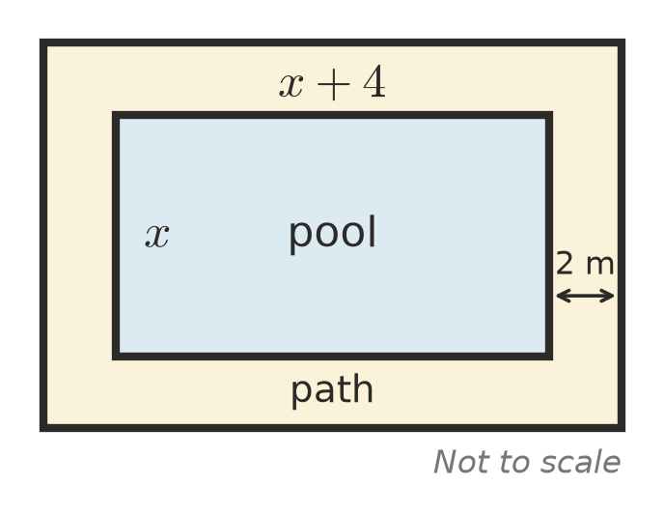
  - Write expressions for the length and width of the pool and path together. ______________
  - Show that the area of the path is $(8x+32)$ m².

  - The path has an area of 96 m². Find the length and width of the pool. ______________
- A square has sides of $n$ cm. It is changed into a rectangle by making one pair of sides 5 cm longer and the other pair 5 cm shorter. Does the area go up or down, and by how much? Show your working.

- Choose four whole numbers in a row, such as 6, 7, 8, 9. Multiply the outer two numbers, then multiply the inner two numbers. Prove that the difference is always 2.

