3.03 Binomial expansion
Year 9 Maths · Worksheet · Level 2 · Core
Name: ____________________ Date: ______________
This worksheet practises expanding binomial products, including perfect squares and the difference of two squares. Tip: learn the patterns. $(a+b)^{2}=a^{2}+2ab+b^{2}$, $(a−b)^{2}=a^{2}−2ab+b^{2}$ and $(a+b)(a−b)=a^{2}−b^{2}$.

 Understanding
- Use this area model to expand $(2x+3)(x+4)$. Fill in each of the four parts.
× | $x$ | 4
$2x$
3

Now add the four parts and simplify: $(2x+3)(x+4)$ = ______________
- Explain why $(a−b)^{2}$ is not the same as $a^{2}−b^{2}$. Use $a=5$ and $b=2$ in your answer.

 Fluency
- Expand and simplify.
  - $(x+7)(x−3)$ = ______________
  - $(a−6)(a−2)$ = ______________
  - $(3m+4)(m+2)$ = ______________
  - $(2y−5)(3y+1)$ = ______________
  - $(4−x)(x+3)$ = ______________
  - $(2a+b)(a−3b)$ = ______________
  - $(x^{2}+2)(x−1)$ = ______________
  - $(5k−2)(2k−3)$ = ______________
- Expand and simplify.
  - $(x+6)^{2}$ = ______________
  - $(2a−5)^{2}$ = ______________
  - $(3m+2n)^{2}$ = ______________
  - $(y+8)(y−8)$ = ______________
  - $(5x−1)(5x+1)$ = ______________
  - $(4−3k)^{2}$ = ______________
- Expand and simplify.
  - $3(x+2)(x−4)$ = ______________
  - $−2(a−3)(a+5)$ = ______________
  - $(x+3)(x+2)−x(x+4)$ = ______________
  - $(m+4)^{2}−(m−4)^{2}$ = ______________

 Reasoning
- Find the missing number.
  - $(x+□)(x−3)=x^{2}+2x−15$, so □ = ______________
  - $(2x+□)(x+5)=2x^{2}+13x+15$, so □ = ______________
  - $(x−□)^{2}=x^{2}−14x+49$, so □ = ______________
- Zara expanded $(x−4)(x+6)$ and got $x^{2}+2x+24$. Find her mistake and give the correct answer.

- Show that $(n+1)^{2}−n^{2}=2n+1$. What does this tell you about the difference between two square numbers next to each other, such as 25 and 36?

 Problem solving
- Use a binomial expansion to work these out in your head.
  - 31 × 29 = ______________
  - ${51}^{2}$ = ______________
  - ${98}^{2}$ = ______________
- A square pool with sides of $x$ metres has a path 2 m wide all the way around it.
- 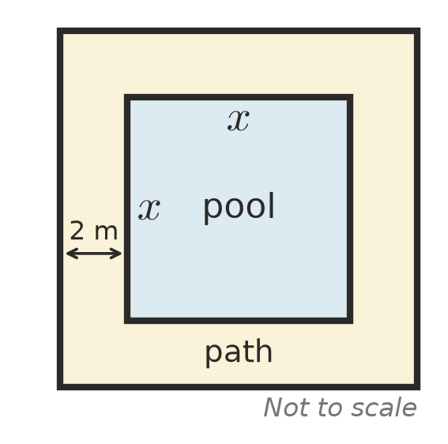
  - Write an expression for the side length of the pool and path together. ______________
  - Write a simplified expression for the area of the path. ______________
  - Find the area of the path when $x=5$. ______________
- Which has the greater area: a square with sides of $(x+3)$ cm, or a rectangle that is $(x+1)$ cm by $(x+5)$ cm? By how much? Show your working.

- Use algebra to show that when two whole numbers differ by 2, their product is always 1 less than the square of the number between them. Check with 14 × 16.

