3.02 Distributive law
Year 9 Maths · A5 question sheet · Level 3 · Challenge
This worksheet stretches your expanding skills: higher powers, fractions, nested brackets and using expansion to prove facts. Tip: with nested brackets, work from the inside out, and simplify inside the square brackets before you expand them.

 Understanding
- This rectangle is split into three parts.
- 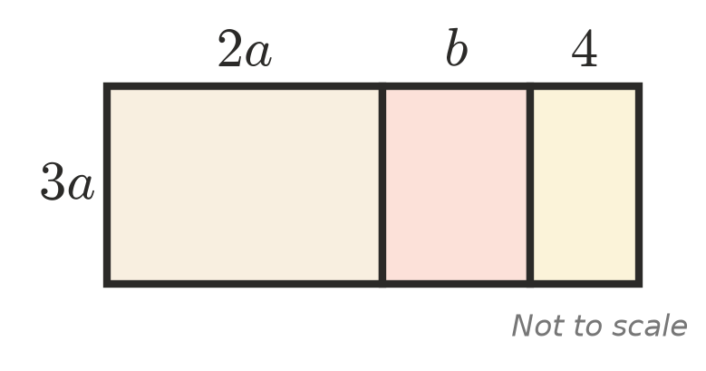
  - Write the area of each part.
  - Use your answer to expand $3a(2a+b+4)$.
- Expanding $x(x+3)$ gives $x^{2}+3x$. Check that this is true when $x=10$, and explain how this is like working out 10 × 13 in your head.

 Fluency
- Expand.
  - $−4x^{2}(3x−2y)$ =
  - $5ab^{2}(2a−3b+1)$ =
  - $\frac{1}{2}(6x−4)$ =
  - $\frac{x}{3}(9x+6)$ =
  - $−\frac{2}{5}(10a−15)$ =
  - $2m^{3}(m^{2}−4m+3)$ =
- Expand and simplify.
  - $4x(2x−3)−3x(x−5)$ =
  - $3a(a−2b)−2b(3a+b)$ =
  - $x^{2}(x+4)−2x(x^{2}−3x)$ =
  - $5−2[3−(x−4)]$ =
  - $\frac{1}{2}(4x+6)−\frac{1}{3}(6x−9)$ =
  - $2y(y^{2}−3y+1)−y^{2}(2y−5)$ =

 Reasoning
- Find the mistake in this working, then give the correct answer.
- $−(2x−5)+3(x−1)=−2x−5+3x−3=x−8$
- Find the values of $a$ and $b$.
  - $a(2x+b)=6x−15$
  - $ax(x+b)+2x=4x^{2}−10x$
- Show that $n(n+3)−n(n−1)$ is always a multiple of 4 when $n$ is a whole number.
- Show that $x(y−z)+y(z−x)+z(x−y)=0$ for all values of $x$, $y$ and $z$.

 Problem solving
- Use the distributive law backwards to work these out in your head.
  - 13 × 99 + 13 =
  - 37 × 18 + 37 × 82 =
  - 24 × 76 − 24 × 26 =
- A corner has been cut out of a rectangle to make this L-shape. All lengths are in metres.
- 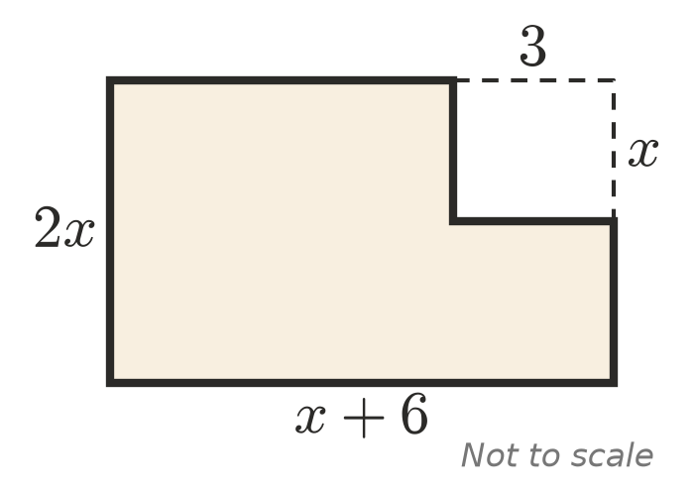
  - Write a simplified expression for the area of the L-shape.
  - Find the area when $x=4$.
  - Write a simplified expression for the perimeter of the L-shape.
- For a church camp of $n$ nights, each student pays $(45n+20)$ dollars. Each leader pays $15n$ dollars less than a student. There are 30 students and 4 leaders.
  - Write a simplified expression for the total paid by the whole group.
  - Find the total paid for a 3-night camp.
- The expression $2(x+k)+3(x−2k)+k(x+1)$ simplifies to $9x−12$. Find the value of $k$, and show that it works for both the $x$ term and the constant term.

