3.02 Distributive law
Year 9 Maths · A5 question sheet · Level 2 · Core
This worksheet practises expanding brackets with powers, negative terms and more than two terms inside, then collecting like terms. Tip: a negative sign in front of brackets changes the sign of every term inside, so $−(x−6)=−x+6$.

 Understanding
- This rectangle is split into two parts.
- 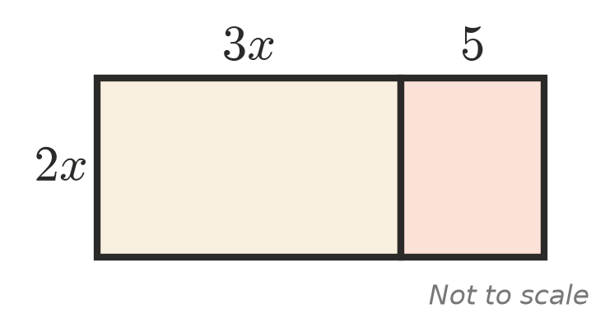
  - Write the area of each part.
  - Use your answer to expand $2x(3x+5)$.
- Explain why $−(x−6)=−x+6$.

 Fluency
- Expand.
  - $−5(2a−3)$ =
  - $4x(2x+7)$ =
  - $−3m(m−4n)$ =
  - $2ab(a+3b)$ =
  - $x^{2}(x−5)$ =
  - $3y^{2}(2y^{2}−y+4)$ =
  - $−2p(3p^{2}−p+1)$ =
  - $(5k−2)×(−3k)$ =
- Expand and simplify.
  - $5(x+3)+2(x−4)$ =
  - $3(2a−1)−4(a−5)$ =
  - $x(x−6)+4(x+2)$ =
  - $3m(m+2)−m(m−5)$ =
  - $2y(3y−1)−3y(y+2)$ =
  - $10−3(2k−4)$ =
  - $a(2a+b)−b(a−3b)$ =
  - $2[3(x+1)−4]$ =

 Reasoning
- Ella expanded and simplified $5x−2(x−3)$ like this:
- $5x−2x−6=3x−6$
- Find her mistake and give the correct answer.
- Find the missing term.
  - $□(3x−4)=−6x+8$, so □ =
  - $4m(□)=8m^{2}−12m$, so □ =
  - $□(a+2b)=3a^{2}+6ab$, so □ =
- Show that $3(x+4)−2(x+6)$ simplifies to $x$.

 Problem solving
- Use the distributive law to work these out in your head.
  - 6 × 199 =
  - 15 × 104 =
  - 8 × 47 =
- A rectangular deck is $3x$ metres long and $(x+2)$ metres wide. A rectangular rug on the deck is $x$ metres long and $(x−1)$ metres wide.
  - Write an expanded expression for the area of the deck.
  - Write an expanded expression for the area of the rug.
  - Write a simplified expression for the area of the deck that the rug does not cover.
  - Find this area when $x=3$.
- At the footy, an adult ticket costs $a$ dollars and a concession ticket costs $8 less. A group buys 3 adult tickets and 4 concession tickets.
  - Write a simplified expression for the total cost.
  - Find the total cost when an adult ticket costs $26.
- Jai’s phone plan costs $(m+15)$ dollars a month for the first 12 months, then $(m+10)$ dollars a month for the next 12 months.
  - Write a simplified expression for the total cost over the two years.
  - Find the total cost when $m=20$.
- Write an expression with brackets that expands to give each of these.
  - $6x^{2}−9x$
  - $−4a+10$

