3.02 Distributive law
Year 9 Maths · A5 question sheet · Level 1 · Warm-up
This worksheet practises expanding brackets: multiplying every term inside the brackets by the term outside. Tip: draw arrows from the term outside to each term inside so you don’t miss one, and watch the signs: $−2(x−3)=−2x+6$.

 Understanding
- This rectangle is split into two parts.
- 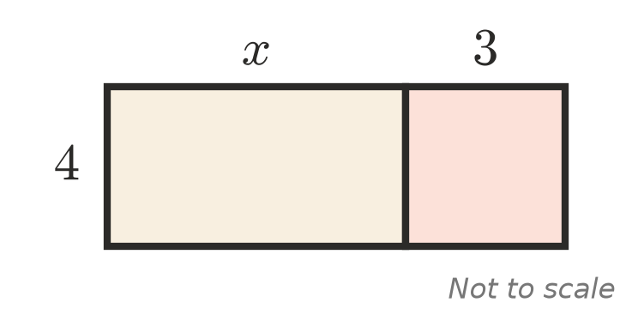
  - Write the area of each part.
  - Use your answer to expand $4(x+3)$.
- Copy and fill in the missing term.
  - $3(a+4)=3a+□$, so □ =
  - $2(x−6)=□−12$, so □ =
  - $x(x+5)=x^{2}+□$, so □ =

 Fluency
- Expand.
  - $6(x+4)$ =
  - $3(2a−5)$ =
  - $−2(y+7)$ =
  - $−4(m−3)$ =
  - $x(x+8)$ =
  - $a(3a−2)$ =
  - $2p(p+5)$ =
  - $−y(4−y)$ =
- Expand and simplify.
  - $3(x+2)+5$ =
  - $4(a+3)+2a$ =
  - $2(m+5)+3(m+1)$ =
  - $5(x+2)−2(x+1)$ =
  - $x(x+3)+2x$ =

 Reasoning
- Ben expanded $3(2x+5)$ and got $6x+5$. What did he forget? Write the correct answer.
- Find the missing number.
  - $□(x+5)=4x+20$, so □ =
  - $3(x+□)=3x+21$, so □ =
  - $−2(x−□)=−2x+10$, so □ =

 Problem solving
- Use the distributive law to work these out in your head. For example, 6 × 102 = 6 × 100 + 6 × 2 = 612.
  - 7 × 102 =
  - 5 × 98 =
  - 9 × 51 =
- At the canteen, a meal deal is a burger that costs $x$ dollars and a drink that costs $3.
  - Write an expression with brackets for the cost of 4 meal deals.
  - Expand your expression.
  - Find the cost of 4 meal deals when a burger costs $7.
- A garden bed is 3 m wide and $(x+5)$ m long.
  - Write an expanded expression for its area.
  - Find the area when $x=4$.
  - Write a simplified expression for its perimeter.
- Think of a number. Double it. Add 10. Halve the result. Subtract the number you first thought of. Try it with two different numbers, then use algebra to show that you always get the same answer.

