4.03 Time zones and the date line
Year 8 Maths · Worksheet · Level 2 · Core
Name: ____________________ Date: ______________
This worksheet practises converting times between Australian and world time zones, including daylight saving and the International Date Line, and working out arrival times for flights. Tip: to change a time from one city to another, find the difference between their UTC offsets. Add it if you are going to a city further east (a bigger offset), and subtract it if you are going west.

 Understanding
- In January, which city is on UTC+10:30? Answer: ______________
  - Darwin
  - Adelaide
  - Brisbane
  - Perth
- The Earth turns once (360°) every 24 hours.
  - How many degrees does it turn in 1 hour? ______________
  - The Sun rises in the east. Who sees the sunrise first on the same day, people in Sydney or people in Perth? Explain.

 Fluency
Use the map of Australia’s time zones for Questions 3 and 7 to 9.
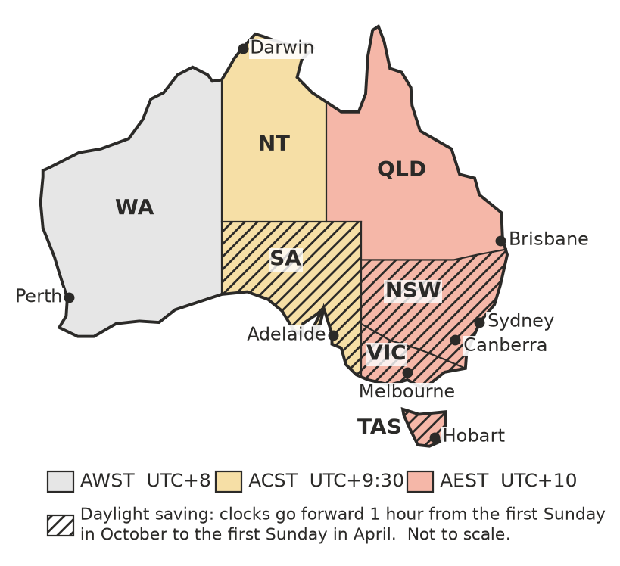
- Complete the table. It shows the time in each city when it is 12:00 noon in Sydney.
City | In June (no daylight saving) | In January (daylight saving)
Sydney | 12:00 pm | 12:00 pm
Brisbane
Adelaide
Darwin
Perth
Hobart

- The table shows the UTC offsets of some world cities in January. Use it to find the time in the second city. Give the day too if it changes.
City | UTC offset in January
London | UTC+0
New York | UTC−5
Los Angeles | UTC−8
Auckland | UTC+13
Tokyo | UTC+9
Delhi | UTC+5:30
Dubai | UTC+4

  - 09:00 in London. Time in Tokyo? ______________
  - 15:00 in Tokyo. Time in Delhi? ______________
  - 08:00 on Tuesday in Dubai. Time in New York? ______________
  - 20:00 on Monday in Los Angeles. Time in Auckland? ______________
- Use the table in Question 4.
  - How many hours is Auckland ahead of Los Angeles in January? ______________
  - How many hours is Delhi behind Tokyo? ______________

 Reasoning
- The International Date Line is roughly along 180° longitude, in the middle of the Pacific Ocean. When you cross it going west, the date jumps forward one day. When you cross it going east, the date goes back one day.
  - A ship sails west across the date line just after 11:00 pm on Wednesday. What day is it on board straight after it crosses? ______________
  - Samoa (UTC+13) and American Samoa (UTC−11) are islands only about 100 km apart, on opposite sides of the date line. When it is 9:00 am on Saturday in Samoa, what time and day is it in American Samoa? ______________
- Ben says, “In January, when it’s 6:00 pm in Adelaide, it’s 6:30 pm in Brisbane, because Brisbane is further east.” Is Ben right? Explain, and give the correct time in Brisbane. ______________

 Problem solving
- It is January. A plane leaves Sydney at 8:30 am (Sydney time) and the flight to Perth takes 5 hours 10 minutes. What is the local time in Perth when it lands? ______________

- It is January. The “red-eye” flight leaves Perth at 11:45 pm (Perth time) and flies to Sydney in 4 hours 20 minutes. What is the local time in Sydney when it lands? ______________

- It is January. A plane leaves Melbourne (UTC+11) at 10:15 am and flies to Tokyo (UTC+9) in 10 hours 25 minutes. What is the local time in Tokyo when it lands? ______________

- In January, a soccer final in London (UTC+0) kicks off at 20:00 on Sunday. When can fans watch it live in:
  - Brisbane (UTC+10)? ______________
  - Perth (UTC+8)? ______________
- In January, a family in Adelaide (UTC+10:30) wants to have a video call with cousins in Dubai (UTC+4). Everyone wants the call to be between 7:00 am and 10:00 pm in their own city.
  - How many hours is Adelaide ahead of Dubai? ______________
  - Between what times, in Adelaide time, can the call happen? ______________

