4.03 Time zones and the date line
Year 8 Maths · Worksheet · Level 1 · Warm-up
Name: ____________________ Date: ______________
This worksheet practises using Australia’s time zones and UTC offsets to change a time from one place to another. Tip: places further east are ahead (their clocks show a later time). UTC+10 means “10 hours ahead of UTC”, the time at 0° longitude, which runs through Greenwich in London.

 Understanding
- Use the map of Australia’s time zones.
- 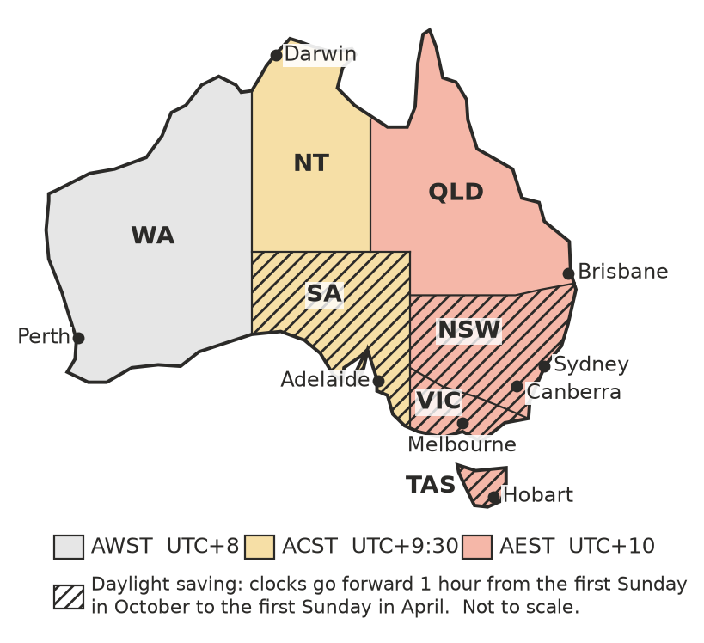
  - Which time zone is Perth in? ______________
  - Which two state capitals are on Australian Central Standard Time? ______________
  - Which states and territories do not use daylight saving? ______________
  - In June (no daylight saving), how many hours is Sydney ahead of Perth? ______________
- True or false?
  - When it is morning in Sydney, it is earlier in the morning in Perth. ______________
  - Adelaide’s time is always exactly 1 hour behind Sydney’s. ______________
  - Brisbane and Melbourne show the same time all year round. ______________

 Fluency
- In June, there is no daylight saving anywhere in Australia. When it is 12:00 noon in Sydney, what time is it in:
  - Brisbane? ______________
  - Perth? ______________
  - Adelaide? ______________
  - Darwin? ______________
  - Hobart? ______________
- It is June. Find the time in the second city.
  - 3:00 pm in Perth. Time in Melbourne? ______________
  - 9:15 am in Adelaide. Time in Brisbane? ______________
  - 7:40 pm in Sydney. Time in Perth? ______________
  - 8:00 am in Darwin. Time in Perth? ______________
- The number line shows the UTC offsets of some cities. It is 2:00 pm on Tuesday in Brisbane (UTC+10). What time and day is it in each city?
- 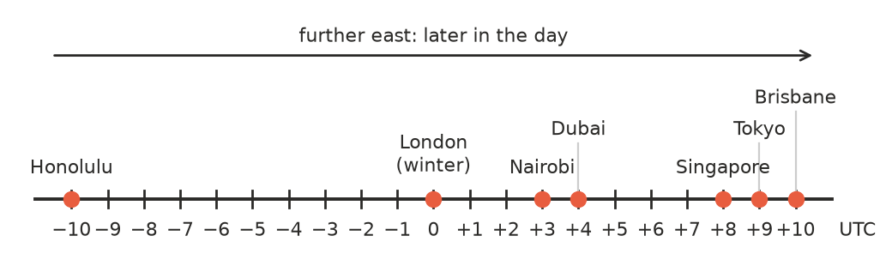
  - Tokyo (UTC+9) ______________
  - Singapore (UTC+8) ______________
  - Dubai (UTC+4) ______________
  - Honolulu (UTC−10) ______________

 Reasoning
- From October to April, New South Wales uses daylight saving (AEDT, UTC+11), but Queensland does not (it stays on AEST, UTC+10).
  - It is 6:00 pm in Sydney in January. What time is it in Brisbane? ______________
  - Tweed Heads (NSW) and Coolangatta (Queensland) are twin towns right next to each other, on either side of the border. Explain why people there can celebrate New Year twice on 31 December.

- The International Date Line runs down the middle of the Pacific Ocean. Places just west of it (like Australia) are almost a whole day ahead of places just east of it (like Hawaii). It is 8:00 am on Tuesday in Brisbane (UTC+10). What time and day is it in Honolulu (UTC−10)? ______________

 Problem solving
- It is June. Ruby lives in Melbourne. She wants to phone her grandma in Perth at 7:30 pm Perth time. What time is that in Melbourne? ______________
- Queensland and Western Australia don’t use daylight saving. A plane leaves Brisbane at 10:20 am and the flight to Perth takes 5 hours 15 minutes.
  - What time is it in Brisbane when the plane lands? ______________
  - What is the local time in Perth when the plane lands? ______________

- It is June. A footy match in Melbourne starts at 7:50 pm. At what time does it start for fans watching it live in:
  - Perth? ______________
  - Adelaide? ______________
- Singapore (UTC+8) has the same time as Perth. A plane leaves Perth at 9:00 am and the flight to Singapore takes 5 hours. What is the local time in Singapore when the plane lands? ______________

