4.02 12 and 24 hour time
Year 8 Maths · Worksheet · Level 1 · Warm-up
Name: ____________________ Date: ______________
This worksheet practises changing between 12-hour time (like 3:45 pm) and 24-hour time (like 15:45), and reading a timetable. Tip: for times from 1:00 pm to 11:59 pm, add 12 to the hours to get 24-hour time. Always write 24-hour time with 4 digits, so 7:05 am is 07:05.

 Understanding
- Complete each statement.
  - Midnight in 24-hour time is ______________
  - Noon (midday) in 24-hour time is ______________
  - In 24-hour time, the hours go from 00 up to ______________
  - “pm” times are the times from noon until ______________
  - To change a time from 1:00 pm to 11:59 pm into 24-hour time, add this number to the hours: ______________
- Write the time on each clock in 24-hour time.
- 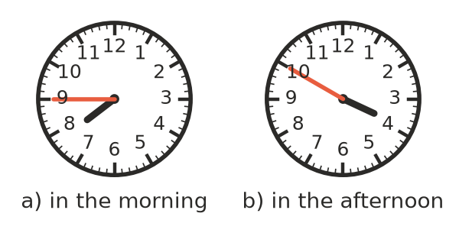
  - ______________
  - ______________

 Fluency
- Write each time in 24-hour time.
  - 6:15 am ______________
  - 2:40 pm ______________
  - 11:05 am ______________
  - 9:30 pm ______________
  - 12:25 pm ______________
  - 12:10 am ______________
- Write each time in 12-hour time, using am or pm.
  - 08:50 ______________
  - 13:20 ______________
  - 19:45 ______________
  - 23:59 ______________
  - 00:35 ______________
  - 12:00 ______________
- How long is it from:
  - 09:15 to 11:45? ______________
  - 13:20 to 17:50? ______________
  - 10:40 to 14:05? ______________
  - 18:35 to 22:10? ______________
- Find the new time in 24-hour time.
  - 2 hours 30 minutes after 14:15 ______________
  - 45 minutes after 21:40 ______________
  - 3 hours before 01:20 ______________

 Reasoning
- Write these times in order from earliest to latest in the day: 3:10 pm, 14:50, 9:05 am, 23:30, 8:55 pm.

- Max says that 17:00 is 7:00 pm. Explain his mistake and give the correct time.

 Problem solving
- Here is part of a morning bus timetable.
Stop | Time
Town Centre | 07:40
Hospital | 07:52
High School | 08:05
Beach Road | 08:21

  - How long does the bus take from Town Centre to High School? ______________
  - Write the time the bus reaches Beach Road in 12-hour time. ______________
  - One day the bus is 9 minutes late at every stop. When does it reach Beach Road? ______________
- An overnight train leaves at 21:15 and arrives at 07:05 the next morning. How long is the trip? ______________

- A cake goes into the oven at 15:35 and needs 50 minutes. When should it come out? Give your answer in 24-hour time and in 12-hour time. ______________

