4.01 Elapsed time
Year 8 Maths · Worksheet · Level 1 · Warm-up
Name: ____________________ Date: ______________
This worksheet practises changing units of time and working out how long something takes. Tip: to find how long it is from one time to another, count up to the next full hour first, then count the whole hours, then the minutes left over.

 Understanding
- Complete each fact.
  - 1 minute = ______________ seconds
  - 1 hour = ______________ minutes
  - 1 day = ______________ hours
  - 1 week = ______________ days
  - 1 year = ______________ days (or 366 in a leap year)
  - 1 decade = ______________ years
  - 1 century = ______________ years
- Each pair of clocks shows when a job started and finished, on the same morning or afternoon. How long did each job take?
- 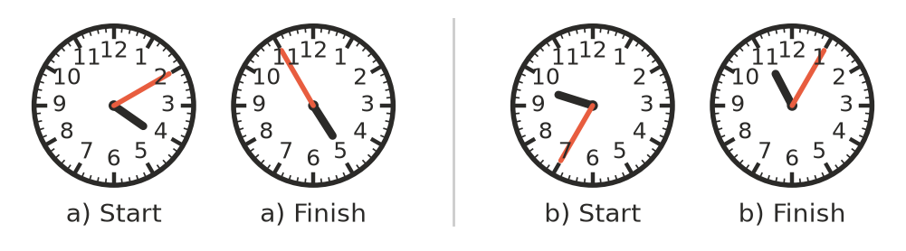
  - Mia’s homework ______________
  - Washing the car ______________

 Fluency
- Change each time to the unit shown.
  - 5 minutes to seconds ______________
  - 3 hours to minutes ______________
  - 2 days to hours ______________
  - 240 seconds to minutes ______________
  - 150 minutes to hours and minutes ______________
  - 4 weeks to days ______________
- Find the new time.
  - 20 minutes after 8:15 am ______________
  - 45 minutes after 10:30 am ______________
  - 2 hours 10 minutes after 1:40 pm ______________
  - 30 minutes before 9:10 am ______________
  - 1 hour 25 minutes before 12:05 pm ______________
- How long is it from:
  - 7:15 am to 7:50 am? ______________
  - 9:40 am to 11:00 am? ______________
  - 10:45 am to 2:15 pm? ______________
  - 11:20 am to 1:05 pm? ______________

 Reasoning
- Hours are split into 60 minutes, not 100, so be careful with decimals.
  - 1.5 hours = ______________ minutes
  - $\frac{1}{4}$ of an hour = ______________ minutes
  - What fraction of an hour is 45 minutes? ______________
  - Write 2.5 hours in hours and minutes. ______________
- Sam wants to know how long it is from 9:50 am to 10:20 am. He writes 1020 − 950 = 70, so he says “70 minutes”. Explain what Sam did wrong, and give the correct answer.

 Problem solving
- A movie starts at 6:45 pm and runs for 1 hour 50 minutes. What time does it finish? ______________

- Ella’s footy training runs from 4:30 pm to 6:15 pm, twice a week. How long does she train each week? ______________

- A school camp starts on Monday 14 March and finishes on Friday 18 March.
  - How many days does the camp last (counting the first and last day)? ______________
  - How many nights do the students sleep at camp? ______________
- Baby Noah is 2 weeks and 3 days old.
  - How many days old is he? ______________
  - How many hours old is he? ______________

- Jo ran 400 m in 1 minute 25 seconds. Kim ran 400 m in 98 seconds. Who was faster, and by how many seconds? ______________

