Statistics: Practice test 3
Year 8 Maths · Test · Test 3
Name: ____________________ Date: ______________
Time: 45 minutes
Total: 40 marks
Show your working in the boxes. Then write each final answer on the answer sheet on the last page.

 Section A: No calculator
- What is the best way to collect data in each situation: survey, observation or experiment?
  - Finding out whether a new kind of netball grip helps players shoot more accurately. (1 mark)

  - Finding out how many birds visit an orchard each morning. (1 mark)

  - Finding out the favourite fruit of Year 8 students. (1 mark)

- An orchard owner wants to know the mean mass of the 20 000 apples on his trees.
  - Give one reason why he should use a sample instead of weighing every apple. (1 mark)

  - Give one reason why a census of every person in Australia is only done every five years. (1 mark)

- A small cinema sold this many tickets for each of its 7 sessions on Saturday.
- 18, 22, 15, 22, 26, 20, 17
  - Find the mode. (1 mark)

  - Find the median. (1 mark)

  - Find the mean. (2 marks)

- Twenty-two students recorded how many hours of homework they did last week. The dot plot shows the results.
- 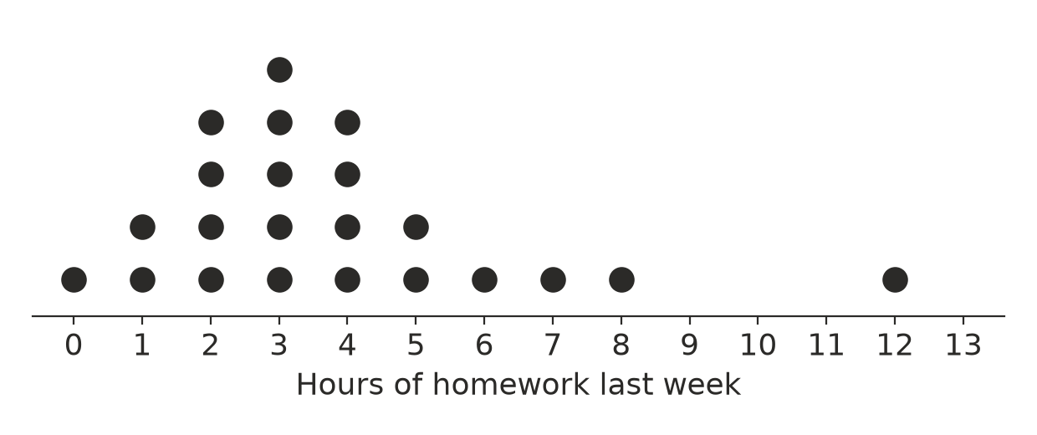
  - Find the range. (1 mark)

  - Find the median. (1 mark)

  - Describe the distribution. Mention where most of the data is, and any gap or outlier. (1 mark)

- Two classes did the same maths test. The table shows a summary of their marks.
Class | Mean | Median | Range
Class A | 64 | 66 | 30
Class B | 64 | 61 | 12

  - Which class had more consistent marks? (1 mark)

  - In which class did at least half of the students score 66 or more? (1 mark)

  - Explain why comparing only the means does not tell you everything about how the two classes went. (1 mark)

- An orchard has 500 apple trees. Each tree has a number from 1 to 500.
  - Describe how the owner could choose a simple random sample of 25 trees. (1 mark)

  - The owner instead walks along each row and picks every 10th tree. What type of sampling is this? (1 mark)

  - The orchard grows three types of apple. Give one advantage of taking a stratified sample by apple type. (1 mark)

- A netball club has 120 junior players, 60 senior players and 20 masters players. The club wants a stratified sample of 40 players. How many players should it choose from each group? (2 marks)

- A fun run has 1500 runners. The organisers survey every 50th runner to cross the finish line. How many runners do they survey? (1 mark)

- A farmer wants to test whether a new fertiliser makes apple trees produce more fruit. He puts the fertiliser on the trees near the dam and compares them with the trees on the dry hill.
  - Explain why this experiment is not fair. (1 mark)

  - Describe how he could make the experiment fairer. (1 mark)

- A cinema wants to find out which type of movie is most popular with people in its town. It asks people as they leave an action movie.
  - Explain why this sample is biased. (1 mark)

  - Suggest a better way to choose the sample. (1 mark)

- A fruit packer wants to know what percentage of the apples in a huge shipment have marks on their skin. Workers took 20 random samples of 10 apples and found the percentage with marks in each sample. Then they took 20 random samples of 50 apples. The two dot plots show the results, but they are not labelled with the sample size.
- 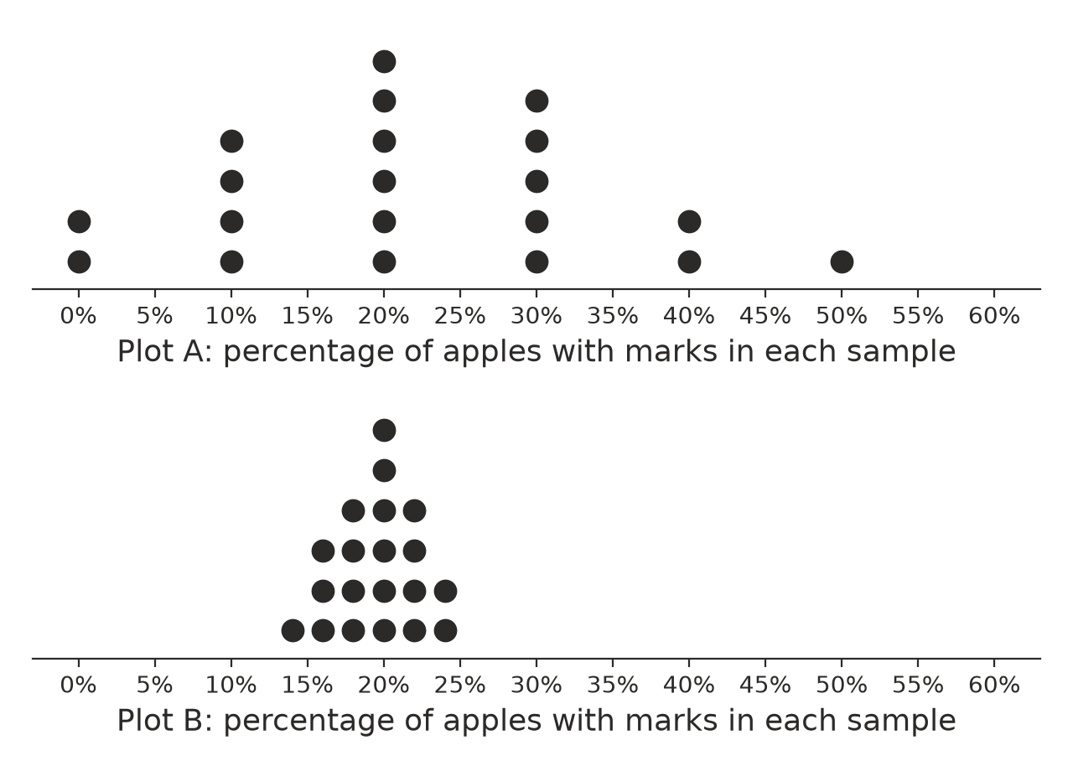
  - Which plot shows the samples of 50 apples? Explain how you know. (1 mark)

  - Find the range of the percentages in each plot. (1 mark)

  - Estimate the percentage of all the apples in the shipment that have marks. (1 mark)

 Section B: Calculator allowed
- In a netball shooting challenge, 40 players each had 10 shots. The table shows how many goals they scored.
Goals scored | 3 | 4 | 5 | 6 | 7 | 8 | 9 | 10
Number of players | 2 | 3 | 5 | 8 | 10 | 7 | 4 | 1

  - Find the mean number of goals, correct to one decimal place. (2 marks)

  - What is the mode? (1 mark)

- A fun run has 2400 entrants. The organisers know that 35% of the entrants are running it for the first time. A random sample of 80 entrants included 31 first-time runners.
  - Find the sample proportion of first-time runners as a percentage. (1 mark)

  - How many of the 2400 entrants are first-time runners? (1 mark)

  - The sample proportion is not exactly 35%. Does this mean the sample was chosen badly? Explain your answer. (1 mark)

- After four tests, Mia’s mean mark is 72. What mark does she need on her fifth test to raise her mean to 75? Show your working. (2 marks)

- Ruby wants to investigate this question: “Do Year 8 students at my school who play a weekend sport spend less time on screens than those who don’t?”
  - What is the population for Ruby’s investigation? (1 mark)

  - Give one thing Ruby should do to make sure her investigation is ethical. (1 mark)

  - Ruby surveys a random sample of 20 students who play a weekend sport and 20 who don’t. The mean screen time is 2.6 hours a day for students who play sport and 3.1 hours a day for those who don’t. Write a conclusion for Ruby’s investigation. Your conclusion should show that the result is not certain. (2 marks)

 Answer sheet
Name: ____________________
Write your final answer for each question in the table.
Question | Answer | Marks | Question | Answer | Marks
1a |  | /1 | 8 |  | /1
1b |  | /1 | 9a |  | /1
1c |  | /1 | 9b |  | /1
2a |  | /1 | 10a |  | /1
2b |  | /1 | 10b |  | /1
3a |  | /1 | 11a |  | /1
3b |  | /1 | 11b |  | /1
3c |  | /2 | 11c |  | /1
4a |  | /1 | 12a |  | /2
4b |  | /1 | 12b |  | /1
4c |  | /1 | 13a |  | /1
5a |  | /1 | 13b |  | /1
5b |  | /1 | 13c |  | /1
5c |  | /1 | 14 |  | /2
6a |  | /1 | 15a |  | /1
6b |  | /1 | 15b |  | /1
6c |  | /1 | 15c |  | /2
7 |  | /2
 |  |  |  | Total | /40

