Statistics: Practice test 2
Year 8 Maths · Test · Test 2
Name: ____________________ Date: ______________
Time: 45 minutes
Total: 40 marks
Show your working in the boxes. Then write each final answer on the answer sheet on the last page.

 Section A: No calculator
- Is each of these data collections a census or a sample?
  - Every household in Australia fills in a form about the people living there on the same night in August. (1 mark)

  - A bakery cuts open 5 loaves from each batch to check that the bread is cooked in the middle. (1 mark)

  - A road trip app sends a questionnaire to 2000 of its 150 000 users. (1 mark)

- A shire council wants to know whether the people in the shire want a new swimming pool.
  - Give one practical reason for the council to use a sample instead of a census. (1 mark)

  - Give one disadvantage of using a sample instead of a census. (1 mark)

- Eight students recorded how many books they borrowed from the library this term.
- 4, 9, 3, 12, 7, 5, 6, 10
  - Find the mean. (2 marks)

  - Find the median. (1 mark)

  - Find the range. (1 mark)

- The stem-and-leaf plot shows the ages of the 15 people at a church working bee.
Stem | Leaf
1 | 2 5 7
2 | 3 8
3 | 1 4 4 6 9
4 | 2 5 8
5 | 7
6 | 6

- Key: 3 | 1 means 31 years old
  - Find the median age. (1 mark)

  - Find the range of the ages. (1 mark)

  - How many people at the working bee were 40 or older? (1 mark)

- A small business pays its four workers and its owner these yearly salaries:
- $65 000, $70 000, $68 000, $72 000, $240 000
  - Find the mean salary. (1 mark)

  - Find the median salary. (1 mark)

  - The owner says, “The average pay at my business is over $100 000.” Is the mean a fair way to describe a typical salary here? Explain your answer. (1 mark)

- A footy club has an alphabetical list of its 400 members. Explain how the club could choose a systematic sample of 20 members from the list. (2 marks)

- Name the sampling method used in each situation: simple random, systematic, stratified, convenience or self-selected.
  - A reporter asks the first 20 people who walk out of a shopping centre. (1 mark)

  - A computer picks 50 customers at random from the list of all of a shop’s customers. (1 mark)

- At a church camp there are 36 Year 7 campers, 24 Year 8 campers and 20 Year 9 campers. The leader wants a stratified sample of 20 campers. How many campers should she choose from each year level? (2 marks)

- Explain why each sample is likely to be biased.
  - To find out how much exercise Australians do each week, a researcher surveys people at a gym. (1 mark)

  - To find out whether students like the new school uniform, a survey is put on the school website and students can fill it in if they want to. (1 mark)

- Here are two survey questions about a bike path.
- Question A: “Do you agree that our town needs a safe, much-needed bike path?”
- Question B: “Should our town build a bike path?”
- Which question is less likely to give biased results? Explain your answer. (2 marks)

- A factory fills packets of trail mix. Each day, a worker takes a random sample of 10 packets and finds their mean mass. The dot plot shows the sample means for 25 days.
- 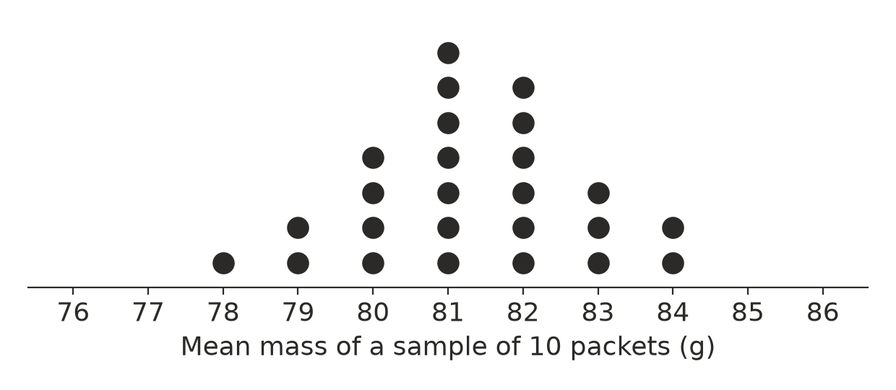
  - How many sample means were greater than 81 g? (1 mark)

  - Find the range of the sample means. (1 mark)

  - Estimate the mean mass of all the packets the factory fills. (1 mark)

 Section B: Calculator allowed
- On a road trip, three students counted the cars towing a caravan. Each student watched a different number of cars.
Student | Cars watched | Cars towing a caravan
Mia | 20 | 7
Jack | 50 | 13
Zara | 200 | 46

  - Write each student’s proportion of cars towing a caravan as a percentage. (2 marks)

  - Which student’s result is likely to be the best estimate for all the cars on that highway? Explain why. (1 mark)

- Two bakeries recorded the number of loaves left unsold each day for a week.
Bakery | Loaves left unsold
Bakery A | 12, 8, 15, 9, 11, 14, 10
Bakery B | 5, 22, 3, 18, 7, 20, 6

  - Find the mean number of unsold loaves for each bakery, correct to one decimal place. (2 marks)

  - Which bakery is more consistent? Use a measure of spread to explain your answer. (1 mark)

- Five whole numbers have a mode of 3, a median of 7, a mean of 8 and a range of 12. Find the five numbers. Show your working. (2 marks)

- Josh wants to find out the favourite sport of the 900 students at his school.
  - Write a fair survey question that Josh could ask. (1 mark)

  - Josh plans to ask only the students in his own class. Explain why this is not a good sample. (1 mark)

  - Josh instead asks a random sample of 50 students, and 18 of them choose football. Estimate how many of the 900 students would choose football, and explain why your answer is only an estimate. (2 marks)

 Answer sheet
Name: ____________________
Write your final answer for each question in the table.
Question | Answer | Marks | Question | Answer | Marks
1a |  | /1 | 7b |  | /1
1b |  | /1 | 8 |  | /2
1c |  | /1 | 9a |  | /1
2a |  | /1 | 9b |  | /1
2b |  | /1 | 10 |  | /2
3a |  | /2 | 11a |  | /1
3b |  | /1 | 11b |  | /1
3c |  | /1 | 11c |  | /1
4a |  | /1 | 12a |  | /2
4b |  | /1 | 12b |  | /1
4c |  | /1 | 13a |  | /2
5a |  | /1 | 13b |  | /1
5b |  | /1 | 14 |  | /2
5c |  | /1 | 15a |  | /1
6 |  | /2 | 15b |  | /1
7a |  | /1 | 15c |  | /2
 |  |  |  | Total | /40

