Statistics: Practice test 1
Year 8 Maths · Test · Test 1
Name: ____________________ Date: ______________
Time: 45 minutes
Total: 40 marks
Show your working in the boxes. Then write each final answer on the answer sheet on the last page.

 Section A: No calculator
- Would a census or a sample be better in each situation? Give a reason for each answer.
  - A cricket coach wants to know the shoe size of each of the 14 players in her squad so she can order new spikes. (1 mark)

  - A juice company wants to check that its bottles of orange juice taste right. To taste the juice, a bottle has to be opened. (1 mark)

  - A council wants to estimate how many of the 85 000 people in its area would use a new skate park. (1 mark)

- Which method of collecting data is being used: survey, observation or experiment?
  - Counting how many cars drive past the school gate between 8 am and 9 am. (1 mark)

  - Growing tomato plants with three different fertilisers and weighing the tomatoes each plant produces. (1 mark)

- A farmer collected this many eggs from her hens on each of 9 days.
- 12, 8, 15, 10, 8, 14, 9, 8, 15
  - Find the median. (1 mark)

  - Find the mean. (2 marks)

  - Find the range. (1 mark)

- Twenty students recorded how many times they went to the beach in January. The dot plot shows the results.
- 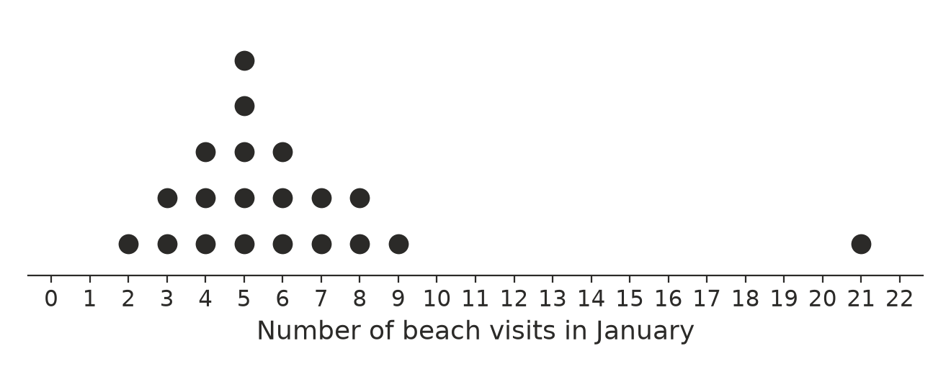
  - Which value is an outlier? (1 mark)

  - Find the median. (1 mark)

  - Would the mean or the median be the better measure of a typical number of visits? Explain your answer. (1 mark)

- Ella and Kai each did five spelling tests, each marked out of 20. Here are their scores.
Student | Scores
Ella | 14, 16, 15, 17, 13
Kai | 20, 9, 18, 12, 16

  - Find the mean score for each student. (1 mark)

  - Find the range of scores for each student. (1 mark)

  - Which student is more consistent? Explain your answer. (1 mark)

- Name the sampling method used in each situation: simple random, systematic, stratified, convenience or self-selected.
  - A teacher puts every student’s name into a hat, mixes them up and draws out 10 names. (1 mark)

  - A radio station asks its listeners to ring in and vote for the best song of the year. (1 mark)

  - A principal chooses students from each year level so that each year level’s share of the sample matches its share of the whole school. (1 mark)

- A farmer has 600 lambs. As the lambs walk through the race, she weighs every 20th lamb. How many lambs does she weigh? (1 mark)

- A school has 240 Year 7 students, 200 Year 8 students and 160 Year 9 students. The principal wants a stratified sample of 30 students. How many students should she choose from each year level? (2 marks)

- The canteen manager wrote this survey question.
- “Wouldn’t you agree that our delicious new pies are better than the old ones?”
  - Explain why this question is biased. (1 mark)

  - Rewrite the question so that it is fair. (1 mark)

- Lily wants to find out how Year 8 students at her school get to school. She asks the students waiting at the bus stop after school. Explain why her sample is biased, and suggest a better way to choose her sample. (2 marks)

- A huge jar at a school fete is full of jelly beans. Thirty students each took a random sample of 20 jelly beans and counted the red ones. The dot plot shows their results.
- 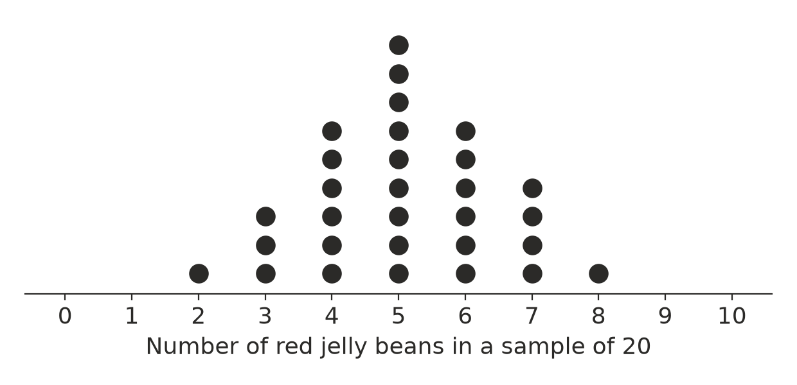
  - How many samples had more than 5 red jelly beans? (1 mark)

  - What was the most common number of red jelly beans in a sample? (1 mark)

  - Use the dot plot to estimate the percentage of jelly beans in the jar that are red. (1 mark)

 Section B: Calculator allowed
- Thirty students were asked how many brothers and sisters they have. The table shows the results.
Number of brothers and sisters | 0 | 1 | 2 | 3 | 4 | 5
Number of students | 6 | 9 | 8 | 4 | 2 | 1

  - Find the mean number of brothers and sisters, correct to one decimal place. (2 marks)

  - Find the median number of brothers and sisters. (1 mark)

- A school has 900 students. Sam and Priya each want to estimate how many students walk to school. Sam asks 10 randomly chosen students and 3 of them walk. Priya asks 60 randomly chosen students and 15 of them walk.
  - Write each sample proportion as a percentage. (1 mark)

  - Whose estimate is likely to be more reliable? Explain why. (1 mark)

  - Use Priya’s sample to estimate how many of the 900 students walk to school. (1 mark)

- The mean height of the 7 players in a netball team is 172 cm. A new player joins the team and the mean height of all 8 players becomes 173 cm. How tall is the new player? Show your working. (2 marks)

- Noah wants to find out how many hours of sleep the 180 Year 8 students at his school get on a school night.
  - Describe how Noah could choose a simple random sample of 30 Year 8 students. (1 mark)

  - Give one thing Noah should do to make sure his survey is ethical. (1 mark)

  - The mean for Noah’s sample is 8.2 hours. Noah writes, “Every Year 8 student at my school sleeps 8.2 hours on a school night.” Explain what is wrong with his statement, and write a better conclusion. (2 marks)

 Answer sheet
Name: ____________________
Write your final answer for each question in the table.
Question | Answer | Marks | Question | Answer | Marks
1a |  | /1 | 7 |  | /1
1b |  | /1 | 8 |  | /2
1c |  | /1 | 9a |  | /1
2a |  | /1 | 9b |  | /1
2b |  | /1 | 10 |  | /2
3a |  | /1 | 11a |  | /1
3b |  | /2 | 11b |  | /1
3c |  | /1 | 11c |  | /1
4a |  | /1 | 12a |  | /2
4b |  | /1 | 12b |  | /1
4c |  | /1 | 13a |  | /1
5a |  | /1 | 13b |  | /1
5b |  | /1 | 13c |  | /1
5c |  | /1 | 14 |  | /2
6a |  | /1 | 15a |  | /1
6b |  | /1 | 15b |  | /1
6c |  | /1 | 15c |  | /2
 |  |  |  | Total | /40

