11.04 Compare samples to populations
Year 8 Maths · A5 question sheet · Level 2 · Core
This worksheet practises comparing samples with the population they come from: working out sample means and proportions, seeing how much they vary from sample to sample, and recognising how the sample size changes that variation. Tip: a sample statistic (like a sample mean or a sample percentage) is an estimate. Larger random samples give estimates that vary less.

 Understanding
- A farmer recorded how many eggs each of her 20 hens laid in one week. This is the whole population.
Hen | 1 | 2 | 3 | 4 | 5 | 6 | 7 | 8 | 9 | 10 | 11 | 12 | 13 | 14 | 15 | 16 | 17 | 18 | 19 | 20
Eggs | 5 | 6 | 4 | 7 | 6 | 5 | 3 | 7 | 6 | 4 | 5 | 6 | 7 | 2 | 6 | 5 | 4 | 6 | 7 | 5

  - Find the population mean and the population range.
  - Sample A is hens 7, 10, 14 and 16. Find the sample mean.
  - Sample B is hens 1, 4, 6, 8, 10, 11, 13, 15, 17 and 20. Find the sample mean and the sample range.
  - Which sample mean is closer to the population mean? Why would you expect this?
  - Why is the range of a sample usually smaller than (or equal to) the range of the population?
- Explain what is meant by sampling variation.

 Fluency
- The 600 students at a school recorded how many minutes it takes them to travel to school. The population mean is 20 minutes. A class took 20 random samples of 5 students and 20 random samples of 25 students. The dot plots show the mean of each sample, rounded to the nearest minute.
- 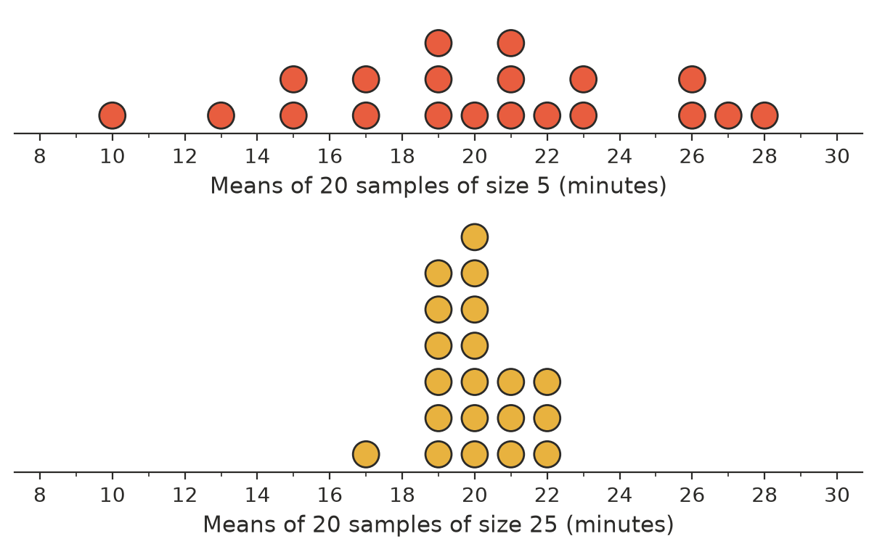
  - Find the range of the sample means for each sample size.
  - How many of the samples of 5 had a mean within 2 minutes of 20 (from 18 to 22)? How many of the samples of 25?
  - Describe how the sample size affects the sample means.
- A bag holds 500 lollies, and 30% of them are green. Some students took random samples, put the lollies back after each sample, and counted the green ones.
Samples of 20 lollies | 5 green | 7 green | 4 green | 8 green
Samples of 100 lollies | 28 green | 33 green | 31 green | 27 green

  - Write each result as a percentage.
  - Find the lowest and highest percentage for each sample size.
  - Which sample size gives percentages closer to the true 30%?
- In a random sample of 40 of the 1200 students at a school, 14 play a musical instrument.
  - What percentage of the sample plays an instrument?
  - Estimate how many students at the school play an instrument.

 Reasoning
- Ruby says, “My random sample of 10 students had a mean of 6.5 hours of sleep, and Kai’s random sample of 10 had a mean of 8.0 hours. One of us must have made a mistake.” Do you agree? What could they do to get a more reliable estimate?
- Which estimate is likely to be more reliable: one from a random sample of 1000 Australians, or one from a random sample of 100 people in your town? Explain.
- A sample of 25 students has a mean travel time of 23 minutes. Using the dot plots in Question 3, is this a surprising result if the population mean is 20 minutes? What about a sample mean of 30 minutes?

 Problem solving
- Three random samples of Year 8 students were asked whether they own a bike.
Sample | Size | Number who own a bike
P | 20 | 13
Q | 50 | 29
R | 80 | 46

  - Find the percentage who own a bike in each sample.
  - Combine all three samples to make one estimate.
  - There are 240 Year 8 students. Use your answer to part b to estimate how many own a bike.
- A council wants to estimate the mean number of people per household in a town of 3000 households. A random sample of 10 households gave a mean of 3.4. A random sample of 100 households gave a mean of 2.7.
  - Which estimate should the council use? Why?
  - Estimate the number of people living in the town.
- A survey company says its random sample of 400 voters is “accurate to within 5%”. Explain what this means, and why a larger sample would be “accurate to within” a smaller percentage.

