11.01 Measures of centre and spread
Year 8 Maths · Worksheet · Level 3 · Challenge
Name: ____________________ Date: ______________
This worksheet revises the mean, median, mode, range and interquartile range with decimals, grouped data and comparisons between two groups, and asks you to work backwards from a measure to the data. Tip: when you work backwards from a mean, start with the total: total = mean × number of values.

 Understanding
- A farmer weighed 10 eggs from her free-range hens. The masses (in grams) were:
- 58.2, 61.5, 59.8, 63.0, 57.4, 60.1, 62.3, 59.8, 64.6, 60.3
  - Find the mean. ______________
  - Find the median. ______________
  - Find the mode and the range. ______________
  - Find Q1, Q3 and the IQR. ______________
- Use a small example of your own to explain why the IQR is often a better measure of spread than the range when the data has an outlier.

 Fluency
- The table shows the number of hours of organised sport that 35 Year 8 students played last week.
Hours | 0 | 1 | 2 | 3 | 4 | 5 | 6 | 7
Frequency | 2 | 5 | 8 | 9 | 6 | 3 | 1 | 1

  - Find the mean, correct to 2 decimal places. ______________
  - Find the median and the mode. ______________
  - Find the range and the IQR. ______________
- The back-to-back stem-and-leaf plot shows the resting pulse rates (beats per minute) of 14 students who play weekly sport and 16 students who do not.
Weekly sport (leaf) | Stem | No weekly sport (leaf)
8 2 | 5
8 7 4 3 1 | 6 | 0 6 9
9 5 2 2 0 | 7 | 1 3 4 4 8
6 1 | 8 | 0 3 5 8
 | 9 | 1 4 7
 | 10 | 1

- Key: 1 | 6 | 0 = 61 for weekly sport and 60 for no weekly sport
  - Find the median of each group. ______________
  - Find the IQR of each group. ______________
  - Compare the two groups, using a measure of centre and a measure of spread.

- The histogram shows the lengths of 36 fish caught on a fishing trip.
- 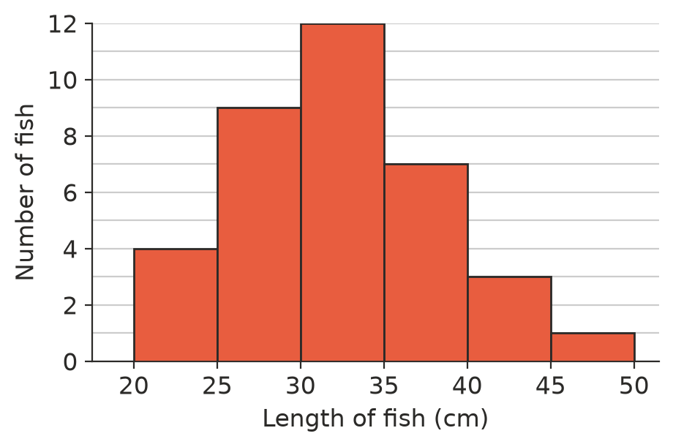
  - Which class contains the median? ______________
  - Use the middle of each class (22.5, 27.5, …) to estimate the mean length, correct to 1 decimal place. ______________
  - Only fish 30 cm or longer may be kept. What percentage of the fish could be kept? Round to the nearest whole percent. ______________
  - Why is your answer to part b only an estimate? ______________

 Reasoning
- The ages of the eight people in a youth Bible study group are 15, 16, 16, 17, 17, 18, 19 and 74 (the leader).
  - Find the mean and the median, with and without the leader. ______________
  - Which measure changed more? By how much did it change, correct to 1 decimal place? ______________
  - Which measure better describes the age of the group members? Explain.

- Write a data set of four whole numbers where the mean, median and mode are all different, and the mode is the largest of the three. Show the three measures.

- The houses sold in one street last year sold for (in thousands of dollars): 610, 640, 655, 680, 700, 720, 1850.
  - Find the mean and the median, correct to the nearest thousand dollars. ______________
  - A real estate agent wants owners in the street to think their houses are worth a lot. Which measure would she quote? Is it a fair choice? Explain.

 Problem solving
- Five whole numbers have a mean of 12, a median of 11, a mode of 9 and a range of 10. Find the numbers, and explain why there is only one answer.

- The mean score of 11 students on a test is 15. Two tests are re-marked: one score goes up by 4 and another goes down by 1. Then a new student does the test, and the mean of all 12 scores is 16. What did the new student score?

- The data set 2, 4, 5, 7, 9, x has its mean equal to its median. Find every possible whole-number value of x.

- Class A has 24 students with a mean test score of 68. Class B has 26 students with a mean score of 73. Find the mean score of all 50 students. Why is it not just halfway between 68 and 73?

- Write a set of 8 whole numbers with a range of 20 and an IQR of 4.

