11.01 Measures of centre and spread
Year 8 Maths · Worksheet · Level 1 · Warm-up
Name: ____________________ Date: ______________
This worksheet revises the mean, median and mode (measures of centre) and the range and interquartile range (measures of spread). Tip: always put the data in order before you look for the median or the quartiles.

 Understanding
- Write the letter of the description that matches each word.
- A: the middle value when the data is in order
- B: the highest value minus the lowest value
- C: the total of the values divided by how many values there are
- D: the value that appears most often
- E: the spread of the middle half of the data, Q3 − Q1
  - mean ______________
  - median ______________
  - mode ______________
  - range ______________
  - interquartile range (IQR) ______________
- The data is already in order: 4, 7, 7, 9, 13
  - Find the mode. ______________
  - Find the median. ______________
  - Find the range. ______________
  - Find the mean. ______________

 Fluency
- A netball team scored these goals in 7 games: 12, 15, 9, 15, 20, 11, 16
  - Write the scores in order. ______________
  - Find the mean. ______________
  - Find the median. ______________
  - Find the mode and the range. ______________
- Six students recorded how many hours they slept last night: 8, 5, 12, 7, 9, 7
  - Write the data in order. ______________
  - There are 6 values, so the median is halfway between the 3rd and 4th values. Find the median. ______________
  - Find the mean. ______________
  - Find the range. ______________
- The dot plot shows the number of pets owned by some students.
- 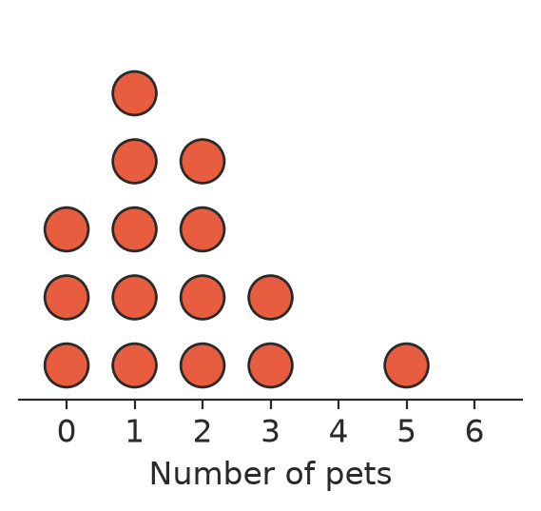
  - How many students are shown? ______________
  - Find the mode. ______________
  - Find the median. ______________
  - Find the range. ______________
  - Find the mean. ______________
- The table shows the number of brothers and sisters of the students in a Year 8 class.
Number of siblings | Frequency | Number × frequency
0 | 4 | 0
1 | 7
2 | 6
3 | 3
Total

  - Complete the table. ______________
  - Find the mean number of siblings. ______________
  - Find the mode. ______________
- The stem-and-leaf plot shows the scores of some students on a quiz out of 50.
Stem | Leaf
2 | 4 8
3 | 0 3 5 5 9
4 | 1 2 6
5 | 0

- Key: 3 | 0 = 30
  - How many students did the quiz? ______________
  - Find the median. ______________
  - Find the mode and the range. ______________
- Follow the steps to find the interquartile range (IQR) of this ordered data: 2, 4, 6, 8, 10, 12, 14, 20
  - Split the data into a lower half and an upper half. Lower half: ______________ Upper half: ______________
  - Q1 is the median of the lower half. Q1 = ______________
  - Q3 is the median of the upper half. Q3 = ______________
  - IQR = Q3 − Q1 = ______________

 Reasoning
- Five students timed their walk to school, in minutes: 8, 10, 12, 12, 48
  - Find the mean and the median. ______________
  - Which value is an outlier? ______________
  - Which measure, the mean or the median, better describes a typical walk? Explain.

- Jack says, “The mean must always be one of the numbers in the data.” Is he right? Use the data in Question 6 to explain.

 Problem solving
- The mean of four numbers is 6. Three of the numbers are 4, 5 and 9. What is the fourth number?

- Write five whole numbers that have a mode of 4, a median of 5 and a range of 6.

