11.01 Measures of centre and spread
Year 8 Maths · A5 question sheet · Level 2 · Core
This worksheet revises the measures of centre (mean, median and mode) and the measures of spread (range and interquartile range), and finds them from lists, dot plots, tables, stem-and-leaf plots and histograms. Tip: to find the quartiles, order the data, split it into a lower half and an upper half (leave out the median if there is an odd number of values), then find the median of each half.

 Understanding
- Here are 8 values: 14, 9, 11, 20, 9, 16, 12, 13
  - Write the values in order.
  - Find the mean.
  - Find the median.
  - Find the mode and the range.
  - Find Q1, Q3 and the interquartile range (IQR).
- Both the range and the interquartile range measure spread. Explain the difference between them, and say which one is not affected by one very large value.

 Fluency
- The dot plot shows the number of goals a footy player kicked in each of 20 games.
- 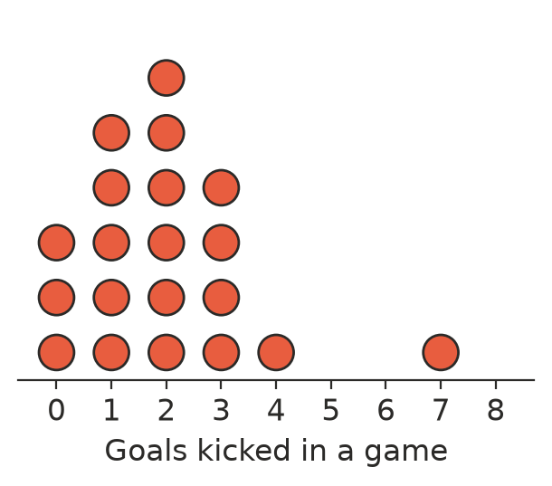
  - Find the mean.
  - Find the median and the mode.
  - Find the range and the IQR.
  - Which value is an outlier?
- A ranger counted the number of people in each car that arrived at a beach car park.
People in the car | Frequency
1 | 6
2 | 9
3 | 5
4 | 4
5 | 1

  - How many cars were counted?
  - Find the mean number of people per car.
  - Find the median and the mode.
  - Find the IQR.
- The stem-and-leaf plot shows the 100 m times of 16 runners at an athletics carnival.
Stem | Leaf
12 | 8
13 | 1 4 4 9
14 | 0 2 5 6 6 6
15 | 1 3 8
16 | 2
17 | 0

- Key: 13 | 4 = 13.4 seconds
  - Find the median.
  - Find the mode and the range.
  - Find Q1, Q3 and the IQR.
- The histogram shows the screen time of 30 students in one week.
- 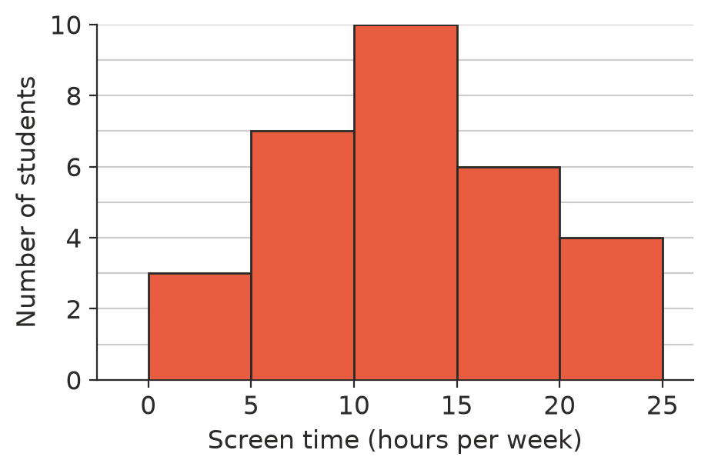
  - Which class has the most students (the modal class)?
  - Which class contains the median?
  - What fraction of the students had 15 hours or more of screen time?
  - Why can’t you find the exact mean from the histogram?

 Reasoning
- A small café pays its six staff these weekly wages: $850, $900, $900, $950, $1000, $3200 (the manager).
  - Find the mean and the median wage.
  - An advertisement says, “Average weekly wage: $1300.” Is this a fair description of a typical wage? Explain.
  - Without the manager, would the range change a lot or a little? Would the IQR change a lot or a little?
- Which measure of centre (mean, median or mode) is best in each case? Give a reason.
  - A shoe shop wants to know which size to order the most of.
  - A report describes house prices in a town where a few houses are worth millions.
  - A teacher wants one number that uses every student’s test score.
- Two Year 8 classes did the same quiz. Here are seven scores from each class.
- Class A: 6, 7, 7, 8, 8, 9, 11
- Class B: 2, 5, 7, 8, 9, 10, 15
  - Show that both classes have the same mean and the same median.
  - Find the range of each class.
  - Which class had more consistent scores? Explain.

 Problem solving
- The mean of six numbers is 15. Five of them are 12, 18, 9, 20 and 14. Find the sixth number.
- The mean of a student’s first 9 test scores is 72. After the 10th test, the mean is 74. What did the student score on the 10th test?
- Find five whole numbers with a mean of 10, a median of 8, a mode of 6 and a range of 14.

