Investigation: Random sampling
Year 8 Maths · Worksheet
Name: ____________________ Date: ______________
The picture shows a population of 50 rectangles, numbered 01 to 50. Each rectangle is made of small squares. Your job is to estimate the mean area of all 50 rectangles by looking at a sample of only a few of them. You will try two ways of choosing a sample, compare them with the rest of your class, and find out which way gives better estimates. You will need a calculator.
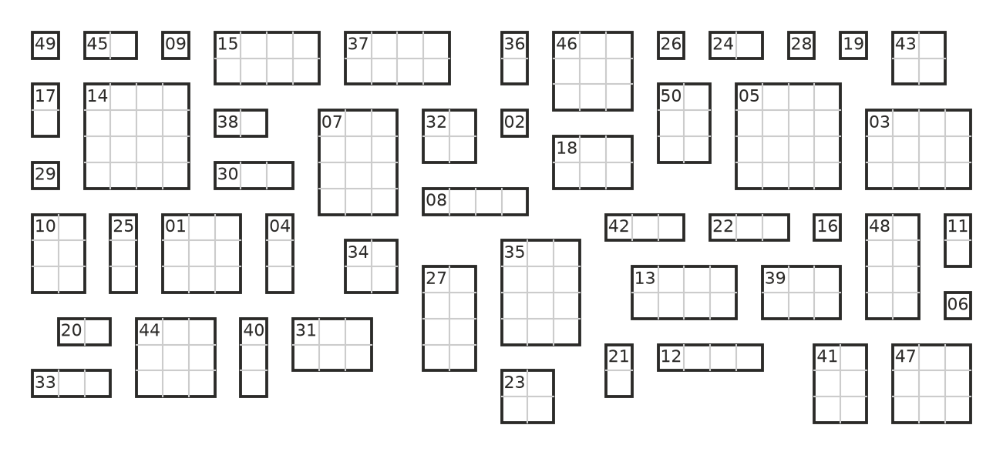

Part A: Choose a sample yourself
- Look at the picture for about 10 seconds. Without counting anything, choose 5 rectangles that you think are typical of the whole population. This is called a judgement sample.
Rectangle number
Area (squares)

- Find the mean area of your judgement sample. Show your working.
- Mean = ______________

Part B: A random sample
In a random sample, every rectangle has the same chance of being chosen. Use the table of random digits below. Start at any row your teacher gives you, read the pairs of digits from left to right, and use each pair as a rectangle number. Skip 00, any number above 50, and any number you have already used.
Row | Random digits
1 | 15 40 64 65 82 13 28 76 79 71 53 73
2 | 70 93 99 98 62 96 98 75 56 30 00 78
3 | 10 14 36 12 57 01 87 62 86 40 26 50
4 | 32 44 45 48 95 65 81 09 92 43 11 71
5 | 68 37 36 58 18 82 90 91 73 39 03 90
6 | 47 46 59 54 11 51 74 70 63 14 54 64
7 | 96 76 62 50 67 33 53 72 61 65 66 03
8 | 73 28 98 16 06 90 66 85 13 91 79 54

- Choose a random sample of 5 rectangles. Count the squares in each one.
- I started at row ______________
Rectangle number
Area (squares)

- Mean = ______________
- Now choose a random sample of 10 rectangles. Start at a different row (when you reach the end of row 8, go back to row 1).
- I started at row ______________
Rectangle number
Area (squares)

- Mean = ______________
- Your teacher might ask you to use a calculator or a phone’s random number generator instead of the table. Why do we skip numbers that have already been used?

Part C: Put the class results together
- Collect the means from everyone in your class. Round each mean to the nearest whole number, and draw three dot plots (one dot for each student).
- 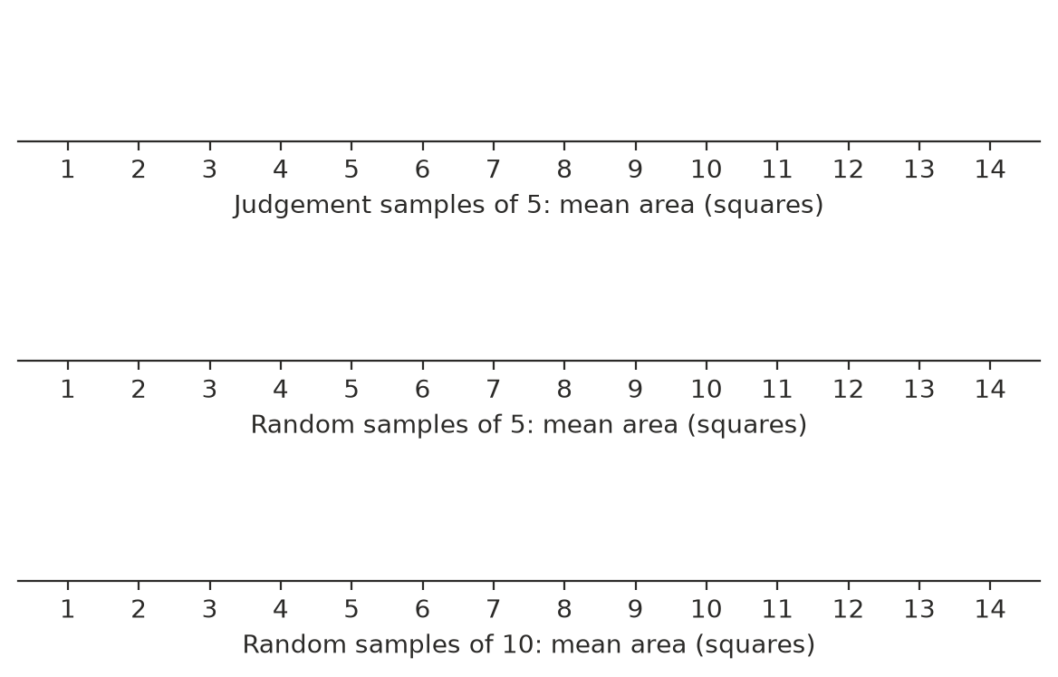
- Describe what you notice about the centre and the spread of each dot plot.
  - Judgement samples of 5: ______________
  - Random samples of 5: ______________
  - Random samples of 10: ______________

Part D: The whole population
- The total area of all 50 rectangles is 250 squares. Find the mean area of the whole population.
- Population mean = ______________
- Counting every member of a population like this is called a census.
- Mark the population mean on each of your three dot plots with an arrow. Which kind of sample gave means that were:
  - closest to the population mean, on the whole? ______________
  - most often too big? ______________
- Many people find that their judgement samples give a mean that is too big. Suggest a reason why.

 Part E: Reflect
- What effect did making the random sample bigger (10 instead of 5) have on the dot plot? Why do you think this happens?

- Here it was quick to measure every rectangle. Give two real-life examples where a census would be too slow, too expensive or impossible, so a random sample is used instead.

- A survey company says, “Our results come from a random sample of 1000 Australians.” Using what you found in this investigation, explain why “random” and “1000” both matter.

