Investigation: The golden ratio
Year 8 Maths · A5 question sheet
The golden ratio is a famous irrational number, about 1.618. It is often written with the Greek letter φ (phi, said “fye”), and its exact value is $\frac{1+\sqrt{5}}{2}$. In this investigation you will find φ hiding in a number pattern, in a five-pointed star and in a rectangle, and think about why a measurement can only ever get close to it. You will need a calculator, a ruler marked in millimetres and a pair of compasses.
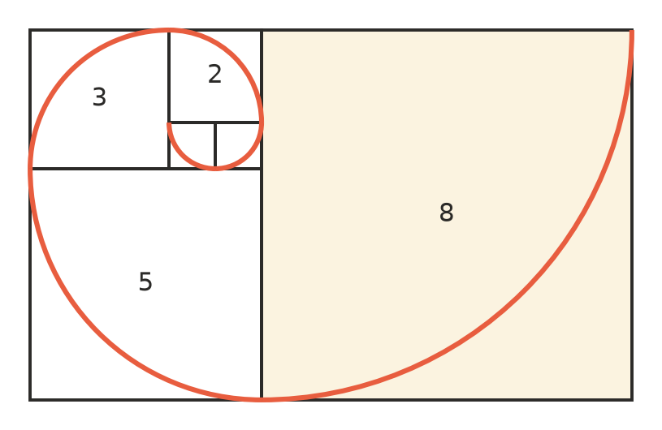

Part A: A number pattern
The Fibonacci sequence starts 1, 1, and then each number is the sum of the two numbers before it: 1, 1, 2, 3, 5, 8, …
- Write the first 12 numbers of the Fibonacci sequence.
- 1, 1, 2, 3, 5, 8, ______________, ______________, ______________, ______________, ______________,
- Divide each Fibonacci number by the one before it. Write each answer correct to 4 decimal places.
Division
1 ÷ 1
2 ÷ 1
3 ÷ 2
5 ÷ 3
8 ÷ 5
13 ÷ 8
21 ÷ 13
34 ÷ 21
55 ÷ 34
89 ÷ 55
144 ÷ 89

- Describe what happens to the answers as you go down the table. Do they go up, down, or both?

Part B: The number itself
- Use your calculator to work out φ = $\frac{1+\sqrt{5}}{2}$. Write down every digit your calculator shows.
- φ =
- Use your calculator to complete these. Use the full value of φ, not a rounded one.
  - φ × φ =
  - φ + 1 =
  - 1 ÷ φ =
  - φ − 1 =
- What do you notice?
- Every answer in your table in Question 2 is a fraction of two whole numbers. Can any of them ever be exactly equal to φ? Explain, using the words rational and irrational.

Part C: The five-pointed star
The picture is printed at true size. The red lines are the diagonals of the pentagon ABCDE, and P is where diagonals AC and BE cross.
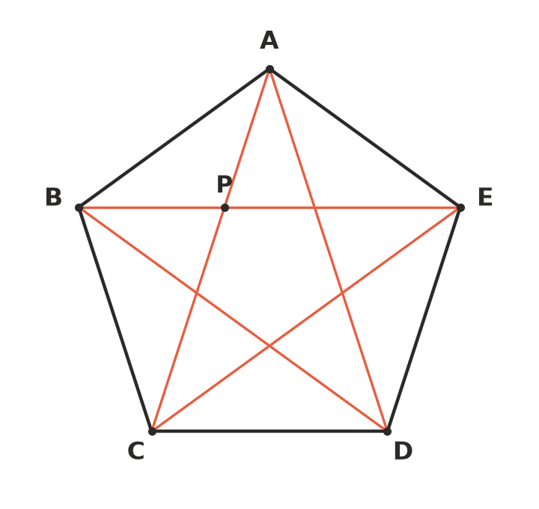
- Measure each length in millimetres.
  - the side AB = ______________ mm
  - the diagonal AC = ______________ mm
  - AC ÷ AB = ______________ (to 2 decimal places)
- Now measure the two parts of the diagonal AC.
  - AP = ______________ mm
  - PC = ______________ mm
  - PC ÷ AP = ______________ (to 2 decimal places)
- How do your answers to Questions 7c and 8c compare with φ? Why might they not be exactly the same?

Part D: The golden rectangle
These rectangles are printed at true size.
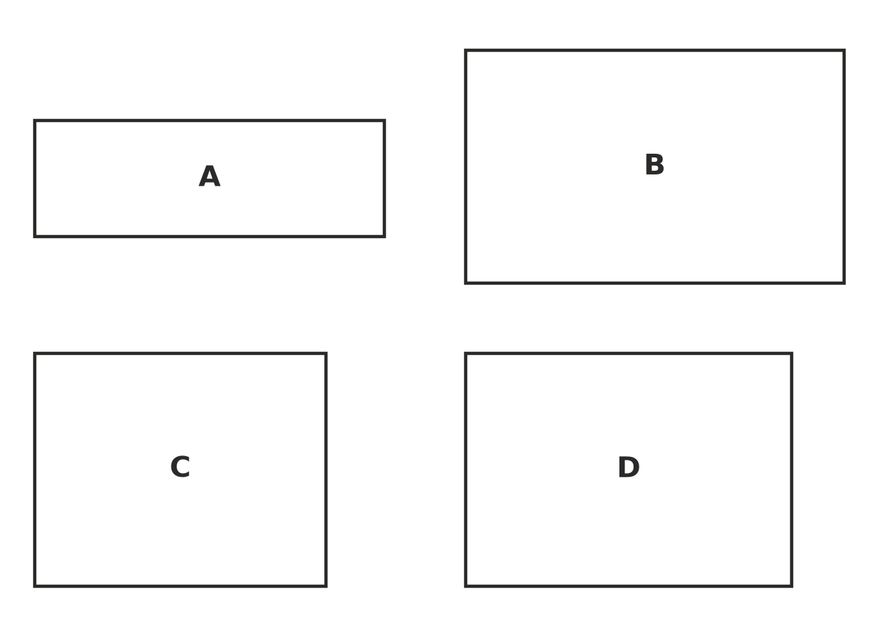
- Which rectangle looks the nicest shape to you? There is no right answer.
- Measure each rectangle in millimetres, then copy and complete the table.
Rectangle | Length (mm) | Width (mm) | Length ÷ width (2 decimal places)
A
B
C
D

Which rectangle has a length ÷ width closest to φ? This is a golden rectangle. Did you choose it in Question 10?
- Construct your own golden rectangle on a blank sheet of paper.
  - Draw a square ABCD with sides of 5 cm, with AB along the bottom. Extend the bottom line AB to the right by about 5 cm.
  - Mark M, the midpoint of AB.
  - Put the point of your compasses on M and the pencil on C. Draw an arc down until it meets the extended line at E.
  - Draw a line straight up from E, and extend DC to the right until the two lines meet at F. AEFD is a golden rectangle.
  - Measure AE. AE = ______________ mm
  - Work out AE ÷ AD. ______________ (to 2 decimal places)

 Part E: Reflect
- Your measured ratios were all close to 1.6. Explain why measuring with a ruler can never show that a ratio is exactly φ.
- You may read that the golden ratio is found in sunflowers, seashells, famous buildings and paintings. Some of these claims are true and some are not. Why is it important to measure carefully before believing a claim like this?

