1.06 Rational and irrational numbers
Year 8 Maths · Worksheet · Level 2 · Core
Name: ____________________ Date: ______________
This worksheet practises sorting real numbers into rational and irrational, estimating square roots and using irrational numbers in real situations. Tip: a number is rational if you can write it as a fraction of two integers. If its decimal goes on forever without a repeating pattern, it is irrational.

 Understanding
- Show that each number is rational by writing it as a fraction $\frac{a}{b}$.
  - 0.8 = ______________
  - −4 = ______________
  - 1.25 = ______________
  - $−3\frac{1}{2}$ = ______________
  - $0.\dot{6}$ = ______________
  - $\sqrt{36}$ = ______________
- Put a tick in every column that describes the number.
Number | Integer | Rational | Irrational
12
−7
$\frac{5}{8}$
$\sqrt{15}$
−0.4
$π$
$\sqrt{81}$
$0.\dot{2}$

 Fluency
- Write rational or irrational for each number.
  - $\sqrt{121}$ ______________
  - $\sqrt{120}$ ______________
  - $2π$ ______________
  - $\frac{22}{7}$ ______________
  - $−\sqrt{64}$ ______________
  - $\sqrt{0.25}$ ______________
  - 3.1416 ______________
  - 1.010010001… (the number of 0s keeps growing) ______________
- Write the two whole numbers next to each other that each number lies between. Then use a calculator to write it correct to 2 decimal places.
  - $\sqrt{40}$ is between ______________ and ______________ $\sqrt{40}$ ≈ ______________
  - $\sqrt{75}$ is between ______________ and ______________ $\sqrt{75}$ ≈ ______________
  - $\sqrt{130}$ is between ______________ and ______________ $\sqrt{130}$ ≈ ______________
  - $−\sqrt{18}$ is between ______________ and ______________ $−\sqrt{18}$ ≈ ______________
- Write these numbers in order from smallest to largest. You may use a calculator.
- $\sqrt{8}$, 2.9, $π$, $\frac{17}{6}$, 3
- Order: ______________

 Reasoning
- Mark and label these numbers on the number line, as accurately as you can: $−\sqrt{5}$, $−\frac{1}{2}$, $\sqrt{3}$, $\frac{7}{3}$, $π$.
- 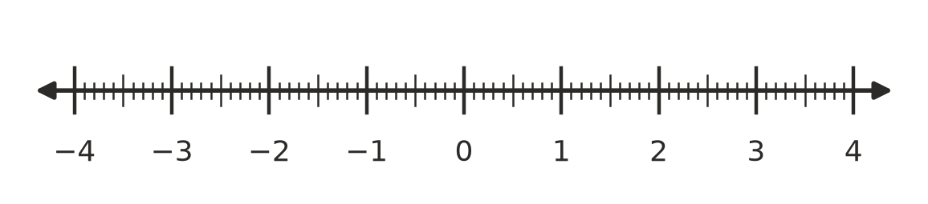
- Liam says $\frac{22}{7}$ and $π$ are the same number. Use a calculator to compare them, and explain why Liam is wrong.

- Give an example of each.
  - an irrational number between 4 and 5 ______________
  - a rational number between $\sqrt{2}$ and $\sqrt{3}$ ______________
  - two irrational numbers that multiply to give a rational number ______________

 Problem solving
- A square garden bed has an area of 30 m².
  - Write the exact side length. ______________
  - Is the side length rational or irrational? ______________
  - How much edging is needed to go all the way around the bed? Give your answer correct to the nearest centimetre. ______________
- A round trampoline is 3 m across. The distance around it is $π$ × 3 m.
  - Write the exact distance around the trampoline. ______________
  - Write the distance correct to 2 decimal places. ______________
  - Max says the distance around is exactly 9.42 m. Explain why he is not quite right. ______________
- The diagonal of a square tile with sides of 1 m is $\sqrt{2}$ m long. Five tiles are laid corner to corner in a straight line, so their diagonals join up. How long is the line? Give the exact length, and the length correct to 2 decimal places.

- A builder needs a square concrete slab with an area of 50 m². Can she mark out the side length exactly with a tape measure? Explain.

