1.06 Rational and irrational numbers
Year 8 Maths · A5 question sheet · Level 3 · Challenge
This worksheet stretches your understanding of rational and irrational numbers: tricky cases, estimating without a calculator, and what happens when you add or multiply them. Tip: before you decide, simplify. $\sqrt{1.44}$ looks irrational, but it equals 1.2.

 Understanding
- Show that each number is rational by writing it as a fraction $\frac{a}{b}$ in simplest form.
  - −2.125 =
  - $0.\dot{4}$ =
  - $\sqrt{\frac{9}{16}}$ =
  - ${\left(\sqrt{7}\right)}^{2}$ =
- Put a tick in every column that describes the number.
Number | Integer | Rational | Irrational
$−\sqrt{49}$
$\sqrt{0.4}$
$0.\dot{1}\dot{8}$
$\frac{π}{2}$
$−\frac{12}{4}$
0

 Fluency
- Write rational or irrational for each number, and give a reason.
  - $\sqrt{1.44}$
  - $\sqrt{200}$
  - $π−3$
  - $\frac{\sqrt{8}}{\sqrt{2}}$ (use a calculator)
  - 0.121221222… (the number of 2s keeps growing)
  - $\sqrt{2}+\sqrt{2}$
- Without a calculator, write the two integers next to each other that each number lies between.
  - $\sqrt{150}$ is between ______________ and
  - $−\sqrt{90}$ is between ______________ and
  - $\sqrt{1000}$ is between ______________ and
  - $2π$ is between ______________ and
- Mark and label these numbers on a copy of the number line in your book, as accurately as you can: $−\sqrt{10}$, $−\frac{π}{2}$, $0.\dot{6}$, $\sqrt{5}$, $\frac{11}{4}$.
- 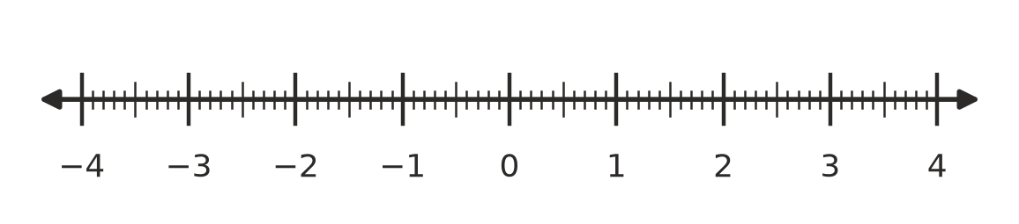
- Write these numbers in order from smallest to largest. You may use a calculator.
- $\frac{22}{7}$, $π$, $\sqrt{10}$, 3.14, $3.\dot{1}\dot{4}$
- Order:

 Reasoning
- Is each statement always true, sometimes true or never true? Write Always, Sometimes or Never, and give an example for each one that is “Sometimes”.
Statement | Always, sometimes or never
The sum of two rational numbers is rational.
The sum of two irrational numbers is irrational.
A rational number times an irrational number is irrational.
The square root of a whole number is irrational.

- Find the whole number n for which $\sqrt{n}$ is between 7.5 and 7.6. Explain how you found it.
- Your calculator shows $\sqrt{2}$ = 1.414213562. Explain why this display can’t prove that $\sqrt{2}$ is irrational.

 Problem solving
- A square photo has an area of 72 cm².
  - Write the exact side length.
  - Between which two whole numbers is the side length?
  - Find the perimeter of the photo, correct to 2 decimal places.
- The inside lane of a circular running track is a circle 64 m across. One lap is $π$ × 64 m.
  - How long is one lap, correct to 2 decimal places?
  - What is the smallest number of full laps you must run to cover at least 5 km?
- A square room has an area between 20 m² and 21 m². Its side length is a rational number. Give a possible side length and the area that goes with it.

