1.01 Add and subtract integers
Year 8 Maths · A5 question sheet · Level 2 · Core
This worksheet revises adding and subtracting integers, with bigger numbers and longer calculations. Tip: change double signs first (+ (−) becomes −, and − (−) becomes +), then picture the jumps on a number line.

 Understanding
- This number line shows a jump that starts at the black dot.
- 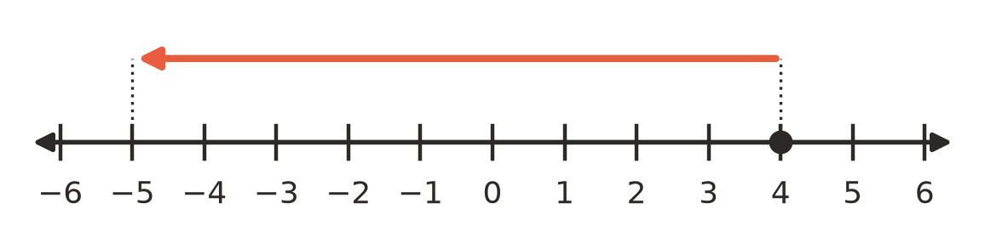
  - Write a subtraction that the jump shows, with the answer.
  - Write an addition that the jump shows, with the answer.
- Rewrite each calculation using only one sign, then work it out.
  - −14 + (−9) =
  - 23 − (−17) =
  - −31 − (−12) =
  - 8 + (−26) =
- Work out each value, then write the four calculations in order from smallest answer to largest answer.
- −7 + 2; −3 − 6; 4 − (−1); −10 − (−12)
- Order:

 Fluency
- Calculate.
  - −27 + 45 =
  - 16 − 53 =
  - −38 − 24 =
  - −72 + 19 =
  - −105 + 60 =
  - 0 − (−48) =
- Calculate.
  - 34 + (−58) =
  - −46 + (−29) =
  - 62 − (−38) =
  - −83 − (−47) =
  - −120 − (−200) =
  - −15 + (−15) − (−30) =
- Work from left to right.
  - −14 + 30 − 25 =
  - 18 − (−7) + (−40) =
  - −9 − 16 − (−11) + 8 =
  - −50 + (−25) − (−90) =

 Reasoning
- Find the missing number.
  - −18 + □ = −5, so □ =
  - □ − 22 = −40, so □ =
  - 15 − □ = 27, so □ =
  - −6 − □ = −20, so □ =
- Write + or − in your book to make the statement true.
  - 9 □ (−4) = 13
  - −12 □ 5 = −17
  - −3 □ (−8) = −11
  - 6 □ (−6) = 0
- Is each statement always true, sometimes true or never true? Write Always, Sometimes or Never in your book.
Statement
A positive number plus a negative number gives a negative answer.
Subtracting a negative number from a number gives a bigger answer.
A negative number minus a positive number gives a positive answer.

- Josh says −15 + 9 = −24, “because 15 + 9 = 24 and the answer is negative”. Explain his mistake, then write the correct answer.

 Problem solving
- In a golf tournament, Ella’s scores compared with par for four rounds were −3, +2, −5 and +1. What is her total score compared with par? Did she finish under or over par?
- One winter’s day in Canberra, the minimum temperature was −6 °C and the maximum was 14 °C.
  - What is the difference between the maximum and minimum temperatures?
  - The next morning was 5 degrees colder than −6 °C. What was the temperature?
- The school canteen’s bank account started the week at −$85 (it was overdrawn). During the week, deposits of $240 and $65 were made, and payments of $130 and $210 came out. What was the balance at the end of the week? Show your working.
- The lowest point in Australia, at Kati Thanda–Lake Eyre, is about 15 m below sea level. The highest point, the top of Mount Kosciuszko, is 2228 m above sea level. What is the difference in height between them? Show your working.

