1.01 Add and subtract integers
Year 8 Maths · A5 question sheet · Level 1 · Warm-up
This worksheet revises adding and subtracting integers: positive and negative whole numbers, and zero. Tip: change any double signs first. Adding a negative is the same as subtracting, so + (−) becomes −. Subtracting a negative is the same as adding, so − (−) becomes +.

 Understanding
- Each number line shows a jump that starts at the black dot. Write the number sentence it shows, with the answer.
  - Jump A
  - 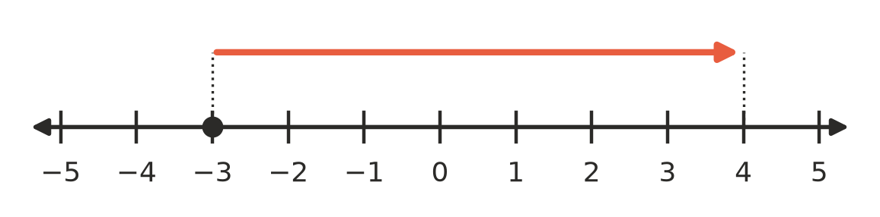
  - Number sentence:
  - Jump B
  - 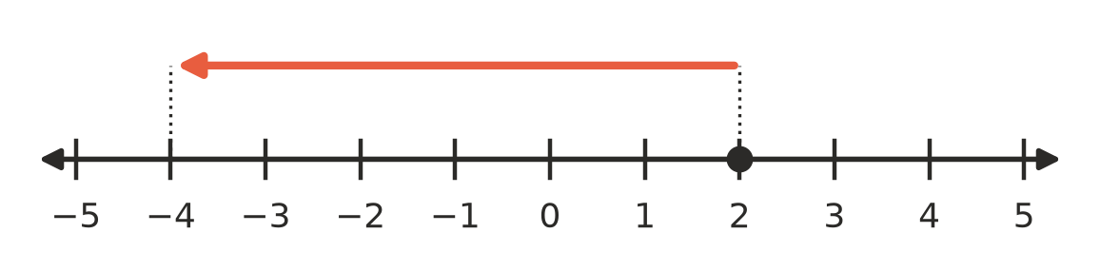
  - Number sentence:
- Rewrite each calculation using only one sign, then work it out.
  - 9 + (−4) =
  - 2 − (−6) =
  - −5 + (−3) =
  - −1 − (−8) =
- Write an integer for each description.
  - 6 degrees below zero
  - a deposit of $40 into a bank account
  - 15 metres below sea level
  - losing 3 points in a game

 Fluency
- Calculate.
  - −6 + 10 =
  - 3 − 11 =
  - −8 − 7 =
  - −12 + 5 =
  - −9 + 9 =
  - 0 − 13 =
- Calculate. Change the double signs first.
  - 7 + (−12) =
  - −4 + (−11) =
  - 10 − (−6) =
  - −9 − (−5) =
  - −3 − (−3) =
  - 15 + (−20) =
- Work from left to right.
  - −2 + 8 − 9 =
  - 5 − 12 + 10 =
  - −6 − (−4) + (−7) =

 Reasoning
- Find the missing number.
  - −5 + □ = 2, so □ =
  - □ − 4 = −9, so □ =
  - 3 + □ = −6, so □ =
- Write True or False in your book.
Statement
−7 + 3 gives a negative answer.
Subtracting a negative number makes the answer bigger.
−10 − 2 = −8
Adding two negative numbers always gives a negative answer.

- Mia worked out −3 − (−7) and got −10. Explain her mistake, then write the correct answer.

 Problem solving
- At 6 am the temperature at Thredbo was −4 °C. By noon it had risen by 11 degrees. What was the temperature at noon? Show your working.
- A lift starts on level 3 of a building. It goes down 5 floors to the car park, then up 9 floors. Level 0 is the ground floor. Which level is the lift on now? Show your working.
- A submarine is at −120 m (120 m below sea level). A helicopter is flying 250 m above sea level, straight above it. How far apart are they? Show your working.

