Ratios and rates: Practice test 2
Year 8 Maths · Test · Test 2
Name: ____________________ Date: ______________
Time: 45 minutes
Total: 40 marks
Show your working in the boxes. Then write each final answer on the answer sheet on the last page.

 Section A: No calculator
- Write each ratio in simplest form.
  - 42 : 70 (1 mark)

  - 18 : 27 : 63 (1 mark)

- Write each ratio in simplest form, using whole numbers.
  - 2.5 : 4 (1 mark)

  - $1\frac{1}{2}$ : $\frac{3}{4}$ (1 mark)

- Write the ratio 40 minutes to 1.5 hours in simplest form. Change to the same units first. (1 mark)

- Find the value of x that makes these ratios equivalent: 12 : x = 9 : 15 (1 mark)

- A netball club has 120 players. The ratio of juniors to seniors is 5 : 3.
  - How many juniors are in the club? (1 mark)

  - Then 15 more seniors join the club. Write the new ratio of juniors to seniors in simplest form. (1 mark)

- A builder mixes concrete from cement, sand and gravel in the ratio 1 : 2 : 4. She has 60 kg of sand and plenty of cement and gravel. How many kilograms of concrete mix can she make if she uses all of the sand? (2 marks)

- A road map has a scale of 1 : 200 000.
  - Two towns are 3.5 cm apart on the map. How far apart are they in real life, in kilometres? (1 mark)

  - A road is 15 km long. How long is it on the map, in centimetres? (1 mark)

- A model of a car is 21 cm long. The real car is 4.2 m long.
  - Write the scale of the model in the form 1 : n. (1 mark)

  - A wheel on the model is 3 cm across. How wide is the real wheel, in centimetres? (1 mark)

- Write each of these as a unit rate.
  - 360 L of water pumped in 8 minutes, in litres per minute (1 mark)

  - $12 for 400 g of cashews, in dollars per kilogram (1 mark)

- Convert 15 m/s to kilometres per hour (km/h). Show your working. (2 marks)

- The travel graph shows a family’s car trip to the coast. They stopped once for lunch.
- 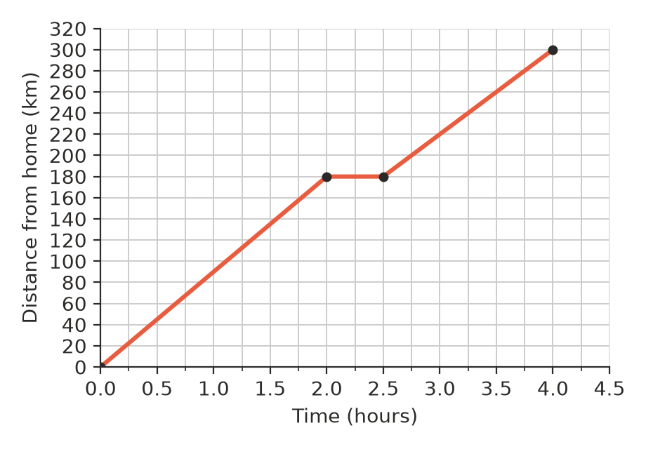
  - What was the car’s speed during the first 2 hours? (1 mark)

  - What was the average speed for the whole trip, including the lunch stop? (1 mark)

- Mia earns $19 an hour at a bakery. Jack earns $720 for a 40-hour week at a hardware store. Jack says, “I earn more than Mia for each hour I work.” Is Jack right? Explain your answer. (2 marks)

- The ratio of Sam’s age to his dad’s age is 2 : 7. In 8 years’ time, the ratio of their ages will be 2 : 5. How old is Sam now? Show your reasoning. (3 marks)

- A 500 g tub of yoghurt costs $3.50 and a 1 kg tub costs $6.40. Work out the cost per 100 g of each tub, and say which tub is better value. (2 marks)

 Section B: Calculator allowed
- Ava puts $3500 into a savings account that pays 4.2% simple interest per year. Simple interest means she earns the same amount of interest every year, worked out on the $3500. How much interest does she earn in 3 years? (2 marks)

- On a school trip to Japan, the exchange rate is $1 AUD = 98.5 yen.
  - How many yen will a student get for $600? (1 mark)

  - A bowl of ramen costs 2400 yen. How much is this in Australian dollars? Round to the nearest cent. (1 mark)

- A breakfast cereal comes in three sizes: 375 g for $4.95, 530 g for $6.60 and 805 g for $10.20. Find the cost per 100 g of each size, rounded to the nearest cent, and say which size is the best buy. (2 marks)

- An empty rainwater tank holds 4500 L. A hose fills it at a rate of 18 L per minute. How long does it take to fill the tank? Give your answer in hours and minutes. (2 marks)

- A household is charged 31.5 cents for each kilowatt-hour (kWh) of electricity it uses, plus a supply charge of $1.05 per day. In a 30-day month the household uses 520 kWh. How much is the electricity bill for that month? (2 marks)

- Mr Nguyen mixes blue paint and yellow paint in the ratio 3 : 5 to make the green for a mural. He needs 14 L of green paint. Blue and yellow paint are each sold only in 2 L tins, and every tin costs $32. How many tins of each colour must he buy, and what is the total cost? (3 marks)

 Answer sheet
Name: ____________________
Write your final answer for each question in the table.
Question | Answer | Marks | Question | Answer | Marks
1a |  | /1 | 9b |  | /1
1b |  | /1 | 10 |  | /2
2a |  | /1 | 11a |  | /1
2b |  | /1 | 11b |  | /1
3 |  | /1 | 12 |  | /2
4 |  | /1 | 13 |  | /3
5a |  | /1 | 14 |  | /2
5b |  | /1 | 15 |  | /2
6 |  | /2 | 16a |  | /1
7a |  | /1 | 16b |  | /1
7b |  | /1 | 17 |  | /2
8a |  | /1 | 18 |  | /2
8b |  | /1 | 19 |  | /2
9a |  | /1 | 20 |  | /3
 |  |  |  | Total | /40

