3.03 Rates
Year 8 Maths · Worksheet · Level 3 · Challenge
Name: ____________________ Date: ______________
This worksheet practises harder rate problems: converting units, rates from graphs, average speed over a whole trip, and rates that combine. Tip: average speed is always total distance ÷ total time. Never just average the two speeds.

 Understanding
- Change each rate to the units shown.
  - 1.2 m/s to km/h ______________
  - 90 km/h to metres per minute ______________
  - $3.60 per 100 g to $/kg ______________
  - 0.9 L/min to mL/s ______________
- The graph shows two cyclists riding away from home on the same road. Amy leaves at 8 am. Ben leaves later.
- 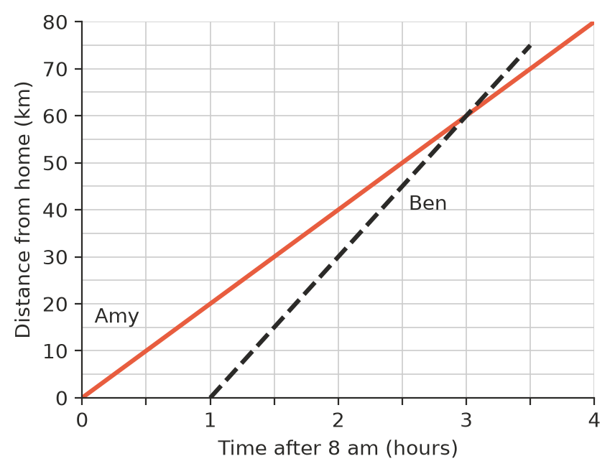
  - What is the speed of each cyclist? ______________
  - At what time does Ben catch up with Amy, and how far from home are they? ______________
  - How can you tell from the graph which cyclist is faster? ______________

 Fluency
- Answer each part. Watch the units.
  - A car travels 192 km in 2 hours 24 minutes. What is its average speed in km/h? ______________
  - How many minutes does it take to walk 3.6 km at 4.8 km/h? ______________
  - Lawn mowing costs $32.50 for 1 hour 15 minutes. What is the rate per hour? ______________
- A 600 L water tank is filled by two hoses at the same time. One hose delivers 12 L/min and the other delivers 18 L/min.
  - How long does it take to fill the empty tank? ______________
  - The tank has a leak that loses 5 L/min. How long does it take to fill it now? ______________
- Lawn fertiliser should be spread at 35 g per square metre. A lawn is 12 m long and 8.5 m wide.
  - How much fertiliser is needed, in kilograms? ______________
  - Fertiliser comes in 2.5 kg bags. How many bags must be bought? ______________

 Reasoning
- Tom drives 60 km at 60 km/h, then another 60 km at 120 km/h. He says, “My average speed for the trip was 90 km/h.” Is he right? Explain. ______________

- Three workers can build a fence in 8 hours. How long would 4 workers take, if they all work at the same rate? Explain your thinking. ______________

 Problem solving
- A family drives 540 km to their holiday house. They drive the first 240 km at an average speed of 80 km/h, stop for 30 minutes, then drive the rest at an average speed of 100 km/h.
  - How long does the whole trip take, including the stop? ______________
  - What is the average speed for the whole trip, including the stop? Round to 1 decimal place. ______________
  - They leave home at 7:15 am. At what time do they arrive? ______________

- A heart beats about 70 times per minute. About how many times does it beat in 80 years? Ignore leap years and round your answer to the nearest hundred million. ______________

- A runner completes a 5 km parkrun in 23 minutes 20 seconds.
  - What was her average pace, in minutes and seconds per kilometre? ______________
  - What was her average speed in km/h, to 1 decimal place? ______________

- Ruby’s shower uses 9 L of water per minute, and she showers for 8 minutes each day. She buys a water-saving shower head that uses 7 L/min and cuts her shower to 5 minutes. How much water does she save in a week? ______________

- Sound travels through air at about 340 m/s.
  - You hear thunder 6 seconds after you see the lightning. How far away is the storm, in kilometres? ______________
  - A storm is 3 km away. How long after the lightning will you hear the thunder? Round to 1 decimal place. ______________
- Ella can paint 12 m² of fence in 3 hours. Jack can paint 15 m² in 2.5 hours. How long will it take them to paint 60 m² of fence if they work together? ______________

