3.03 Rates
Year 8 Maths · Worksheet · Level 2 · Core
Name: ____________________ Date: ______________
This worksheet practises unit rates, changing the units of a rate, speed, distance and time, and reading a rate from a graph. Tip: to change km/h to m/s, change kilometres to metres (× 1000) and hours to seconds (× 3600).

 Understanding
- Which of these is a rate? Answer: ______________
  - 3 : 4
  - 25 m/s
  - $\frac{2}{5}$ of the class
  - a map scale of 1 : 100
- A car uses 7 L of petrol per 100 km.
  - Is this a unit rate? ______________
  - Write the rate in litres per kilometre. ______________
  - How much petrol does the car use on a 350 km trip? ______________

 Fluency
- Write each as a unit rate.
  - $27.60 for 4 kg ______________
  - 1020 km in 12 hours ______________
  - 4.5 L in 90 seconds (in litres per minute) ______________
  - 1440 words in 32 minutes ______________
  - $1092 for 42 hours of work ______________
- Change each rate to the units shown.
  - 72 km/h to m/s ______________
  - 15 m/s to km/h ______________
  - $4.50/kg to cents per gram ______________
  - 2.4 L/min to mL/s ______________
  - 300 mL/min to L/h ______________
- Use speed, distance and time.
  - How far does a car travel in 2.5 hours at 84 km/h? ______________
  - How long does it take to drive 156 km at 78 km/h? ______________
  - A hiker walks 9 km in 45 minutes. What is her speed in km/h? ______________
  - How long does it take to run 600 m at 4 m/s? Give your answer in minutes and seconds. ______________

 Reasoning
- The graph shows the water in a tank as it is filled with a hose.
- 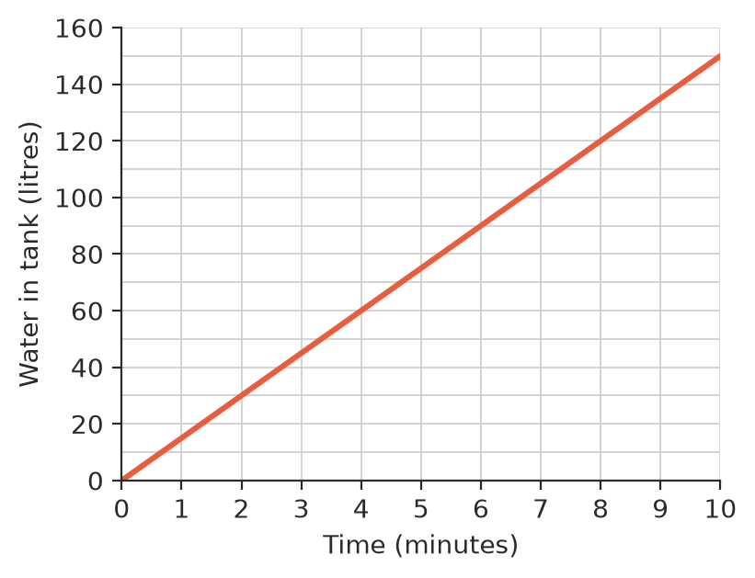
  - At what rate does the tank fill, in litres per minute? ______________
  - If the water keeps flowing at this rate, how many minutes after the start will the tank hold 240 L? ______________
  - How does the graph show that the water flows at a constant rate? ______________

- Which is faster, 20 m/s or 70 km/h? Explain. ______________

 Problem solving
- A cyclist rides 42 km in 1 hour 45 minutes.
  - What is her average speed in km/h? ______________
  - At the same speed, how long would it take her to ride 66 km? ______________

- Leo’s resting heart rate is 68 beats per minute. How many times does his heart beat in one day? ______________

- A car uses 6.5 L of petrol per 100 km. The family drives 480 km.
  - How many litres of petrol do they use? ______________
  - Petrol costs $1.95 per litre. How much does the petrol cost? ______________
- A backyard pool holds 18 000 L. A hose fills it at 25 L/min. How many hours does it take to fill the pool? ______________

- Printer A prints 24 pages in 1.5 minutes. Printer B prints 35 pages in 2.5 minutes. Which printer is faster, and by how many pages per minute? ______________

- A country town has 12 000 people and covers an area of 48 km². What is its population density, in people per square kilometre? ______________

