3.02 Maps and scale
Year 8 Maths · Worksheet · Level 3 · Challenge
Name: ____________________ Date: ______________
This worksheet practises harder scale work: reading a scale bar, finding the scale from measurements, changing between two maps, enlargements, areas on plans and choosing your own scale. Tip: a length on a plan is multiplied by the scale, but an area is multiplied by the scale twice. You will need a ruler for Question 2.

 Understanding
- Answer each part.
  - Write “1 cm stands for 3.5 km” as a ratio in the form 1 : n. ______________
  - A map has a scale of 1 : 2 500 000. Complete: 1 cm stands for □ km. ______________
  - Write “4 mm stands for 10 m” as a ratio in the form 1 : n. ______________
  - A diagram has a scale of 5 : 1. Is the diagram bigger or smaller than the real object? ______________
- The map shows a coastal walk. It is drawn at true size, so you can measure it with your ruler. Measure between the centres of the dots. The walk follows the dashed path from the Car park to the Lookout, then the Beach, then the Lighthouse.
- 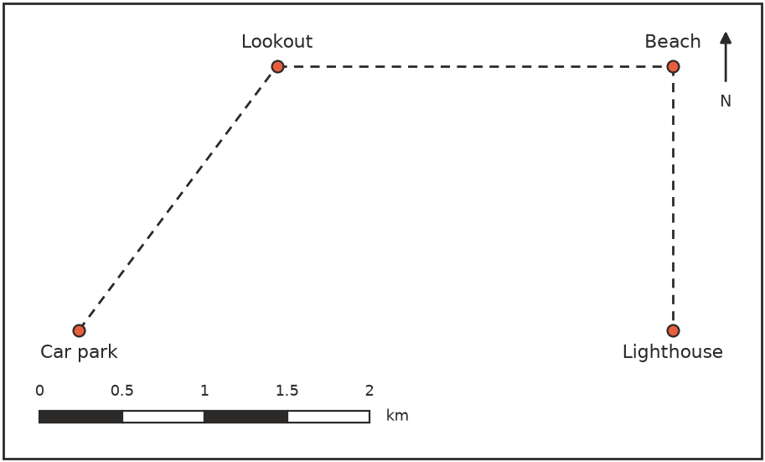
  - Use the scale bar to write the scale of the map as a ratio. ______________
  - What is the total real length of the walk? ______________

  - How much shorter is the straight-line distance from the Car park to the Lighthouse than the walk? ______________

 Fluency
- A map of Australia has a scale of 1 : 2 000 000.
  - Two towns are 4.6 cm apart on the map. How far apart are they in real life, in kilometres? ______________
  - Two cities are 350 km apart. How far apart are they on the map? ______________
- Find each scale as a ratio.
  - 12 cm on a map stands for 3.6 km. ______________
  - 2.5 cm on a map stands for 125 km. ______________
  - An insect 4 mm long is drawn 6 cm long. ______________
- Map A has a scale of 1 : 20 000 and map B has a scale of 1 : 50 000. A road is 7.5 cm long on map A. How long is it on map B? ______________

 Reasoning
- A house plan has a scale of 1 : 200. On the plan, a room is 3 cm long and 2 cm wide.
  - What is the real area of the room, in square metres? ______________
  - The area of the room on the plan is 6 cm². How many times bigger is the real area than the area on the plan? Explain why the answer is not 200. ______________

- Jess says, “A map with a scale of 1 : 50 000 is a larger-scale map than one with a scale of 1 : 25 000, because 50 000 is bigger.” A large-scale map is one where things are drawn larger. Explain whether Jess is right.

 Problem solving
- The plan shows a block of land with a scale of 1 : 500. The measurements are lengths on the plan.
- 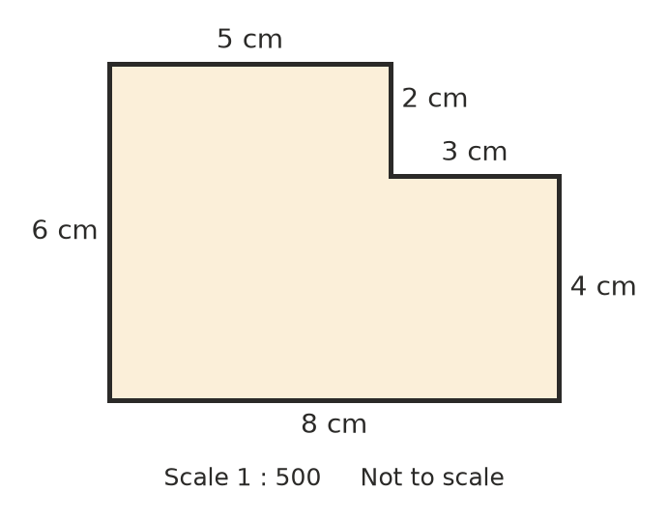
  - What is the real perimeter of the block, in metres? ______________
  - What is the real area of the block, in square metres? ______________

  - Fencing costs $35 per metre. How much will it cost to fence the whole block? ______________
- A model car is built to a scale of 1 : 18.
  - The model is 26 cm long. How long is the real car, in metres? ______________
  - The real car is 1.8 m wide. How wide is the model, in centimetres? ______________
- In a drone photo of a footy oval, the oval’s length of 160 m is shown as 8 cm.
  - What is the scale of the photo? ______________
  - The oval’s width on the photo is 6.5 cm. What is its real width? ______________
- On a road map with a scale of 1 : 250 000, a winding road between two towns measures 18.4 cm. The straight-line distance between the towns on the map is 14 cm. How much further is it to drive along the road than to go in a straight line? ______________

- Mr Scott wants to draw a plan of the church hall, which is 24 m long and 15 m wide. The plan must fit on a page, with the long side between 15 cm and 20 cm. Choose a scale in the form 1 : n, and find the length and width of the hall on your plan. ______________

