3.02 Maps and scale
Year 8 Maths · Worksheet · Level 2 · Core
Name: ____________________ Date: ______________
This worksheet practises writing scales as ratios, finding real distances and map distances, working out the scale of a map, and using scale drawings. Tip: change both measurements to centimetres first (1 m = 100 cm and 1 km = 100 000 cm). You will need a ruler for Question 6.

 Understanding
- Write each scale as a ratio in the form 1 : n.
  - 1 cm stands for 5 m ______________
  - 1 cm stands for 2 km ______________
  - 1 mm stands for 1 m ______________
  - 2 cm stands for 1 km ______________
- A map has a scale of 1 : 20 000.
  - 1 cm on the map stands for how many metres? ______________
  - How many centimetres on the map stand for 1 km? ______________

 Fluency
- A map has a scale of 1 : 40 000. Find each real distance in kilometres.
  - 5 cm ______________
  - 12 cm ______________
  - 7.5 cm ______________
  - 8.5 cm ______________
- A road map has a scale of 1 : 250 000. How long is each real distance on the map, in centimetres?
  - 10 km ______________
  - 35 km ______________
  - 4 km ______________
  - 750 m ______________
- Find the scale of each map as a ratio in the form 1 : n.
  - 6 cm on the map stands for 300 m. ______________
  - 4 cm on the map stands for 20 km. ______________
  - 15 cm on the plan stands for 45 m. ______________
- The map of a country town is drawn at true size, so you can measure it with your ruler. Measure between the centres of the dots.
- 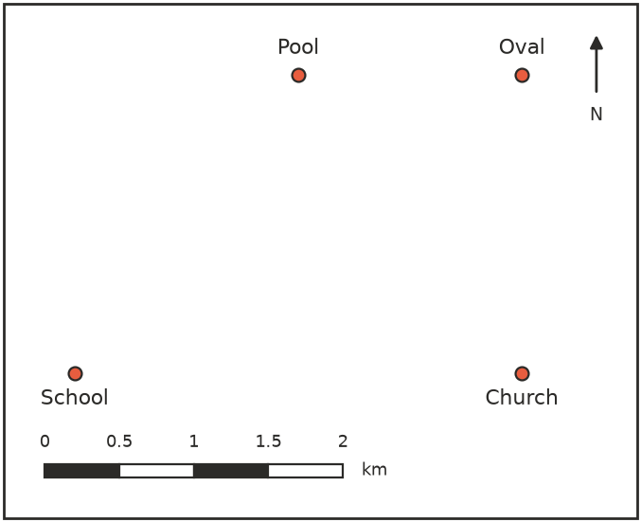
  - Use the scale bar to write the scale of the map as a ratio. ______________
  - What is the real straight-line distance from the School to the Church? ______________
  - What is the real straight-line distance from the School to the Pool? ______________
  - What is the real distance from the Pool to the Oval? ______________

 Reasoning
- Map A has a scale of 1 : 10 000 and map B has a scale of 1 : 50 000. Both maps show the same road, which is 1 km long. On which map is the road drawn longer, and by how many centimetres? ______________

- A science book shows a drawing of an ant at a scale of 5 : 1.
  - Explain what the scale 5 : 1 means. ______________

  - The ant in the drawing is 3 cm long. How long is the real ant, in millimetres? ______________

 Problem solving
- A house plan has a scale of 1 : 50. On the plan, a bedroom is 8 cm long and 7 cm wide.
  - What are the real length and width of the bedroom? ______________
  - Carpet costs $45 per square metre. How much will it cost to carpet the bedroom? ______________

- The main arch of the Sydney Harbour Bridge is about 500 m long. A model of the bridge is built to a scale of 1 : 2000. How long is the arch on the model, in centimetres? ______________

- Two country towns are 12 km apart.
  - How far apart are they on a map with a scale of 1 : 25 000? ______________
  - What scale would make the two towns exactly 20 cm apart on the map? ______________

- A rectangular paddock is 600 m long and 450 m wide. It is drawn on a map with a scale of 1 : 15 000.
  - What are the length and width of the paddock on the map? ______________
  - The diagonal of the paddock on the map measures 5 cm. How long is the real diagonal? ______________

