3.02 Maps and scale
Year 8 Maths · A5 question sheet · Level 1 · Warm-up
This worksheet practises using a scale to change map distances into real distances and back again. Tip: a scale of 1 : 500 means 1 cm on the map stands for 500 cm (5 m) in real life. You will need a ruler for Question 7.

 Understanding
- A map has a scale of 1 : 1000.
  - 1 cm on the map stands for how many centimetres in real life?
  - 1 cm on the map stands for how many metres in real life?
  - Two trees are 4 cm apart on the map. How far apart are they in real life, in metres?
- A plan has a scale of 1 : 200, so 1 cm on the plan stands for 2 m. Copy and complete the table.
Distance on the plan (cm) | 1 | 3 | 5
Real distance (m) | 2 |  |  | 16 | 30

- Write each scale in words, as “1 cm stands for …”. Use metres or kilometres.
  - 1 : 100
  - 1 : 5000
  - 1 : 100 000

 Fluency
- A house plan has a scale of 1 : 50. Find the real length, in metres, of a wall that is this long on the plan.
  - 2 cm
  - 8 cm
  - 13 cm
- A map has a scale of 1 : 25 000, so 1 cm on the map stands for 250 m. Find each real distance in metres.
  - 4 cm
  - 10 cm
  - 6 cm
- A plan has a scale of 1 : 200. How long should each real length be drawn on the plan, in centimetres?
  - 10 m
  - 16 m
  - 3 m
- The map shows part of a church camp. The map is drawn at true size, so you can measure it with your ruler. Measure between the centres of the dots.
- 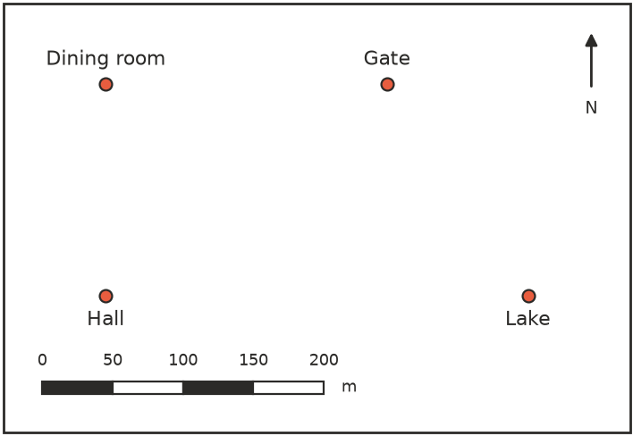
  - Use the scale bar: 1 cm on the map stands for how many metres?
  - Measure the distance from the Hall to the Lake on the map, in centimetres.
  - What is the real distance from the Hall to the Lake?
  - What is the real distance from the Dining room to the Gate?

 Reasoning
- A map has a scale of 1 : 500. Liam says, “1 cm on the map stands for 500 m.” Explain his mistake, and write what 1 cm really stands for.
- One map has a scale of 1 : 1000 and another has a scale of 1 : 100 000. Which map would be better for showing the buildings in your school? Explain.

 Problem solving
- A model plane is built to a scale of 1 : 72. The real plane is 18 m long. How long is the model, in centimetres?
- A bushwalking map has a scale of 1 : 50 000, so 1 cm on the map stands for 500 m.
  - A track is 9 cm long on the map. How long is the real track, in kilometres?
  - Another track is 6 km long. How long is it on the map?
- A floor plan of a classroom has a scale of 1 : 100. On the plan, the room is 8 cm long and 6 cm wide.
  - What are the real length and width of the room?
  - What is the real area of the floor?

