Pythagoras' theorem: Practice test 3
Year 8 Maths · Test · Test 3
Name: ____________________ Date: ______________
Time: 45 minutes
Total: 40 marks
Show your working in the boxes. Then write each final answer on the answer sheet on the last page. Diagrams are not drawn to scale. In Section B, round each answer as the question asks.

 Section A: No calculator
- Evaluate each of these.
  - ${15}^{2}$ (1 mark)

  - $\sqrt{169}$ (1 mark)

  - $(\sqrt{20})^{2}$ (1 mark)

  - $\sqrt{6^{2}+8^{2}}$ (1 mark)

- Answer each part about $\sqrt{110}$.
  - Between which two consecutive whole numbers does $\sqrt{110}$ lie? (1 mark)

  - Is $\sqrt{110}$ closer to the smaller or the larger of these two numbers? Explain how you know. (1 mark)

- Use the right-angled triangle to answer each part.
- 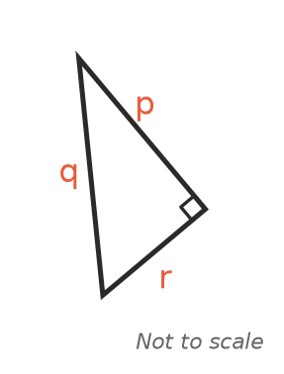
  - Which letter names the hypotenuse? (1 mark)

  - Write Pythagoras’ theorem for this triangle, using p, q and r. (1 mark)

- Find the value of x. (2 marks)
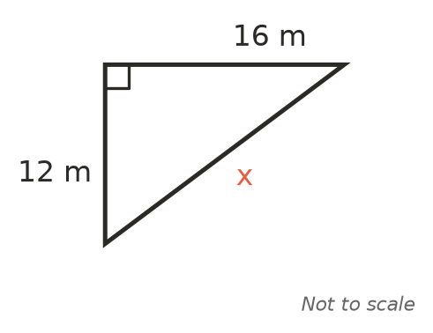

- A right-angled triangle has shorter sides of 7 cm and 24 cm. Find the length of its hypotenuse. (2 marks)

- Find the value of y. (2 marks)
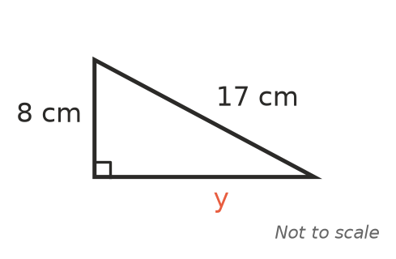

- Use the triangle to answer each part.
- 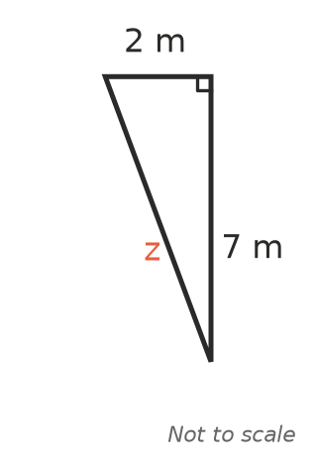
  - Find the exact value of z. Leave your answer as a square root. (2 marks)

  - Between which two consecutive whole numbers does z lie? (1 mark)

- A triangle has sides of 12 m, 35 m and 37 m. Is it a right-angled triangle? Show working to explain your answer. (2 marks)

- A right-angled triangle has a hypotenuse of 26 cm and one shorter side of 10 cm. Mia finds the third side like this:
- $x^{2}={26}^{2}+{10}^{2}=776$, so x = $\sqrt{776}$ cm.
- Explain Mia’s mistake and find the correct length of the third side. (2 marks)

- The numbers 5, 12 and 13 form a Pythagorean triad (triple), because $5^{2}+{12}^{2}={13}^{2}$.
- Multiply each number by 3. Show that the three new numbers also form a Pythagorean triad. (2 marks)

- Find the distance between points A and B. (2 marks)
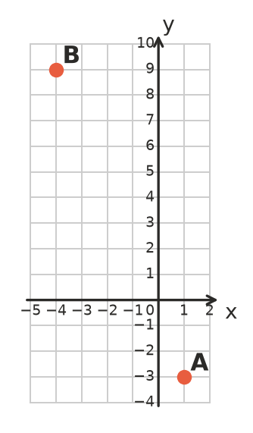

- The shape ABCD is made from two right-angled triangles. Find the value of x. (3 marks)
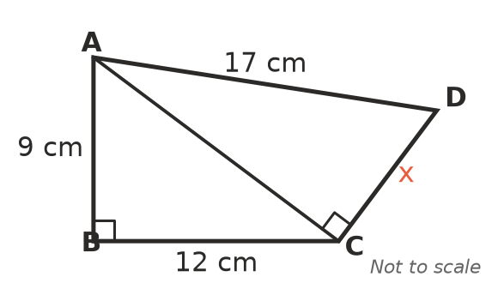

 Section B: Calculator allowed
- Find the value of d, correct to 1 decimal place. (2 marks)
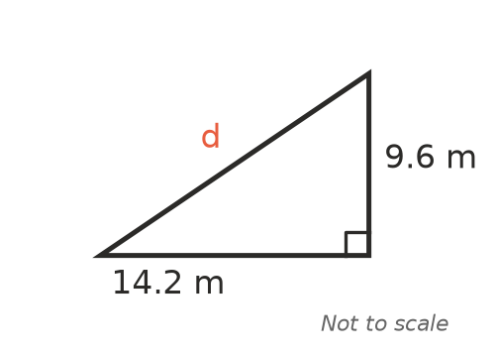

- Find the value of s, correct to 2 decimal places. (2 marks)
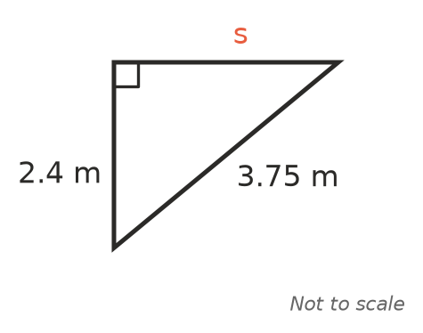

- On a road trip, a family drives 48 km due east and then 35 km due north. How far are they from their starting point, in a straight line? Give your answer correct to 1 decimal place. (2 marks)

- A farm gate is a rectangle 3.6 m long and 1.2 m high. A timber brace runs diagonally from one corner of the gate to the opposite corner. How long is the brace? Give your answer in metres, correct to the nearest centimetre. (2 marks)

- A 5.5 m ladder leans against a wall, with its top 5 m above the ground. The foot of the ladder then slides 0.8 m further away from the wall.
  - How far was the foot of the ladder from the wall at the start? Give your answer correct to 2 decimal places. (1 mark)

  - How far down the wall does the top of the ladder slide? Give your answer correct to 2 decimal places. (3 marks)

 Answer sheet
Name: ____________________
Write your final answer for each question in the table.
Question | Answer | Marks | Question | Answer | Marks
1a |  | /1 | 7b |  | /1
1b |  | /1 | 8 |  | /2
1c |  | /1 | 9 |  | /2
1d |  | /1 | 10 |  | /2
2a |  | /1 | 11 |  | /2
2b |  | /1 | 12 |  | /3
3a |  | /1 | 13 |  | /2
3b |  | /1 | 14 |  | /2
4 |  | /2 | 15 |  | /2
5 |  | /2 | 16 |  | /2
6 |  | /2 | 17a |  | /1
7a |  | /2 | 17b |  | /3
 |  |  |  | Total | /40

