Pythagoras' theorem: Practice test 2
Year 8 Maths · Test · Test 2
Name: ____________________ Date: ______________
Time: 45 minutes
Total: 40 marks
Show your working in the boxes. Then write each final answer on the answer sheet on the last page. Diagrams are not drawn to scale. In Section B, round each answer as the question asks.

 Section A: No calculator
- Evaluate each of these.
  - ${12}^{2}$ (1 mark)

  - $\sqrt{81}$ (1 mark)

  - $\sqrt{0.25}$ (1 mark)

  - $\sqrt{100−36}$ (1 mark)

- Answer each part.
  - Between which two consecutive whole numbers does $\sqrt{75}$ lie? (1 mark)

  - Which one of these numbers is irrational? (1 mark)
- $\sqrt{121}$ $\sqrt{90}$ $\sqrt{144}$ $\sqrt{1}$

- Use the right-angled triangle XYZ to answer each part.
- 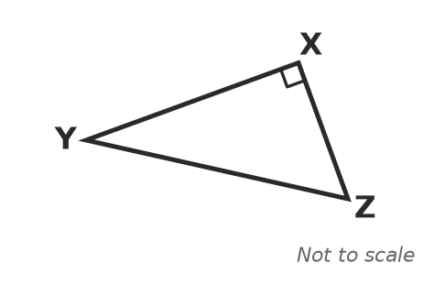
  - Which side is the hypotenuse? (1 mark)

  - Which equation is true for this triangle? Answer: ______________ (1 mark)
  - $XY^{2}=XZ^{2}+YZ^{2}$
  - $YZ^{2}=XY^{2}+XZ^{2}$
  - $XZ^{2}=XY^{2}+YZ^{2}$
  - $YZ^{2}=XY^{2}−XZ^{2}$

- Find the value of a. (2 marks)
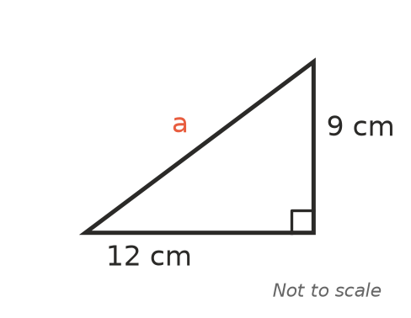

- The two shorter sides of a right-angled triangle are 8 m and 15 m. Find the length of the hypotenuse. (2 marks)

- Find the value of b. (2 marks)
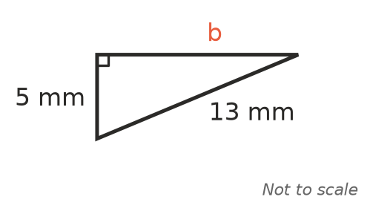

- Use the triangle to answer each part.
- 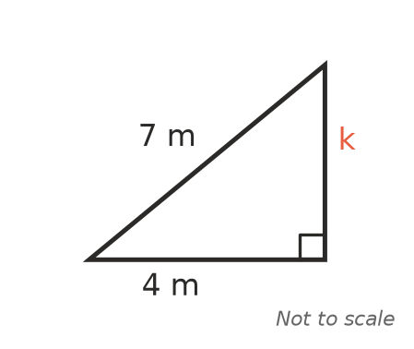
  - Find the exact value of k. Leave your answer as a square root. (2 marks)

  - Between which two consecutive whole numbers does k lie? (1 mark)

- A triangle has sides of 11 cm, 60 cm and 61 cm. Is it a right-angled triangle? Show working to explain your answer. (2 marks)

- The shorter sides of a right-angled triangle are 9 cm and 40 cm. Ben says the hypotenuse must be 49 cm, because 9 + 40 = 49.
- Explain why Ben is wrong and find the correct length of the hypotenuse. (2 marks)

- Squares are drawn on each side of a right-angled triangle. The square on the hypotenuse has an area of 100 cm². The square on one of the shorter sides has an area of 64 cm².
  - What is the area of the third square? (1 mark)

  - How long is the third side of the triangle? (1 mark)

- Find the distance between points A and B. (2 marks)
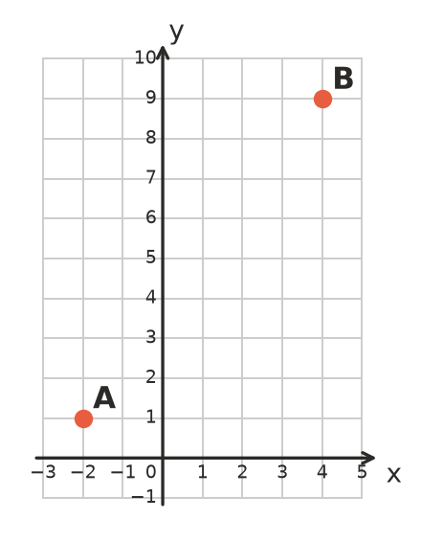

- An isosceles triangle has two equal sides of 10 cm and a base of 12 cm. Find the area of the triangle. (3 marks)

 Section B: Calculator allowed
- Find the value of x, correct to 1 decimal place. (2 marks)
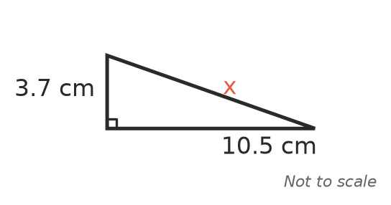

- Find the value of t, correct to 1 decimal place. (2 marks)
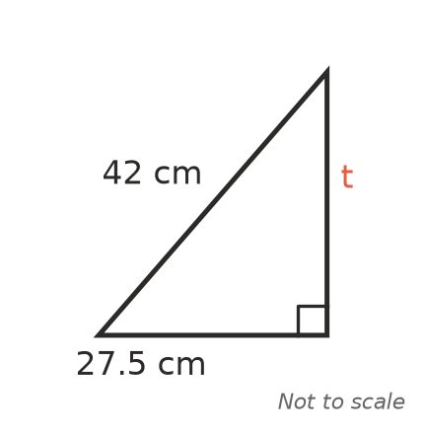

- A wheelchair ramp at the front of the church rises 0.6 m over a horizontal distance of 7.2 m. How long is the sloping surface of the ramp? Give your answer correct to 2 decimal places. (2 marks)

- A phone screen is a rectangle 6.8 cm wide and 14.5 cm tall. The size of a screen is the length of its diagonal. Find the size of this screen, correct to 1 decimal place. (2 marks)

- A storage box is a rectangular prism 40 cm long, 30 cm wide and 20 cm high. The red line goes from a bottom corner to the opposite top corner.
- 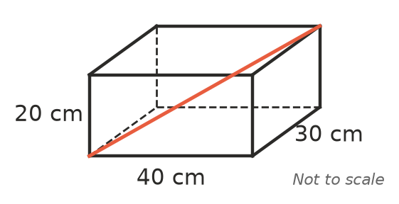
  - Find the length of the diagonal across the bottom of the box. (1 mark)

  - Find the length of the red line, correct to 1 decimal place. (2 marks)

  - Can a thin metal rod 54 cm long fit inside the closed box? Give a reason. (1 mark)

 Answer sheet
Name: ____________________
Write your final answer for each question in the table.
Question | Answer | Marks | Question | Answer | Marks
1a |  | /1 | 8 |  | /2
1b |  | /1 | 9 |  | /2
1c |  | /1 | 10a |  | /1
1d |  | /1 | 10b |  | /1
2a |  | /1 | 11 |  | /2
2b |  | /1 | 12 |  | /3
3a |  | /1 | 13 |  | /2
3b |  | /1 | 14 |  | /2
4 |  | /2 | 15 |  | /2
5 |  | /2 | 16 |  | /2
6 |  | /2 | 17a |  | /1
7a |  | /2 | 17b |  | /2
7b |  | /1 | 17c |  | /1
 |  |  |  | Total | /40

