Pythagoras' theorem: Practice test 1
Year 8 Maths · Test · Test 1
Name: ____________________ Date: ______________
Time: 45 minutes
Total: 40 marks
Show your working in the boxes. Then write each final answer on the answer sheet on the last page. Diagrams are not drawn to scale. In Section B, round each answer as the question asks.

 Section A: No calculator
- Evaluate each of these.
  - $7^{2}$ (1 mark)

  - $\sqrt{144}$ (1 mark)

  - ${0.3}^{2}$ (1 mark)

  - $\sqrt{9+16}$ (1 mark)

- Answer each part.
  - Between which two consecutive whole numbers does $\sqrt{40}$ lie? (1 mark)

  - Which one of these numbers is irrational? (1 mark)
- $\sqrt{49}$ $\sqrt{64}$ $\sqrt{80}$ $\sqrt{100}$

- Use the right-angled triangle PQR to answer each part.
- 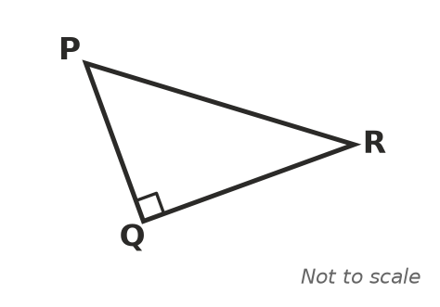
  - Which side is the hypotenuse? (1 mark)

  - Write Pythagoras’ theorem for this triangle, using the side names. (1 mark)

- Find the value of x. (2 marks)
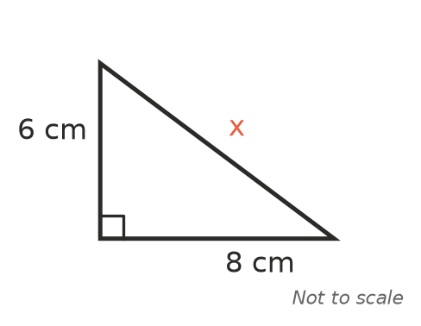

- A right-angled triangle has shorter sides of 5 cm and 12 cm. Find the length of its hypotenuse. (2 marks)

- Find the value of y. (2 marks)
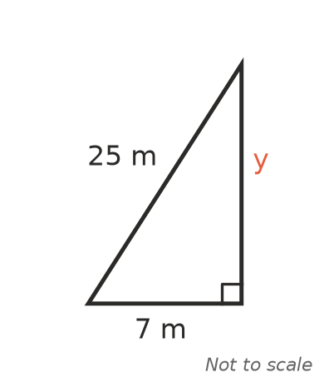

- Use the triangle to answer each part.
- 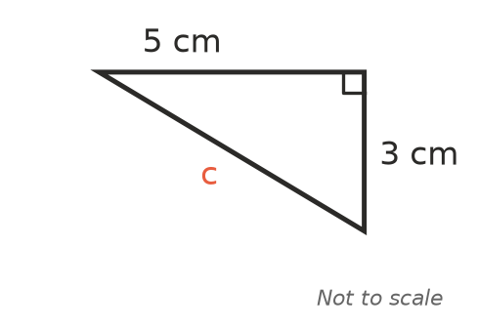
  - Find the exact value of c. Leave your answer as a square root. (2 marks)

  - Between which two consecutive whole numbers does c lie? (1 mark)

- A triangle has sides of 9 cm, 12 cm and 16 cm. Is it a right-angled triangle? Show working to explain your answer. (2 marks)

- A right-angled triangle has a hypotenuse of 10 m and one shorter side of 6 m. Jordan finds the third side like this:
- $x^{2}={10}^{2}+6^{2}=136$, so x = $\sqrt{136}$ m.
- Explain Jordan’s mistake and find the correct length of the third side. (2 marks)

- Squares are drawn on each side of a right-angled triangle. The squares on the two shorter sides have areas of 11 cm² and 14 cm².
  - What is the area of the square on the hypotenuse? (1 mark)

  - How long is the hypotenuse? (1 mark)

- Find the distance between points A and B. (2 marks)
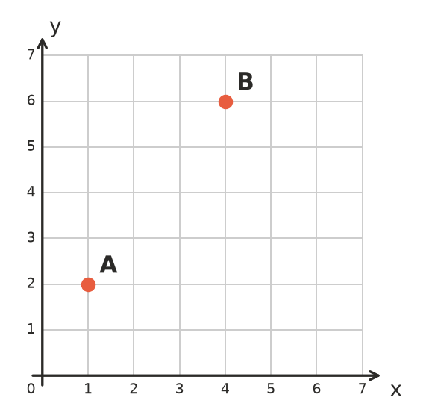

- A rectangle has a diagonal of 15 cm. One side of the rectangle is 9 cm long. Find the perimeter of the rectangle. (3 marks)

 Section B: Calculator allowed
- Find the value of x, correct to 1 decimal place. (2 marks)
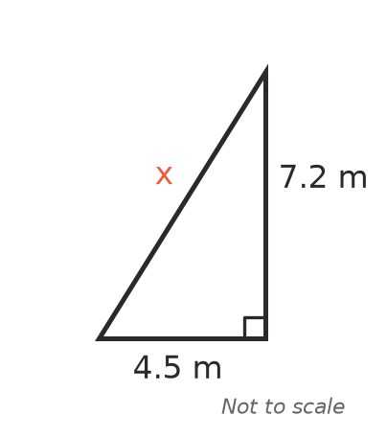

- Find the value of w, correct to 2 decimal places. (2 marks)
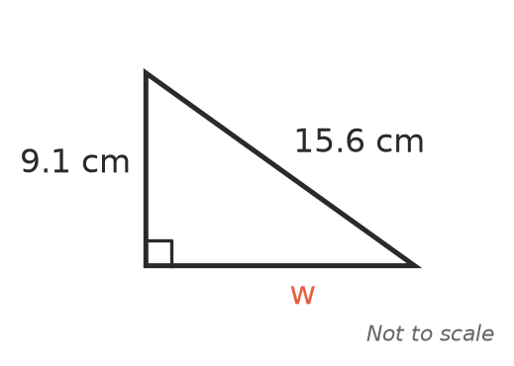

- A 6 m ladder leans against the wall of the school canteen. The foot of the ladder is 1.8 m from the bottom of the wall. How high up the wall does the ladder reach? Give your answer correct to 1 decimal place. (2 marks)

- The front of a shed roof is an isosceles triangle. Its base is 8.4 m wide and each sloping edge is 5.2 m long. Find the height of the roof, h, correct to 2 decimal places. (3 marks)
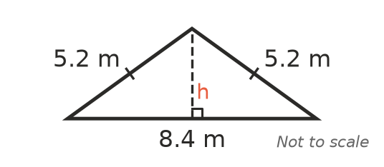

- A park is a rectangle 85 m long and 40 m wide. Kai usually walks along two sides of the park to get from one corner to the opposite corner. Today he walks straight across the diagonal. How much shorter is his walk? Give your answer to the nearest metre. (3 marks)

 Answer sheet
Name: ____________________
Write your final answer for each question in the table.
Question | Answer | Marks | Question | Answer | Marks
1a |  | /1 | 7b |  | /1
1b |  | /1 | 8 |  | /2
1c |  | /1 | 9 |  | /2
1d |  | /1 | 10a |  | /1
2a |  | /1 | 10b |  | /1
2b |  | /1 | 11 |  | /2
3a |  | /1 | 12 |  | /3
3b |  | /1 | 13 |  | /2
4 |  | /2 | 14 |  | /2
5 |  | /2 | 15 |  | /2
6 |  | /2 | 16 |  | /3
7a |  | /2 | 17 |  | /3
 |  |  |  | Total | /40

