8.05 Applications of Pythagoras' theorem
Year 8 Maths · Worksheet · Level 2 · Core
Name: ____________________ Date: ______________
This worksheet uses Pythagoras’ theorem to solve real problems about ladders, sports fields, roofs, maps and shapes. Tip: draw a diagram for every problem, find the right-angled triangle in it, and mark the hypotenuse. Give units in your answer and round as the question asks.

 Understanding
- A 4.5 m ladder leans against a wall with its foot 1.2 m from the wall. How far up the wall does it reach? Round to 2 decimal places.

- A netball court is a rectangle 30.5 m long and 15.25 m wide. How long is a diagonal of the court? Round to 2 decimal places.

 Fluency
- Find the perimeter of the trapezium.
- 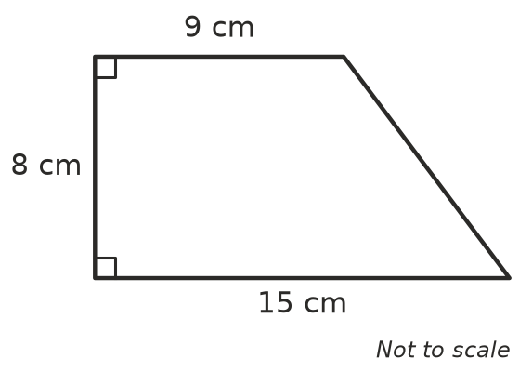

- Find the distance between the points A(1, −3) and B(6, 9). Hint: sketch the points and draw a right-angled triangle.

- An isosceles triangle has two equal sides of 17 cm and a base of 16 cm.
  - Find its height. ______________
  - Find its area. ______________
- A roof is 10 m wide and rises 2.4 m in the middle. How long is each sloping side of the roof? Round to 2 decimal places.

 Reasoning
- A square has a perimeter of 40 cm. Find the length of its diagonal, correct to 2 decimal places.

- The back wall of a lift is 1.5 m wide and 2.4 m high. Can a 2.7 m pole fit against the back wall, from one corner to the opposite corner? Explain.

- A carpenter makes a rectangular window frame 1.2 m wide and 1.6 m high. She measures one diagonal as 2.05 m. Are the corners of the frame right angles? Explain.

 Problem solving
- A flying fox starts from a platform 12 m above the ground and lands on the ground 35 m away, measured along the ground.
  - Draw a diagram and label the lengths you know.

  - How long is the cable, assuming it is straight? ______________
- A ladder safety rule says the foot of a ladder should be 1 m out from the wall for every 4 m it reaches up the wall. A ladder that follows this rule reaches 6 m up a wall. How long is the ladder? Round to 2 decimal places.

- A park is a rectangle 240 m long and 70 m wide. Ella walks along the diagonal instead of along two sides.
  - How many metres does she save? ______________
  - She walks at 1.5 m per second. How many seconds does she save? ______________
- A garden bed is a right-angled triangle. The two shorter sides are 6 m and 8 m. Edging costs $25 per metre. Find the cost of edging all the way around the bed.

