8.05 Applications of Pythagoras' theorem
Year 8 Maths · Worksheet · Level 1 · Warm-up
Name: ____________________ Date: ______________
This worksheet uses Pythagoras’ theorem to solve real problems. Tip: draw a right-angled triangle, label the sides you know, and mark the side you want. Then decide: am I finding the hypotenuse (add the squares) or a shorter side (subtract)?

 Understanding
- A 2.6 m ladder leans against a wall. The foot of the ladder is 1 m from the wall.
- 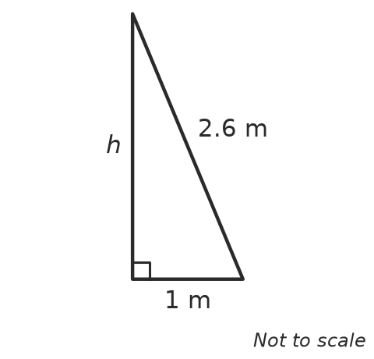
  - Which side of the triangle is the hypotenuse? ______________
  - How far up the wall does the ladder reach? ______________
- A rectangular lawn is 9 m wide and 12 m long. A path goes straight across the lawn from one corner to the opposite corner. How long is the path?

 Fluency
- A boat sails 8 km east and then 15 km north. How far is it from where it started?

- A TV screen is 60 cm wide and 34 cm tall. Find the length of its diagonal, correct to 1 decimal place.

- A kite is flying on a 25 m string. The kite is directly above a point 7 m from the person holding the string. How high is the kite? (Ignore the person’s height.)

- A ramp rises 0.5 m over a horizontal distance of 6 m. How long is the ramp? Round to 2 decimal places.

 Reasoning
- A school oval is a rectangle 100 m long and 75 m wide. Mia walks across the oval from one corner to the opposite corner instead of walking along two sides.
  - How long is Mia’s walk across the oval? ______________
  - How much shorter is her walk than walking along the two sides? ______________
- A square floor tile has sides of 30 cm. Find the length of its diagonal, to 1 decimal place.

- The floor of a car boot is a rectangle 1.2 m wide and 0.5 m deep. Can a 1.25 m fishing rod lie flat on the floor of the boot? Explain.

 Problem solving
- A roof frame is an isosceles triangle. It is 8 m wide at the bottom and 3 m tall in the middle.
- 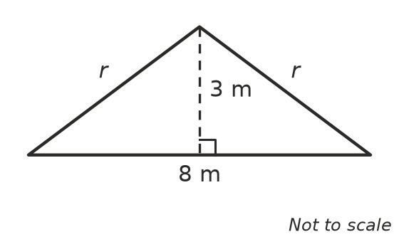
- How long is each sloping rafter, r? ______________
- A wire 10 m long runs from the top of an 8 m pole to a peg in the ground.
  - Draw a diagram and label the lengths you know.

  - How far is the peg from the base of the pole? ______________

