8.05 Applications of Pythagoras' theorem
Year 8 Maths · A5 question sheet · Level 3 · Challenge
This worksheet uses Pythagoras’ theorem in multi-step problems: composite shapes, journeys, paddocks and paths over a box. Tip: you may need to find one length first and then use it in a second triangle. Keep the full calculator value until the last step.

 Fluency
- The diagram shows an isosceles trapezium.
- 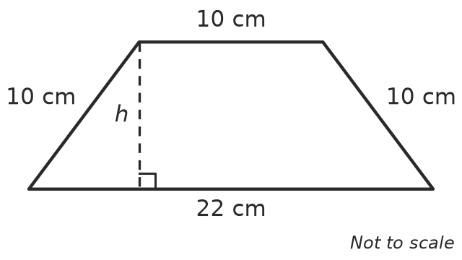
  - Find the height h.
  - Find the area of the trapezium.
- The end wall of a shed is shown. Find its perimeter, correct to 2 decimal places.
- 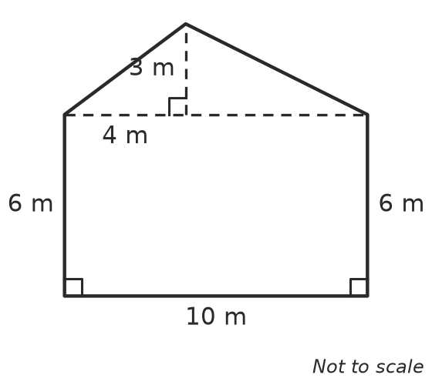
- A ship sails 5 km north, then 12 km east, then 4 km north. How far is the ship from where it started, in a straight line?
- Find the distance between the points C(−4, −1) and D(8, 4).

 Reasoning
- Ben says, “A 3 m ladder with its foot 1 m from a wall reaches 2 m up the wall, because 3 − 1 = 2.” Explain why Ben is wrong, and find how far up the wall the ladder really reaches, to 2 decimal places.
- A square has an area of 50 cm². Without a calculator, show that its diagonal is exactly 10 cm.
- A right-angled triangle has shorter sides x cm and (x + 2) cm, and a hypotenuse of 10 cm. Find x by trying different whole numbers. Show your checking.

 Problem solving
- The diagram shows a kite ABCD. Its diagonals cross at right angles at O, and O is the midpoint of BD.
- 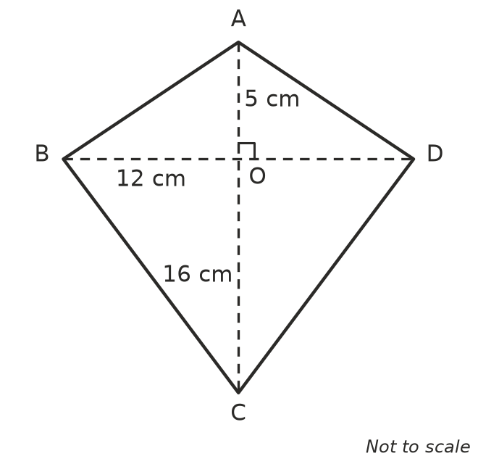
  - Find AB and BC. AB = ______________ BC =
  - Find the perimeter of the kite.
- A paddock is a right-angled triangle with shorter sides of 120 m and 160 m. A fence goes all the way around it, with a post every 4 m (including one at each corner).
  - Find the perimeter of the paddock.
  - How many fence posts are needed?
- An ant walks from corner A to corner B of a box, crossing the top and the front. When the two faces are unfolded flat, they make a rectangle, and the ant’s shortest path is a straight line.
- 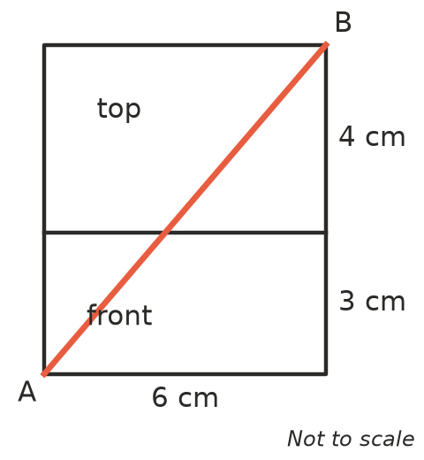
- Find the length of the shortest path, correct to 2 decimal places.
- A rectangular gate is 1.5 m high. Its diagonal brace can be no longer than 2.5 m. What is the widest the gate can be?
- A ladder 7 m long must reach a window sill that is 6.5 m above the ground. How far from the wall should the foot of the ladder be placed? Round to 2 decimal places.

