8.04 Find a short side
Year 8 Maths · Worksheet · Level 2 · Core
Name: ____________________ Date: ______________
This worksheet practises finding a shorter side of a right-angled triangle, and choosing whether to add or subtract. Tip: if you know the hypotenuse, subtract: $a^{2}=c^{2}−b^{2}$. If you are finding the hypotenuse, add: $c^{2}=a^{2}+b^{2}$.

 Understanding
- For each triangle, write whether the unknown is the hypotenuse or a shorter side. Then write an equation and solve it.
- 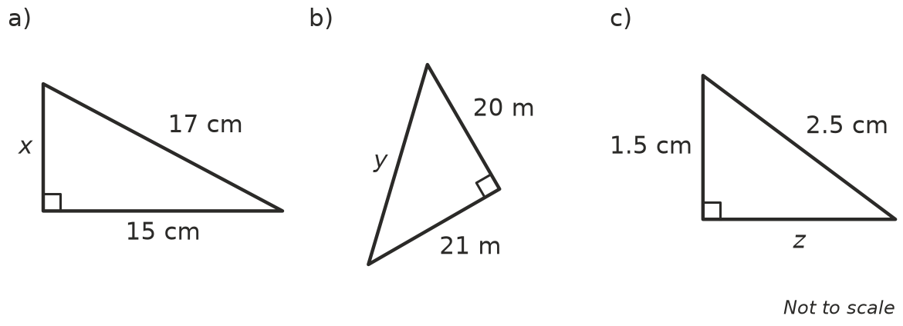
  - ______________ Equation: ______________ x = ______________
  - ______________ Equation: ______________ y = ______________
  - ______________ Equation: ______________ z = ______________

 Fluency
- Find the length of the unknown side in each triangle. Each answer is exact.
- 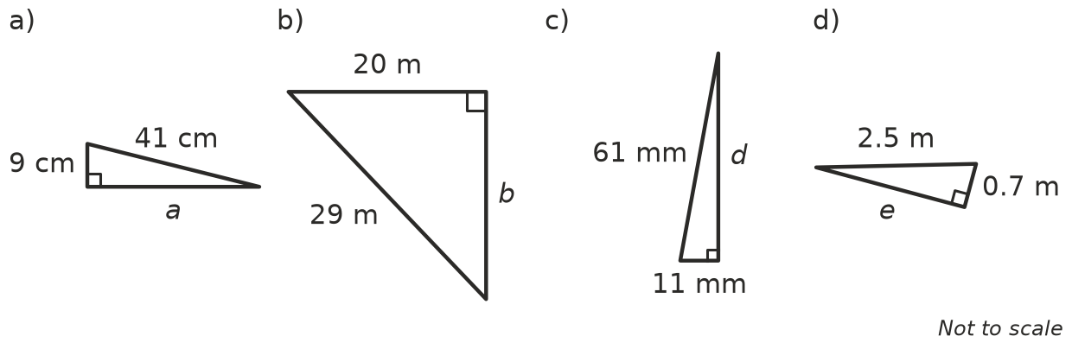
  - a = ______________
  - b = ______________
  - d = ______________
  - e = ______________
- Find the length of the unknown side in each triangle. Round your answers to 1 decimal place.
- 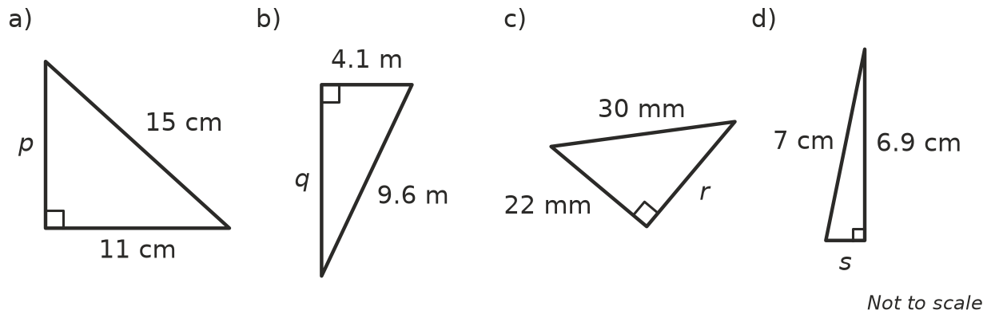
  - p = ______________
  - q = ______________
  - r = ______________
  - s = ______________
- Some of these unknowns are hypotenuses and some are shorter sides. Find each one, correct to 2 decimal places.
- 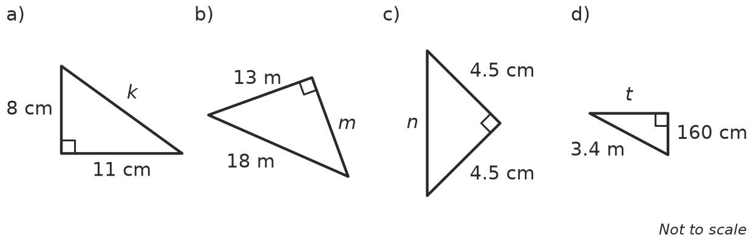
  - k = ______________
  - m = ______________
  - n = ______________
  - t = ______________

 Reasoning
- Grace is finding a shorter side x. The hypotenuse is 15 cm and the other shorter side is 12 cm. She writes x² = 12² − 15² = 144 − 225, and says the question cannot be done. Explain her mistake and find x.

- A right-angled triangle has a hypotenuse of 6 cm and a shorter side of 4 cm.
  - Find the exact length of the other shorter side, using a square root. ______________
  - Is this length rational or irrational? ______________
- Explain how you decide whether to add or subtract when you use Pythagoras’ theorem.

 Problem solving
- A 6 m ladder leans against a wall and reaches 5.7 m up the wall. How far is the foot of the ladder from the wall? Round to 2 decimal places.

- A skateboard ramp has a sloping surface 2.5 m long. It covers 2.4 m along the ground. How high is the top of the ramp?

- A TV has a diagonal of 102 cm and a width of 90 cm. How tall is the screen?

- A flagpole is held up by a wire 13 m long. The wire goes from the top of the pole to a peg in the ground 5 m from the base of the pole. How tall is the flagpole?

- An isosceles triangle has two equal sides of 10 cm and a base of 12 cm. The height cuts the base in half.
- 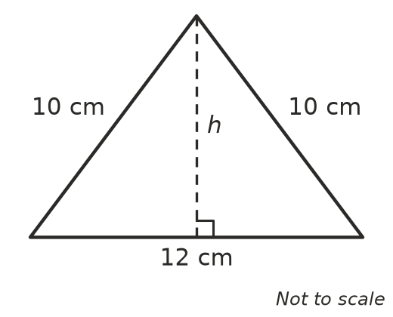
  - Find the height h. ______________
  - Find the area of the triangle. ______________
- A rectangular paddock is 20 m wide and its diagonal is 29 m long.
  - Find the length of the paddock. ______________
  - Find the perimeter of the paddock. ______________

