8.04 Find a short side
Year 8 Maths · Worksheet · Level 1 · Warm-up
Name: ____________________ Date: ______________
This worksheet practises using Pythagoras’ theorem to find one of the two shorter sides of a right-angled triangle. Tip: to find a shorter side, square the hypotenuse and subtract the square of the other short side, then take the square root. Your answer must be shorter than the hypotenuse.

 Understanding
- Fill in the gaps to find the shorter side a.
- 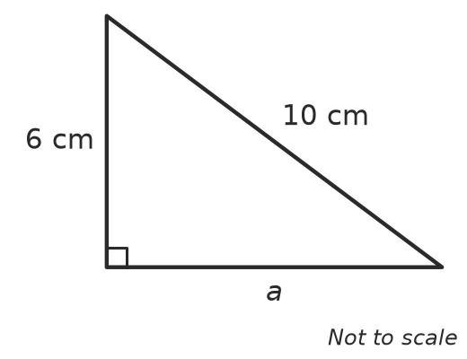
- a² = 10² − 6²
- a² = ______________ − ______________
- a² = ______________
- a = ______________ = ______________ cm
- Fill in the gaps to find the shorter side b.
- 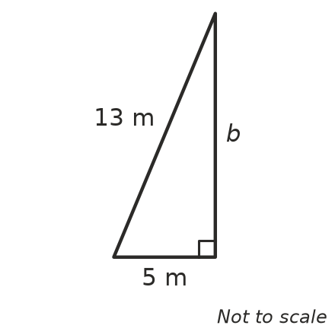
- b² = ______________ − ______________
- b² = ______________
- b = ______________ m

 Fluency
- Find the length of the unknown side in each triangle. Each answer is a whole number.
- 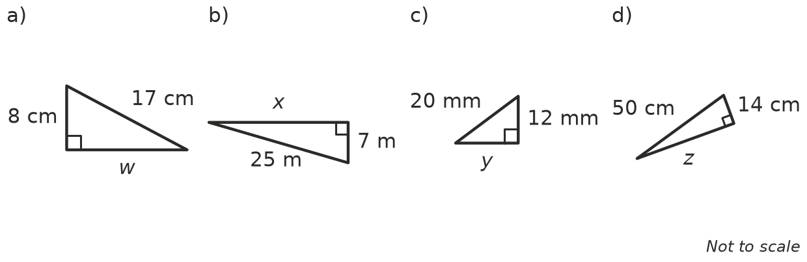
  - w = ______________
  - x = ______________
  - y = ______________
  - z = ______________
- Use a calculator to find the unknown side in each triangle. Round your answers to 1 decimal place where needed.
- 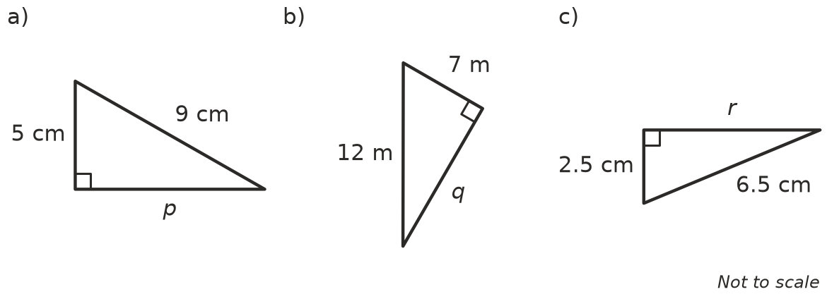
  - p = ______________
  - q = ______________
  - r = ______________
- In one triangle the unknown is the hypotenuse, and in the other it is a shorter side. For each triangle, write add or subtract, then find the unknown.
- 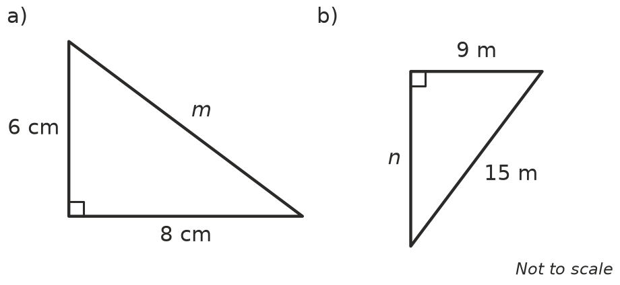
  - add or subtract? ______________ m = ______________
  - add or subtract? ______________ n = ______________

 Reasoning
- Noah needs to find a shorter side of a right-angled triangle. The hypotenuse is 13 cm and the other shorter side is 5 cm. His working is: x² = 13² + 5² = 194, so x = 13.9 cm.
  - How can you tell straight away that Noah’s answer is wrong? ______________
  - Find the correct answer. ______________
- Explain why the shorter sides of a right-angled triangle are always shorter than the hypotenuse.

 Problem solving
- A 5 m ladder leans against a wall. The foot of the ladder is 1.4 m from the wall. How far up the wall does the ladder reach?

- A rectangle has a diagonal of 26 cm and a width of 10 cm. How long is the rectangle?

- A kite is flying on a 50 m string. The kite is directly above a point on the ground that is 30 m from the person holding the string. How high is the kite? (Ignore the person’s height.)

- A playground slide is 3.5 m long. The bottom of the slide is 2.8 m from the foot of the ladder, measured along the ground. The ladder is vertical. How tall is the ladder?

